

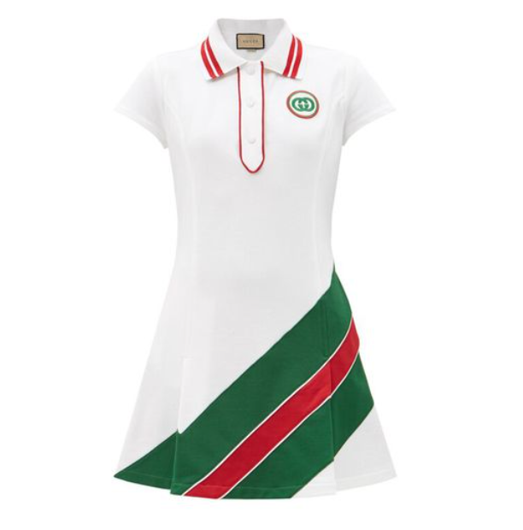

**Gucci Runway Coat** is a luxurious and fashionable piece from the prestigious Gucci collection. Crafted from a blend of wool, this winter coat is designed to provide warmth and style. Inspired by runway trends, it's a perfect blend of high fashion and practicality for the winter season.

**History:** The Gucci Runway Coat is a part of Gucci's innovative approach to high fashion. This coat, with its runway-inspired design, showcases the brand's commitment to blending contemporary fashion trends with timeless elegance.

**Design:** The design of the Gucci Runway Coat is both sophisticated and trendy. Made from a wool blend, it offers warmth and comfort during the colder months. The coat's design reflects the latest trends in fashion, making it a statement piece for any winter wardrobe.



**General Information:**

* Brand: Gucci
* Material: Wool Blend
* Style: Coat
* Size: Various
* Weather Suitability: Winter
* Special Feature: Runway Inspired
* Price: $410

**About the Coat:** The Gucci Runway Coat is ideal for fashion-forward individuals who want to stay warm and stylish during the winter. The wool blend material ensures comfort and durability, while the runway-inspired design adds a touch of glamour. This coat is perfect for winter events, outdoor gatherings, or simply making a fashion statement.

**Care Instructions:** To maintain the coat's quality and appearance, it is recommended to follow Gucci's care instructions. Dry clean only, and store in a cool, dry place to prevent any damage to the fabric.