

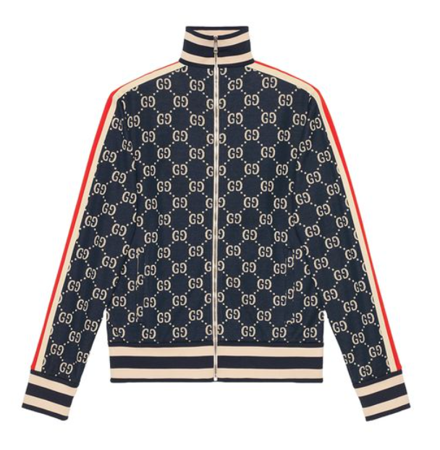

**Gucci Signature Suit** is a hallmark of luxury and style, embodying the essence of the Gucci brand. Crafted from the finest wool, this all-season suit is designed for those who appreciate the blend of classic elegance and modern sophistication. The suit's signature style makes it a distinguished choice for formal and professional settings.

**History:** The Gucci Signature Suit is a representation of Gucci's longstanding heritage in creating timeless fashion pieces. This suit, with its signature style, is a testament to the brand's commitment to excellence and innovation in fashion design.

**Design:** The design of the Gucci Signature Suit is both classic and contemporary. Made from premium wool, it offers a perfect fit and a refined look. The suit's signature style is a reflection of Gucci's dedication to creating pieces that are both elegant and fashion-forward.



**General Information:**

* Brand: Gucci
* Material: Wool
* Style: Suit
* Size: Various
* Weather Suitability: All-Season
* Special Feature: Signature Style
* Price: $420

**About the Suit:** The Gucci Signature Suit is ideal for individuals who seek a blend of traditional elegance and modern style. The wool material ensures comfort and durability, making it suitable for various formal occasions. This suit is a perfect choice for business meetings, formal events, or any occasion where a sophisticated and distinguished appearance is desired.

**Care Instructions:** To maintain the suit's quality and appearance, it is recommended to follow Gucci's care instructions. Dry clean only, and store in a cool, dry place to prevent any damage to the fabric.