

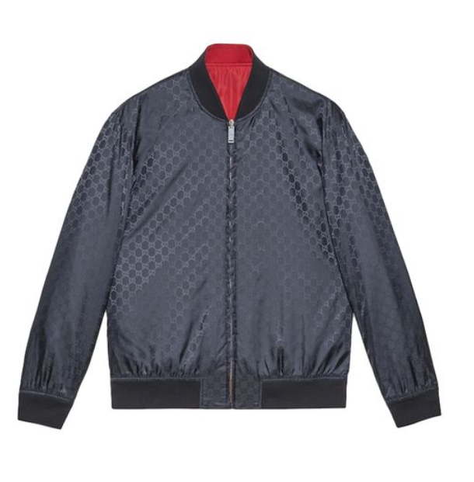

**Gucci Trendy Blazer** is a contemporary and stylish piece from the iconic fashion house, Gucci. Made from a blend of cotton, this all-season blazer combines comfort with a trendy design, making it a versatile addition to any wardrobe.

**History:** The Gucci Trendy Blazer is a reflection of Gucci's commitment to modern fashion trends while maintaining the brand's classic elegance. This blazer is a testament to Gucci's ability to innovate and stay ahead in the fashion industry.

**Design:** The design of the Gucci Trendy Blazer is both modern and sophisticated. The cotton blend material ensures comfort and durability, while the trendy design makes it a fashionable choice for various occasions. The blazer's style is a perfect example of Gucci's expertise in combining fashion with functionality.



**General Information:**

* Brand: Gucci
* Material: Cotton Blend
* Style: Blazer
* Size: Various
* Weather Suitability: All-Season
* Special Feature: Trendy Design
* Price: $360

**About the Blazer:** The Gucci Trendy Blazer is designed for those who appreciate a blend of style and comfort. Its cotton blend material provides a comfortable fit, while the trendy design adds a modern touch to any outfit. This blazer is ideal for business meetings, casual outings, or any occasion where a stylish yet comfortable outfit is desired.

**Care Instructions:** To maintain the blazer's quality and appearance, it is recommended to follow Gucci's care instructions. Regular cleaning and proper storage will ensure the blazer remains in excellent condition.