### Screenshot 2023-12-01 132336

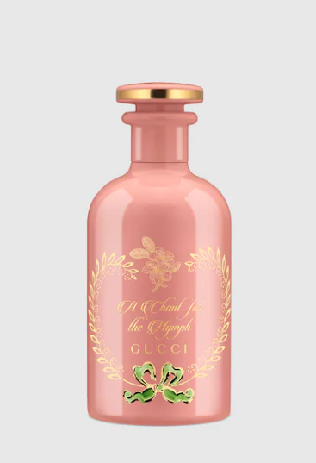

### Gucci Guilty Love Edition Eau de Parfum

**Gucci Guilty Love Edition Eau de Parfum** is a sophisticated fragrance for women, created by the iconic brand **Gucci**. This perfume is celebrated for its unique blend of floral and oriental scents, offering medium longevity and an intriguing aroma. It is available in a 50ml bottle.

**History:** Gucci Guilty Love Edition Eau de Parfum is a tribute to modern love and romance. Launched by Gucci, this fragrance is a fusion of traditional and contemporary elements, creating a scent that is both familiar and novel. Its blend of floral and oriental notes makes it a distinctive choice for the modern woman.

**Design:** The bottle of Gucci Guilty Love Edition Eau de Parfum is a symbol of elegance and luxury. It features a sleek design with a unique color palette, reflecting the romantic and contemporary nature of the fragrance. The Gucci logo adds a touch of sophistication, making the bottle a stylish accessory.



**General Information:**

* Brand: Gucci
* Origin: Italy
* Concentration: Eau de Parfum
* Fragrance Group: Floral Oriental
* Longevity: Medium
* Sillage: Moderate
* Suitable for: Romantic Occasions
* Style: Romantic, contemporary

**About the Fragrance:** Gucci Guilty Love Edition Eau de Parfum is a blend of floral and oriental notes, creating a scent that is both romantic and contemporary. It is perfect for special occasions, particularly those that celebrate love and romance. This fragrance is a testament to Gucci's ability to create scents that resonate with modern sensibilities.

**Storage:** Store in a cool, dry place, away from direct sunlight and heat, to preserve the fragrance's quality and character.