### Screenshot 2023-12-01 132336

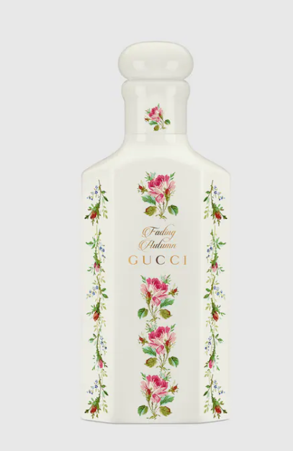

### Gucci Memoire d'une Odeur

**Gucci Memoire d'une Odeur** is an exquisite fragrance for both men and women, crafted by the iconic brand **Gucci**. This perfume is renowned for its unique herbal scent, offering high longevity and a memorable olfactory experience. It is available in a 50ml bottle.

**History:** Gucci Memoire d'une Odeur stands out in the fragrance world for its innovative and timeless scent. Introduced by Gucci, this unisex fragrance has been a game-changer, blending traditional elements with modern creativity. Its herbal aroma is a nod to the past while embracing the future of perfumery.

**Design:** The design of the Gucci Memoire d'une Odeur bottle is a blend of classic and contemporary aesthetics. The bottle, with its clean lines and green color, represents freshness and vitality. The Gucci logo is subtly placed, signifying the brand's legacy and commitment to quality.



**General Information:**

* Brand: Gucci
* Origin: Italy
* Concentration: Eau de Parfum
* Fragrance Group: Herbal
* Longevity: High
* Sillage: Moderate to Strong
* Suitable for: Any Time
* Style: Timeless, innovative

**About the Fragrance:** Gucci Memoire d'une Odeur is a herbal fragrance that offers a unique and refreshing scent. It is perfect for those who seek a fragrance that is both distinctive and versatile, suitable for any time of the day. This perfume is a testament to Gucci's innovative approach to fragrance creation.

**Storage:** Store in a cool, dry place, away from direct sunlight and heat, to preserve the fragrance's integrity.