

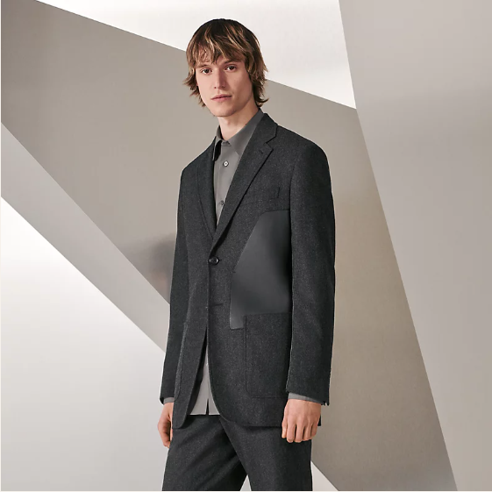

Hermes Exquisite Dress is a stunning evening dress from the luxurious Hermes fashion collection. Made from luxury fabric, this formal dress is perfect for elegant occasions, available in various sizes to suit a range of preferences.

History: The Hermes Exquisite Dress is a testament to Hermes' legacy in creating luxurious formal wear. Designed for high-end events, this dress quickly became popular for its sophisticated craftsmanship and luxurious material. The luxury fabric adds a touch of elegance and exclusivity.

Design: The design of the Hermes Exquisite Dress focuses on sophistication and luxury. The luxury fabric ensures a graceful and comfortable fit, while the evening dress style exudes elegance, making it an ideal choice for formal gatherings.



General Information: • Brand: Hermes • Material: Luxury Fabric • Style: Evening Dress • Size: Various • Weather: Formal • Special Feature: Exquisite Detailing • Image: /ao/aohm8.png • Price: $680

About the Dress: The Hermes Exquisite Dress is designed for those who seek elegance and luxury in their formal wear. The luxury fabric provides a sumptuous feel, while the exquisite detailing makes it a standout piece for any formal occasion. This dress represents Hermes' excellence in high-end fashion design.

Storage: Store in a cool, dry place. Avoid exposure to extreme temperatures and moisture to maintain the quality of the luxury fabric.