

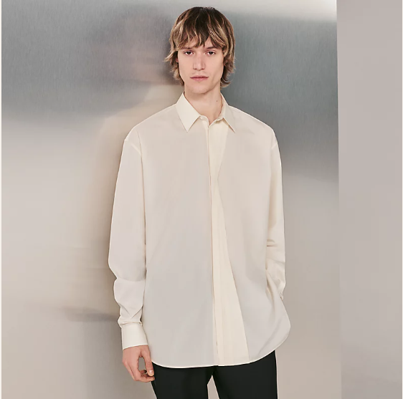

Hermes Stylish Top is a chic and trendy addition to the Hermes clothing line, featuring a casual style made from cotton. This all-season top is designed for comfort and style, available in various sizes to suit a wide range of preferences.

History: The Hermes Stylish Top is a reflection of Hermes' commitment to blending fashion with comfort. Introduced as a versatile all-season piece, it quickly gained popularity for its trendy design and quality cotton material. This top is a testament to Hermes' ability to create fashionable yet comfortable clothing.

Design: The design of the Hermes Stylish Top is modern and trendy, aligning with the latest fashion trends while maintaining the classic Hermes elegance. The cotton material ensures a comfortable and breathable fit, making it suitable for various occasions.



General Information: • Brand: Hermes • Material: Cotton • Style: Casual • Size: Various • Weather: All-Season • Special Feature: Trendy Design • Image: /ao/aohm5.png • Price: $620

About the Top: The Hermes Stylish Top is ideal for those who seek a combination of style and comfort in their everyday wear. Its all-season suitability makes it a practical choice for various settings, while the trendy design ensures a fashionable look. This top showcases Hermes' expertise in creating stylish yet wearable clothing.

Storage: To maintain the quality of the cotton, store in a cool, dry place away from direct sunlight and moisture.