

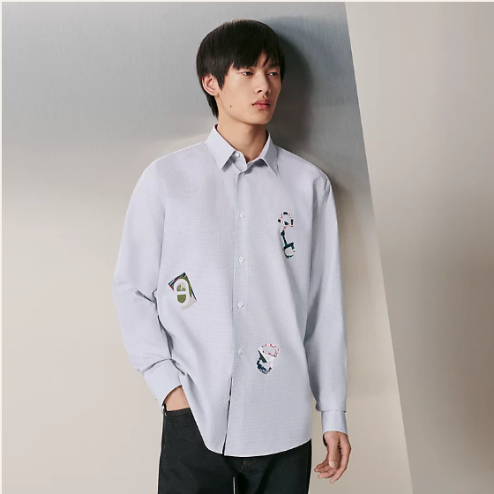

Hermes Trendsetter is a fashion-forward piece from the innovative Hermes clothing line. Made with innovative fabrics, this all-season item is designed for those who want to stand out with a unique style. Available in various sizes, it caters to a wide range of fashion enthusiasts.

History: The Hermes Trendsetter is a symbol of Hermes' dedication to innovation and unique design in fashion. Introduced as a statement piece, it quickly gained popularity for its distinctive style and use of innovative fabrics. This item reflects Hermes' ability to lead fashion trends.

Design: The design of the Hermes Trendsetter is bold and innovative, reflecting the brand's commitment to pushing the boundaries of fashion. The use of innovative fabrics not only makes it a unique piece but also ensures comfort and versatility.



General Information: • Brand: Hermes • Material: Innovative Fabrics • Style: Fashion Forward • Size: Various • Weather: All-Season • Special Feature: Unique Design • Image: /ao/aohm7.png • Price: $660

About the Item: The Hermes Trendsetter is designed for those who appreciate innovation and uniqueness in fashion. Its all-season suitability and innovative fabrics make it a versatile and standout piece in any wardrobe. This item showcases Hermes' expertise in creating trendsetting fashion.

Storage: Store in a cool, dry place. Avoid exposure to extreme temperatures and moisture to maintain the quality of the innovative fabrics.