

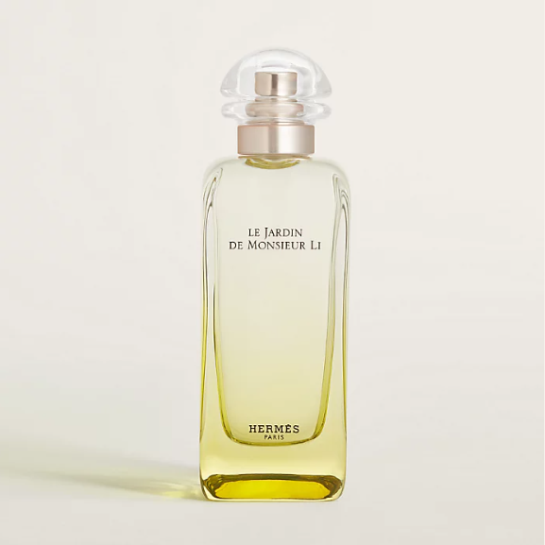

Hermes Le Jardin de Monsieur Li Eau de Toilette is a refreshing and invigorating fragrance from the esteemed Hermes brand. This perfume is known for its citrus scent, offering a medium longevity that is both uplifting and energizing. The fragrance is housed in a beautifully designed bottle, embodying Hermes' dedication to elegance and quality.

**History:** Le Jardin de Monsieur Li Eau de Toilette is a part of Hermes' exceptional fragrance collection, renowned for its unique and captivating scents. This fragrance was crafted to capture the essence of a Chinese garden, blending citrus notes to create a scent that is both refreshing and uplifting.

**Design:** The bottle of Hermes Le Jardin de Monsieur Li Eau de Toilette showcases the brand's commitment to luxury and craftsmanship. The elegant and sophisticated design of the bottle, with its intricate details and refined aesthetics, perfectly encapsulates the essence of the fragrance within.



**General Information:**

* Brand: Hermes
* Origin: France
* Concentration: Eau de Toilette
* Fragrance Group: Citrus
* Longevity: Medium
* Price Range: Luxury
* Suitable for: Day and Night
* Style: Uplifting, Energizing

**About the Fragrance:** Hermes Le Jardin de Monsieur Li Eau de Toilette offers a blend of citrus notes, creating a scent that is both uplifting and energizing. It is ideal for those who prefer a fragrance that is both refreshing and invigorating, suitable for both daytime and evening wear. This fragrance is a celebration of the beauty and tranquility of a Chinese garden.

**Storage:** To maintain the fragrance's quality, store in a cool, dry place away from direct sunlight.