

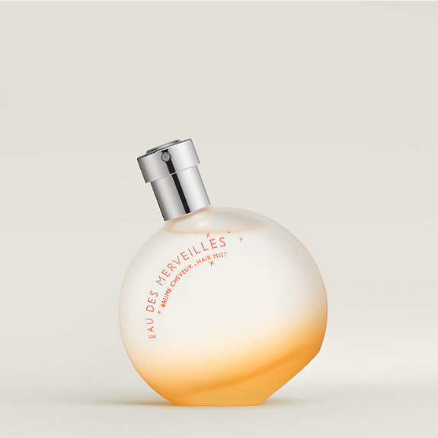

Hermes Terre d'Hermes Eau de Toilette is a distinguished fragrance from the prestigious brand Hermes. This perfume encapsulates a bold and masculine woody spicy scent, renowned for its long-lasting aroma that leaves a memorable impression. It is presented in a luxurious packaging, reflecting the high-end quality of the product.

**History:** Introduced as a part of Hermes' exquisite fragrance collection, Terre d'Hermes Eau de Toilette has established itself as a symbol of sophistication and elegance in the fragrance world. Hermes designed this scent to embody the spirit of the earth, combining woody and spicy notes to create a unique and compelling aroma.

**Design:** The bottle of Hermes Terre d'Hermes Eau de Toilette is a masterpiece of design, showcasing Hermes' commitment to luxury and quality. The sleek, minimalist bottle, with its clean lines and refined appearance, exudes an air of masculine elegance. The branding is subtle yet unmistakable, making it a perfect addition to any collection.



**General Information:**

* Brand: Hermes
* Origin: France
* Concentration: Eau de Toilette
* Fragrance Group: Woody Spicy
* Longevity: Long
* Price Range: Luxury
* Suitable for: Day and Night
* Style: Sophisticated, Bold

**About the Fragrance:** Hermes Terre d'Hermes Eau de Toilette offers a unique blend of woody and spicy notes, creating a scent that is both bold and sophisticated. It is perfect for those who prefer a fragrance with a strong presence and long-lasting effect. Ideal for both day and night wear, it suits individuals who appreciate a scent that makes a statement.

**Storage:** To maintain the quality of the fragrance, store in a cool, dry place away from direct sunlight.