

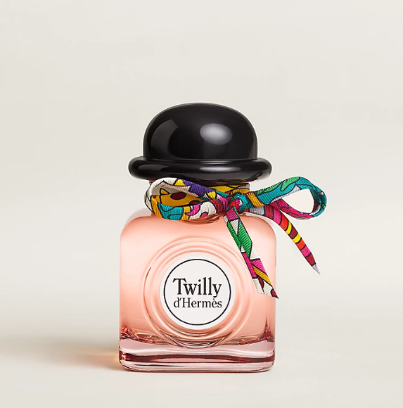

Hermes Twilly d'Hermes Eau de Parfum is an enchanting fragrance from the luxury brand Hermes. This perfume is known for its floral spicy scent, offering a medium longevity that captivates the senses. The fragrance is housed in an elegantly designed bottle, symbolizing the brand's commitment to luxury and quality.

**History:** Twilly d'Hermes Eau de Parfum is a relatively recent addition to Hermes' fragrance line, quickly gaining popularity for its unique blend of floral and spicy notes. This perfume was created to capture the essence of youthful spirit and bold femininity, making it a favorite among modern women.

**Design:** The design of the Twilly d'Hermes Eau de Parfum bottle reflects Hermes' attention to detail and luxury. The bottle, with its sleek and modern look, is adorned with a playful Twilly scarf, adding a touch of whimsy and charm. It's a perfect representation of the fragrance's youthful and vibrant character.



**General Information:**

* Brand: Hermes
* Origin: France
* Concentration: Eau de Parfum
* Fragrance Group: Floral Spicy
* Longevity: Medium
* Price Range: Luxury
* Suitable for: Day and Night
* Style: Youthful, Bold

**About the Fragrance:** Hermes Twilly d'Hermes Eau de Parfum combines floral and spicy notes to create a fragrance that is both bold and feminine. It's perfect for those who enjoy a scent that is both playful and sophisticated, suitable for both daytime and evening wear. This fragrance is a celebration of bold femininity and youthful spirit.

**Storage:** Store in a cool, dry place, away from direct sunlight to preserve the quality of the fragrance.