

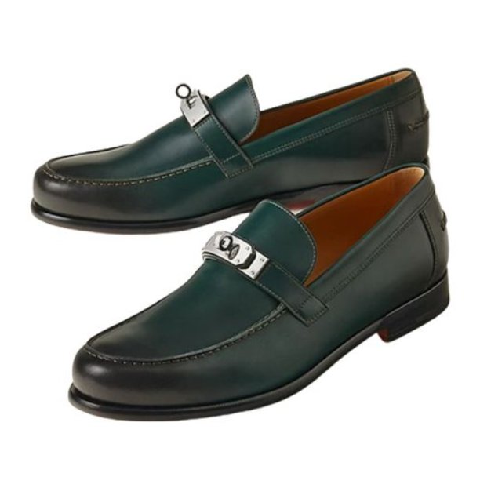

Hermes Chaine d'Ancre Shoes are an exquisite representation of casual elegance, crafted by the renowned brand Hermes. These shoes stand out with their unique design and high-quality leather material, offering a blend of style and comfort. Available in various sizes, they cater to a diverse clientele.

**History:** Hermes Chaine d'Ancre Shoes reflect Hermes' long-standing tradition of excellence in fashion. They are inspired by the brand's iconic Chaine d'Ancre motif, symbolizing the brand's nautical heritage and commitment to luxury.

**Design:** The design of the Hermes Chaine d'Ancre Shoes is both innovative and classic. The leather material provides durability and a luxurious feel, while the distinctive Chaine d'Ancre motif adds a unique and stylish touch.



**General Information:**

* Brand: Hermes
* Material: Leather
* Style: Casual
* Size: Various
* Price: $570
* Image: Hermes Chaine d'Ancre Shoes

**About the Product:** The Hermes Chaine d'Ancre Shoes are a perfect blend of Hermes' traditional craftsmanship and modern design. They are ideal for those who seek a casual yet sophisticated look. The high-quality leather and unique design make these shoes a coveted item in the world of luxury footwear.

**Storage:** Keep the Hermes Chaine d'Ancre Shoes in a cool, dry place, away from direct sunlight, to preserve their quality and appearance.