

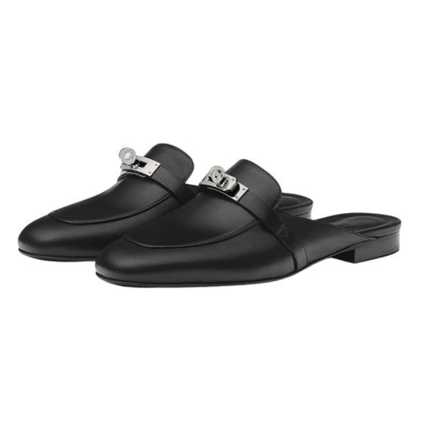

Hermes Izmir Sandals are a distinguished offering from Hermes, showcasing the brand's expertise in creating luxurious leather goods. These sandals are celebrated for their refined design and exceptional comfort, making them a popular choice for various occasions. They are available in multiple sizes to accommodate different preferences.

**History:** The Hermes Izmir Sandals are a testament to Hermes' legacy in the luxury fashion industry. Their design reflects the brand's commitment to elegance and quality, making them a favorite among fashion connoisseurs.

**Design:** The Hermes Izmir Sandals feature a sleek and minimalist design. The high-quality leather ensures both durability and comfort, while the subtle detailing adds a touch of sophistication.



**General Information:**

* Brand: Hermes
* Material: Leather
* Style: Sandals
* Size: Various
* Price: $590
* Image: Hermes Izmir Sandals

**About the Product:** The Hermes Izmir Sandals are an embodiment of luxury and comfort. They are perfect for those who value both style and practicality in their footwear. The sandals' elegant design and superior craftsmanship make them a must-have in any luxury collection.

**Storage:** To maintain the Hermes Izmir Sandals in pristine condition, store them in a cool, dry place, away from direct sunlight and moisture.