

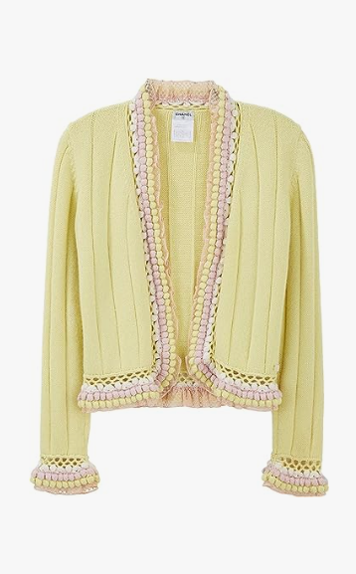

Chanel Classic Suit is a sophisticated suit from the luxury brand Chanel. Crafted from a wool blend, this suit is designed for all-season wear and is available in various sizes to fit different body shapes.

**History:** The Chanel Classic Suit is a representation of Chanel's commitment to timeless elegance and quality. This suit is a part of Chanel's long-standing tradition of creating high-end fashion that combines classic style with modern sensibilities.

**Design:** The design of the Chanel Classic Suit is both elegant and practical. The wool blend material ensures durability and comfort, making it suitable for various occasions. The classic design of this suit reflects Chanel's iconic fashion sense.



**General Information:**

* **Brand:** Chanel
* **Material:** Wool Blend
* **Size:** Various
* **Weather Suitability:** All-Season
* **Special Feature:** Classic Design
* **Image:** /ao/aocn7.png
* **Price:** $560

**About the Garment:** The Chanel Classic Suit is a testament to Chanel's expertise in creating elegant and timeless fashion. This suit is perfect for those who value sophistication and style in their professional and formal attire. The quality material and classic design make it a distinguished choice in fashion.

**Care Instructions:** Dry clean only. Handle with care to maintain the quality of the fabric. Store in a cool, dry place away from direct sunlight.