

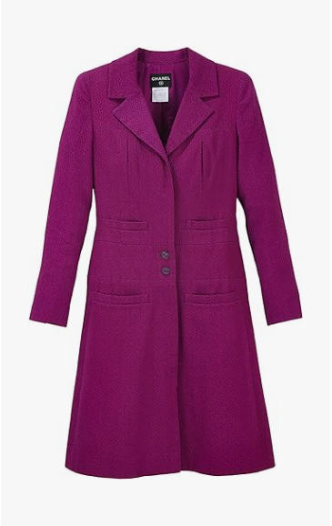

Chanel Evening Silk is an exquisite evening wear piece from the luxurious brand Chanel. Made from the finest silk, this garment is perfect for formal occasions and comes in various sizes to suit different body types.

**History:** The Chanel Evening Silk is part of Chanel's commitment to providing elegant and sophisticated evening wear. This piece reflects the brand's dedication to high-quality craftsmanship and timeless design.

**Design:** The Chanel Evening Silk boasts a design that exudes elegance and sophistication. The use of silk material adds a touch of luxury and grace, making it an ideal choice for formal events. The evening wear style of this garment is both classic and contemporary.



**General Information:**

* **Brand:** Chanel
* **Material:** Silk
* **Size:** Various
* **Weather Suitability:** Formal
* **Special Feature:** Silk Fabric
* **Image:** /ao/aocn4.png
* **Price:** $510

**About the Garment:** The Chanel Evening Silk is a testament to Chanel's expertise in creating luxurious evening wear. The silk fabric ensures a comfortable and elegant fit, making it a must-have for those who value sophistication and style in their formal attire.

**Care Instructions:** Dry clean only. Handle with care to maintain the quality of the silk fabric. Store in a cool, dry place away from direct sunlight.