

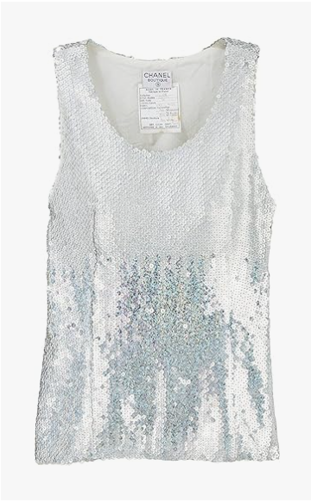

Chanel Spring Collection is a vibrant spring wear piece from the iconic brand Chanel. This garment is made from lightweight fabric, perfect for spring weather, and is available in various sizes.

**History:** The Chanel Spring Collection is a part of Chanel's seasonal fashion offerings, showcasing the brand's versatility and innovation in design. This collection is designed to capture the essence of spring with its light and airy feel.

**Design:** The Chanel Spring Collection features a design that is both fresh and fashionable. The use of lightweight fabric makes it ideal for spring weather, providing comfort and style. The spring wear style of this garment is a blend of contemporary fashion and seasonal charm.



**General Information:**

* **Brand:** Chanel
* **Material:** Lightweight Fabric
* **Size:** Various
* **Weather Suitability:** Spring
* **Special Feature:** Spring Collection
* **Image:** /ao/aocn6.png
* **Price:** $540

**About the Garment:** The Chanel Spring Collection is a testament to Chanel's ability to create fashion that is both stylish and seasonally appropriate. The lightweight fabric and spring wear design make it perfect for the spring season, offering a blend of comfort and contemporary style.

**Care Instructions:** Machine washable at a moderate temperature. Do not bleach. Tumble dry low and iron on a low setting if needed.