

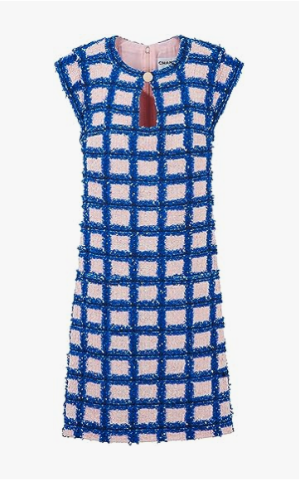

Chanel Vintage Dress is a distinctive piece from the iconic brand Chanel. This dress showcases a vintage style, made from high-quality cotton, suitable for all-season wear. It comes in various sizes, accommodating different body shapes.

**History:** The Chanel Vintage Dress is a tribute to the timeless fashion of past eras. Chanel, renowned for its fashion-forward designs, has created this dress to capture the essence of vintage elegance, blending it with contemporary fashion trends.

**Design:** The design of the Chanel Vintage Dress is a nod to the classic fashion of yesteryears. The cotton material ensures comfort and durability, while the vintage look adds a unique charm. This dress is an ideal choice for those who admire vintage fashion with a modern twist.



**General Information:**

* **Brand:** Chanel
* **Material:** Cotton
* **Size:** Various
* **Weather Suitability:** All-Season
* **Special Feature:** Vintage Look
* **Image:** /ao/aocn2.png
* **Price:** $470

**About the Garment:** The Chanel Vintage Dress is a cotton dress that combines comfort with elegance. Its vintage style makes it suitable for various occasions, offering a blend of classic charm and modern fashion. The dress's unique design and quality material make it a valuable addition to any fashion enthusiast's wardrobe.

**Care Instructions:** Machine wash in cold water with similar colors. Tumble dry low and iron if necessary. Avoid bleach and harsh chemicals.