

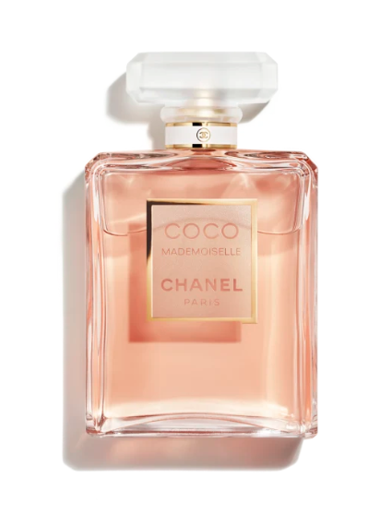

Chanel Bleu de Chanel Eau de Parfum is a distinguished fragrance from the luxury brand Chanel. This perfume is renowned for its woody aromatic scent with long-lasting longevity, epitomizing strength and elegance. It is available in a 50ml bottle.

**History:** Chanel Bleu de Chanel Eau de Parfum was launched as a symbol of freedom and boldness. It represents the spirit of a man who defies convention and seeks his own destiny. The fragrance is a sophisticated blend of woody and aromatic notes, reflecting Chanel's dedication to crafting unique and powerful scents.

**Design:** The bottle design of Chanel Bleu de Chanel Eau de Parfum is sleek and masculine. The deep blue glass bottle, with its clean lines and the iconic Chanel logo, exudes a sense of mystery and sophistication. This design perfectly captures the essence of the modern man.



**General Information:**

* Brand: Chanel
* Origin: France
* Concentration: Eau de Parfum
* Fragrance Group: Woody Aromatic
* Longevity: Long
* Price Range: Luxury
* Suitable for: Day and Night
* Style: Masculine, bold

**About the Fragrance:** Chanel Bleu de Chanel Eau de Parfum is a woody aromatic fragrance that offers a deep and powerful scent. It provides a long-lasting fragrance experience, suitable for both daytime and evening wear. This perfume is ideal for men who value strength, elegance, and freedom.

**Storage:** Store in a cool, dry place, away from direct sunlight.