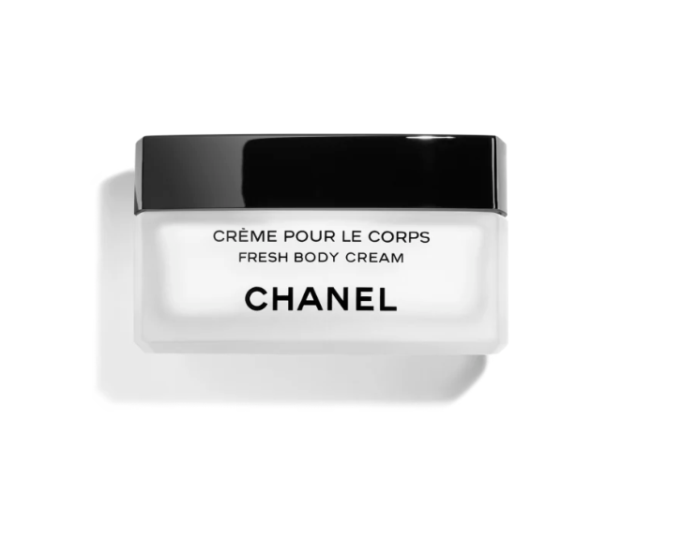

Chanel Coco Noir Eau de Parfum is a captivating fragrance from the luxury brand Chanel. This perfume is known for its floral woody scent with long-lasting longevity, symbolizing mystery and elegance. It is available in a 50ml bottle.

**History:** Chanel Coco Noir Eau de Parfum was launched as a fragrance that embodies the modernity of Chanel's iconic style. It's a scent that captures the intensity and mystery of the night. The fragrance is a sophisticated blend of floral and woody notes, reflecting Chanel's commitment to creating deep and enigmatic scents.

**Design:** The design of the Chanel Coco Noir Eau de Parfum bottle is striking and sophisticated. The opaque black glass bottle, adorned with the Chanel logo, exudes a sense of mystery and luxury. This design perfectly encapsulates the essence of the fragrance.



**General Information:**

* Brand: Chanel
* Origin: France
* Concentration: Eau de Parfum
* Fragrance Group: Floral Woody
* Longevity: Long
* Price Range: Luxury
* Suitable for: Day and Night
* Style: Mysterious, elegant

**About the Fragrance:** Chanel Coco Noir Eau de Parfum is a floral woody fragrance that offers a mysterious and elegant scent. It provides a long-lasting fragrance experience, suitable for both daytime and evening wear. This perfume is ideal for those who admire a scent that is both enigmatic and sophisticated.

**Storage:** Store in a cool, dry place, away from direct sunlight.