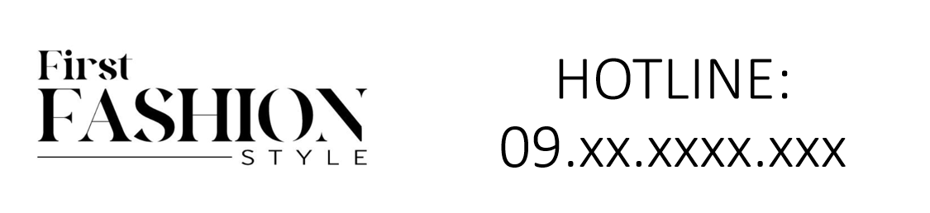

Chanel Gabrielle Eau de Parfum is an elegant fragrance from the esteemed brand Chanel. This perfume is characterized by its pure floral scent with long-lasting longevity, representing a modern expression of femininity. It comes in a 50ml bottle.

**History:** Chanel Gabrielle Eau de Parfum was introduced as a tribute to the spirit of Gabrielle Chanel herself. It embodies the essence of a bold and free woman. The fragrance is a radiant composition of floral notes, symbolizing the light and strength of femininity, and reflects Chanel's legacy in creating empowering scents.

**Design:** The design of the Chanel Gabrielle Eau de Parfum bottle is a masterpiece of simplicity and elegance. The square glass bottle with soft edges and a golden cap, along with the Chanel logo, exudes modernity and sophistication. This design is a tribute to the timeless elegance of Chanel.

**General Information:**

* Brand: Chanel
* Origin: France
* Concentration: Eau de Parfum
* Fragrance Group: Floral
* Longevity: Long
* Price Range: Luxury
* Suitable for: Day and Night
* Style: Modern, feminine

**About the Fragrance:** Chanel Gabrielle Eau de Parfum is a floral fragrance that offers a radiant and modern scent. It provides a long-lasting fragrance experience, making it suitable for both daytime and evening wear. This perfume is ideal for those who admire a modern, feminine, and empowering fragrance.

**Storage:** Store in a cool, dry place, away from direct sunlight.