

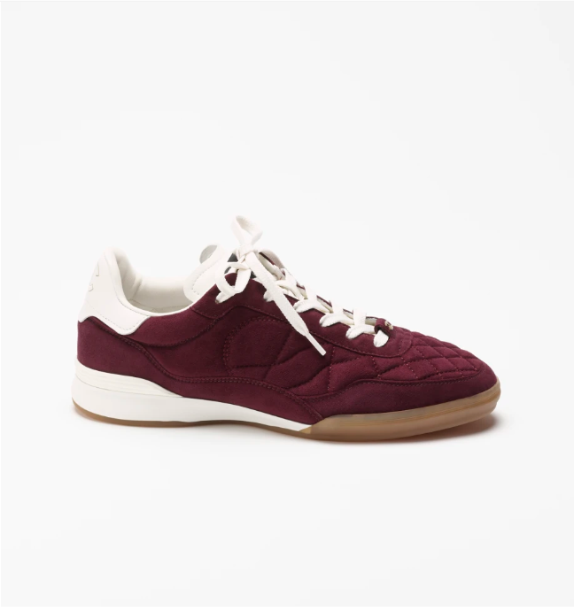

Chanel 19 Shoes are a chic and stylish addition to the Chanel footwear line, crafted from high-quality leather. These shoes are designed to offer both elegance and comfort, making them a perfect choice for fashion-conscious individuals.

**History:** The Chanel 19 Shoes are inspired by the contemporary trends in fashion while staying true to the brand's classic aesthetic. They represent the modern face of Chanel, blending traditional elegance with a fresh, chic style.

**Design:** The design of the Chanel 19 Shoes is both sophisticated and trendy. The leather material provides a luxurious feel, and the chic style makes them suitable for a variety of fashion ensembles.



**General Information:**

* **Brand:** Chanel
* **Material:** Leather
* **Style:** Chic
* **Size:** Various
* **Price:** $510
* **Image:** Chanel 19 Shoes

**About the Shoes:** Chanel 19 Shoes are ideal for those who seek a blend of classic elegance and modern style. They are a testament to Chanel's ability to evolve with fashion trends while maintaining its signature luxury.

**Care Instructions:** Regular cleaning with a soft, dry cloth is recommended to maintain the appearance of these shoes. Store them in a cool, dry place, away from direct sunlight, to preserve their quality.