

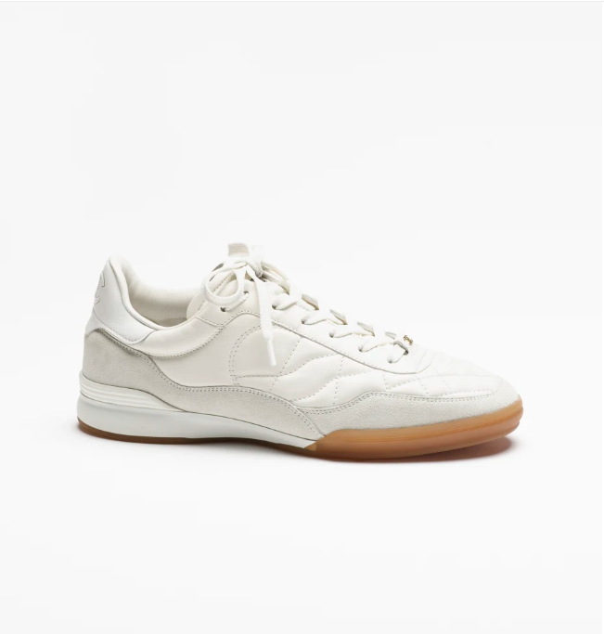

Chanel Boy Shoes offer a blend of casual elegance and modern style, making them a standout addition to the Chanel footwear collection. Crafted from high-quality leather, these shoes are designed for both comfort and durability, embodying the essence of casual luxury.

**History:** Chanel Boy Shoes draw inspiration from the Chanel Boy Bag, known for its bold and edgy design. These shoes reflect the same spirit, combining classic Chanel elements with a contemporary twist. They have quickly become a favorite among fashion-forward individuals.

**Design:** The design of the Chanel Boy Shoes is characterized by its casual yet sophisticated look. The leather material adds a touch of luxury, while the versatile style makes them suitable for various occasions, from everyday wear to special events.



**General Information:**

* **Brand:** Chanel
* **Material:** Leather
* **Style:** Casual
* **Size:** Various
* **Price:** $470
* **Image:** Chanel Boy Shoes

**About the Shoes:** Chanel Boy Shoes are perfect for those who appreciate a blend of modern style and classic elegance. They offer a unique take on casual footwear, showcasing Chanel's ability to innovate while staying true to its heritage.

**Care Instructions:** Regular cleaning with a soft, dry cloth is recommended to maintain the appearance of these shoes. Store them in a cool, dry place, away from direct sunlight, to preserve their quality.