

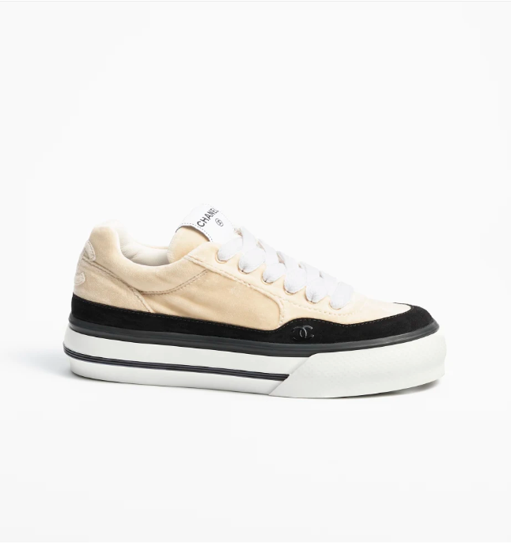

Chanel Espadrilles are a casual yet luxurious footwear option from Chanel, crafted from high-quality canvas. These shoes blend comfort with the brand's iconic style, making them a popular choice for relaxed yet fashionable looks.

**History:** Chanel Espadrilles have become synonymous with casual luxury. They reflect Chanel's ability to infuse elegance into everyday wear, becoming a staple in the wardrobes of those who appreciate relaxed sophistication.

**Design:** The design of the Chanel Espadrilles is simple yet stylish. The canvas material provides a casual look, while the signature Chanel craftsmanship ensures a touch of luxury. These shoes are versatile and can be paired with a variety of casual outfits.



**General Information:**

* **Brand:** Chanel
* **Material:** Canvas
* **Style:** Casual
* **Size:** Various
* **Price:** $540
* **Image:** Chanel Espadrilles

**About the Shoes:** Chanel Espadrilles are ideal for those who seek a blend of comfort and style in their footwear. They are perfect for casual outings and can easily elevate a relaxed look with a touch of Chanel elegance.

**Care Instructions:** To maintain the appearance of these shoes, clean them with a soft, dry cloth and store in a cool, dry place away from direct sunlight.