

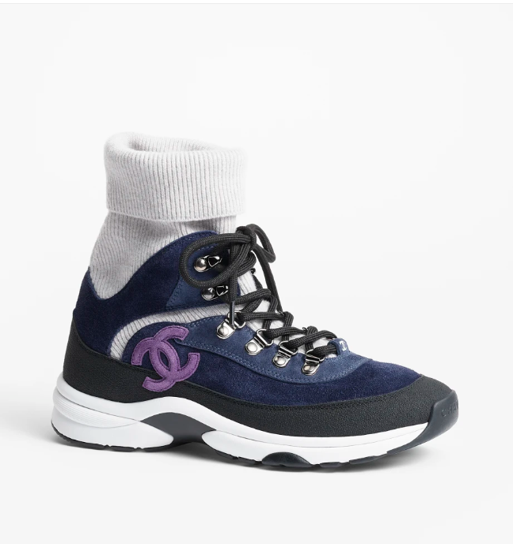

Chanel Loafers are a sophisticated and stylish footwear choice, crafted from high-quality leather by the iconic brand Chanel. These loafers combine classic elegance with modern design, making them a versatile addition to any wardrobe.

**History:** Chanel Loafers draw inspiration from the brand's rich fashion heritage, offering a timeless design that has been admired for years. They embody Chanel's commitment to blending classic style with contemporary fashion.

**Design:** The design of the Chanel Loafers is both elegant and practical. The leather material provides a luxurious feel, while the loafer style ensures versatility and comfort. These shoes are suitable for a range of occasions, from formal to casual.



**General Information:**

* **Brand:** Chanel
* **Material:** Leather
* **Style:** Loafers
* **Size:** Various
* **Price:** $580
* **Image:** Chanel Loafers

**About the Shoes:** Chanel Loafers are perfect for those who appreciate a blend of elegance and practicality. They offer a classic look with a modern twist, showcasing Chanel's ability to create timeless footwear.

**Care Instructions:** To maintain the quality of these loafers, clean them regularly with a soft, dry cloth and store them in a cool, dry place away from direct sunlight.