

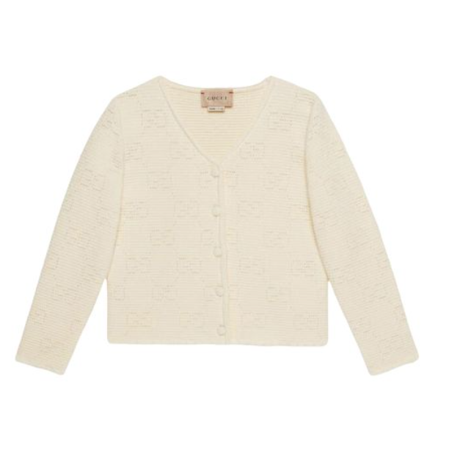

**Gucci Leisure Wear** is a comfortable and stylish casual wear piece from the renowned brand Gucci. Made from high-quality cotton, this all-season wear is designed for comfort and ease, making it a great choice for everyday wear. The special feature of this leisure wear is its comfortable design, perfect for relaxed settings.

**History:** The Gucci Leisure Wear is a part of Gucci's expansion into more casual and comfortable clothing, reflecting the brand's versatility and understanding of modern lifestyle needs.

**Design:** The design of the Gucci Leisure Wear is focused on comfort and simplicity. The high-quality cotton material ensures a soft and comfortable fit, making it ideal for everyday wear. The leisure wear's design is a testament to Gucci's ability to combine comfort with style.



**General Information:**

* Brand: Gucci
* Material: Cotton
* Style: Casual
* Size: Various
* Weather Suitability: All-Season
* Special Feature: Comfortable
* Price: $400

**About the Leisure Wear:** The Gucci Leisure Wear is designed for those who value comfort and style in their everyday clothing. Its cotton material provides a relaxed and comfortable fit, while the simple design makes it versatile for various casual occasions. This leisure wear is perfect for a day out, a casual meeting, or simply lounging at home.

**Care Instructions:** To maintain the leisure wear's quality and appearance, it is recommended to follow Gucci's care instructions. Regular washing and proper storage will ensure the leisure wear remains in excellent condition.