

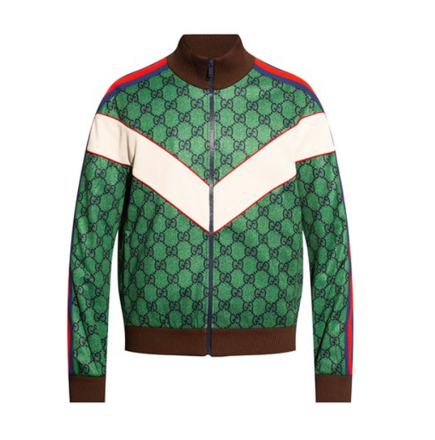

**Gucci Summer Dress** is a stunning addition to the Gucci fashion line, perfect for the summer season. Made from luxurious silk, this dress combines comfort with elegance, making it an ideal choice for warm weather. The lightweight design and summer-specific features make it a must-have for fashion enthusiasts.

**History:** The Gucci Summer Dress is a reflection of Gucci's innovative approach to seasonal fashion. Designed for the summer, this dress is a blend of Gucci's traditional elegance and modern style, catering to the contemporary woman's wardrobe needs.

**Design:** The design of the Gucci Summer Dress is both elegant and practical. Made from high-quality silk, it offers a light and airy feel, perfect for summer days. The dress's design is a testament to Gucci's ability to combine fashion with functionality, making it both stylish and comfortable.



**General Information:**

* Brand: Gucci
* Material: Silk
* Style: Dress
* Size: Various
* Weather Suitability: Summer
* Special Feature: Lightweight
* Price: $390

**About the Dress:** The Gucci Summer Dress is designed for those who seek elegance and comfort in their summer wardrobe. The silk material ensures a luxurious feel, while the lightweight design makes it perfect for hot summer days. This dress is ideal for casual outings, summer parties, or any occasion where a chic and comfortable outfit is desired.

**Care Instructions:** To maintain the dress's quality and appearance, it is recommended to follow Gucci's care instructions. Hand wash or dry clean only, and avoid exposure to direct sunlight to preserve the fabric's color and texture.