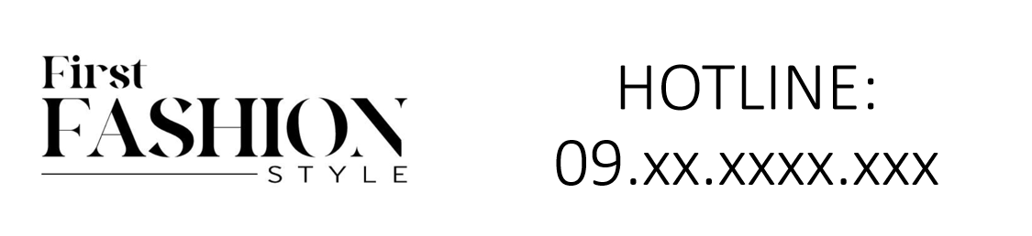

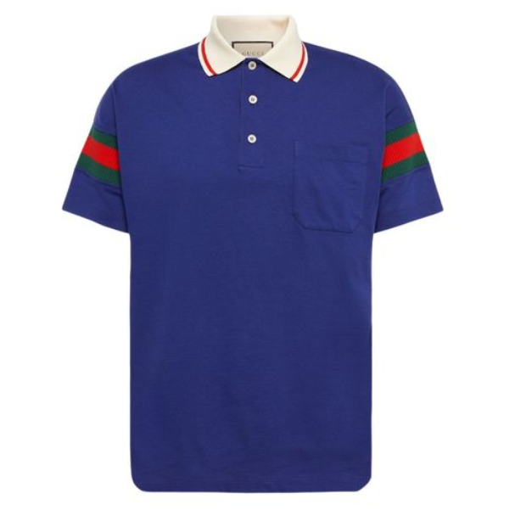

**Gucci Urban Jacket** is a stylish and versatile piece from the iconic brand Gucci. This jacket, made from high-quality cotton, offers comfort and durability, making it suitable for all seasons. Its urban style design makes it a fashionable choice for various occasions.

**History:** The Gucci Urban Jacket is a recent addition to Gucci's fashion line, reflecting the brand's commitment to blending contemporary style with classic elegance. This jacket represents Gucci's innovative approach to urban fashion, combining functionality with high fashion.

**Design:** The design of the Gucci Urban Jacket is modern and sleek. It features a comfortable fit with a focus on urban aesthetics. The jacket's material and craftsmanship showcase Gucci's attention to detail and quality. The urban style of this jacket makes it a standout piece in any wardrobe.



**General Information:**

* Brand: Gucci
* Material: Cotton
* Style: Jacket
* Size: Various
* Weather Suitability: All-Season
* Special Feature: Urban Style
* Price: $350

**About the Jacket:** The Gucci Urban Jacket is designed for those who appreciate a blend of comfort and style. Its cotton material ensures breathability and ease of wear, while the urban design adds a touch of modern sophistication. This jacket is an ideal choice for fashion-forward individuals looking for a versatile piece that can be worn in various settings.

**Care Instructions:** To maintain the quality of the jacket, it is recommended to follow the care instructions provided by Gucci. Avoid exposure to extreme temperatures and harsh chemicals. Regular cleaning and proper storage will ensure the jacket remains in excellent condition.