### Screenshot 2023-12-01 132336

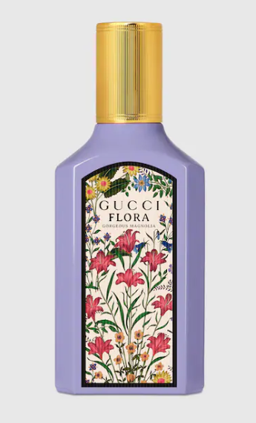

### Gucci Bamboo Eau de Parfum

**Gucci Bamboo Eau de Parfum** is an elegant fragrance for women, offered by the prestigious brand **Gucci**. This perfume is known for its woody floral scent, providing long-lasting longevity and a sophisticated aroma. It is presented in a 50ml bottle.

**History:** Gucci Bamboo Eau de Parfum is inspired by the strength and grace of the bamboo plant. Launched by Gucci, this fragrance is a blend of resilience and femininity, capturing the essence of the modern woman. Its woody floral notes are both refreshing and empowering.

**Design:** The design of the Gucci Bamboo Eau de Parfum bottle is a reflection of the fragrance's character. It features a unique shape that resembles bamboo, symbolizing strength and elegance. The combination of glass and silver accents creates a look of sophistication and luxury.



**General Information:**

* Brand: Gucci
* Origin: Italy
* Concentration: Eau de Parfum
* Fragrance Group: Woody Floral
* Longevity: Long
* Sillage: Strong
* Suitable for: Day and Evening Wear
* Style: Sophisticated, empowering

**About the Fragrance:** Gucci Bamboo Eau de Parfum is a woody floral fragrance that offers a sophisticated and empowering scent experience. It is perfect for the woman who embodies strength and grace, suitable for both day and evening wear. This perfume is a celebration of modern femininity and resilience.

**Storage:** To maintain the fragrance's quality, store in a cool, dry place away from direct sunlight and heat sources.