

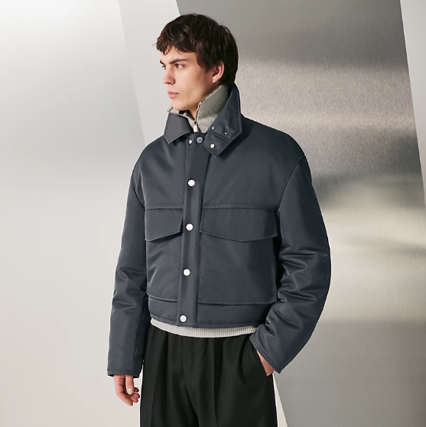

Hermes Beachwear is a luxurious beachwear collection from the prestigious brand Hermes. This line features lightweight fabric, perfect for summer weather, and embodies a beach style that is both elegant and comfortable. The collection offers various sizes, catering to a diverse range of body types.

History: Hermes Beachwear was crafted with the vision of combining luxury with comfort for beach outings. The collection reflects Hermes' commitment to quality and style, making it a popular choice for those seeking high-end beachwear. The use of lightweight fabric ensures comfort even in the warmest weather, while the stylish designs uphold the brand's reputation for elegance.

Design: The Hermes Beachwear collection boasts a sophisticated design, with each piece reflecting the brand's iconic style. The lightweight fabric is not only practical for beach environments but also adds a touch of luxury. The collection's various sizes ensure a perfect fit for every wearer, enhancing the overall beach experience.



General Information: • Brand: Hermes • Material: Lightweight Fabric • Style: Beachwear • Size: Various • Weather: Summer • Special Feature: Beach Style • Image: /ao/aohm1.png • Price: $550

About the Collection: Hermes Beachwear is designed for those who appreciate luxury and comfort in their beach attire. The collection's lightweight fabric makes it ideal for summer, providing both style and practicality. The beach style of the collection is a testament to Hermes' ability to blend fashion with functionality, making it a must-have for any high-end beachwear enthusiast.

Storage: To maintain the quality of the fabric, store in a cool, dry place away from direct sunlight and moisture.