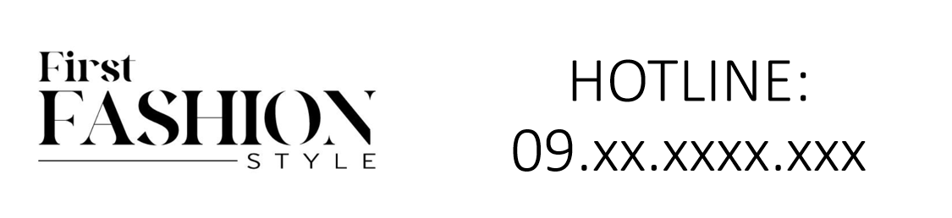

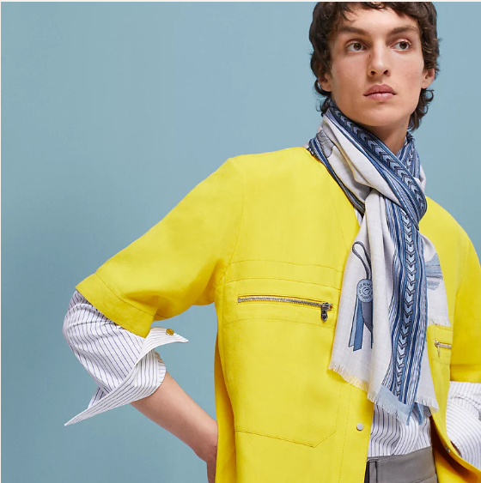

Hermes Formal Attire is an exquisite line of formal wear from the renowned brand Hermes. This collection features a wool blend material, suitable for all-season wear, and is designed to offer an elegant and sophisticated look. Available in various sizes, it caters to a wide audience.

History: Hermes Formal Attire is a testament to the brand's dedication to luxury and elegance in clothing. Introduced as part of Hermes' expansion into formal wear, this collection quickly gained popularity for its quality and design. The wool blend material ensures comfort and durability, making it a preferred choice for formal occasions.

Design: The design of Hermes Formal Attire is centered around elegance and sophistication. Each piece in the collection showcases Hermes' commitment to high-quality craftsmanship. The wool blend material not only provides comfort but also adds a touch of class, making it suitable for various formal events.



General Information: • Brand: Hermes • Material: Wool Blend • Style: Formal • Size: Various • Weather: All-Season • Special Feature: Elegant Design • Image: /ao/aohm2.png • Price: $570

About the Collection: Hermes Formal Attire is designed for individuals who value elegance and sophistication in their formal wear. The collection's all-season wool blend material ensures comfort and versatility, making it an ideal choice for various formal occasions. The elegant design of each piece reflects Hermes' legacy in the fashion industry.

Storage: Store in a cool, dry place. Avoid exposure to extreme temperatures and moisture to maintain the quality of the material.