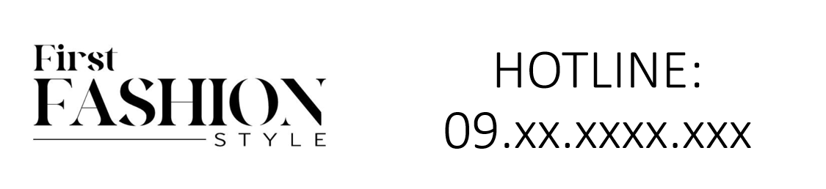



Hermes Luxury Coat is an exquisite piece of winter wear from the prestigious brand Hermes. Made from high-quality wool, this coat is designed for winter weather, offering both warmth and style. It comes in various sizes, catering to a diverse clientele.

History: The Hermes Luxury Coat is a testament to Hermes' excellence in creating high-end winter wear. This coat, with its luxurious wool material, was introduced to provide both warmth and style during the colder months. It quickly became a favorite for its elegance and quality.

Design: The design of the Hermes Luxury Coat is focused on luxury and comfort. The high-quality wool material provides excellent warmth, while the coat's style reflects Hermes' iconic fashion sense. This coat is a perfect blend of functionality and style, making it a must-have for winter.



General Information: • Brand: Hermes • Material: Wool • Style: Coat • Size: Various • Weather: Winter • Special Feature: Luxury Fabric • Image: /ao/aohm6.png • Price: $640

About the Coat: The Hermes Luxury Coat is designed for those who value luxury and comfort in their winter wardrobe. The high-quality wool material ensures warmth and comfort, while the elegant design makes it a fashionable choice for the winter season. This coat exemplifies Hermes' commitment to luxury and quality in fashion.

Storage: Store in a cool, dry place. Avoid exposure to extreme temperatures and moisture to maintain the quality of the wool.