

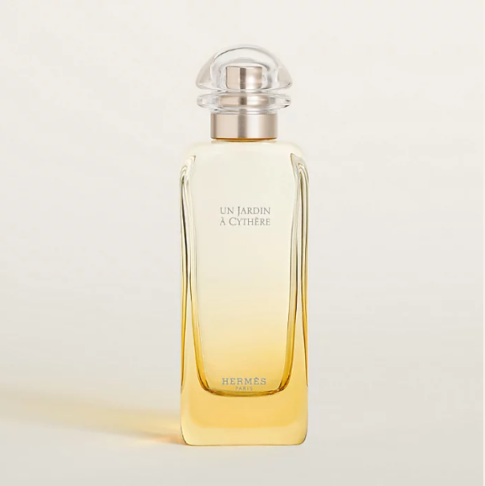

Hermes Eau des Merveilles Bleue Eau de Toilette is a mesmerizing fragrance from the iconic Hermes brand. This perfume is celebrated for its aromatic aquatic scent, offering a medium longevity that is both refreshing and invigorating. The fragrance is presented in a beautifully crafted bottle, showcasing Hermes' excellence in design and quality.

**History:** Eau des Merveilles Bleue Eau de Toilette is a part of Hermes' renowned fragrance collection, known for its innovative and captivating scents. This fragrance was created to evoke the serene and mystical qualities of the sea, blending aromatic and aquatic notes to create a scent that is both refreshing and mesmerizing.

**Design:** The bottle of Hermes Eau des Merveilles Bleue Eau de Toilette reflects the brand's commitment to luxury and innovation. The design, with its elegant and sophisticated aesthetics, perfectly captures the essence of the fragrance, making it a luxurious addition to any collection.



**General Information:**

* Brand: Hermes
* Origin: France
* Concentration: Eau de Toilette
* Fragrance Group: Aromatic Aquatic
* Longevity: Medium
* Price Range: Luxury
* Suitable for: Day and Night
* Style: Refreshing, Mesmerizing

**About the Fragrance:** Hermes Eau des Merveilles Bleue Eau de Toilette combines aromatic and aquatic notes to create a scent that is both refreshing and mesmerizing. It is ideal for those who enjoy a fragrance that captures the essence of the sea, suitable for both daytime and evening wear. This fragrance is a tribute to the mystical qualities of the ocean.

**Storage:** To maintain the fragrance's quality, store in a cool, dry place away from direct sunlight.