

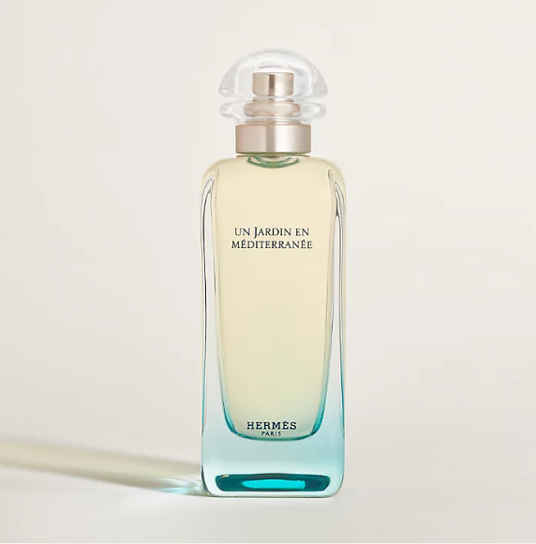

Hermes Jour d'Hermes Eau de Parfum is an elegant fragrance from the prestigious Hermes brand. This perfume is known for its pure floral scent, offering a long-lasting aroma that is both graceful and captivating. The fragrance is encased in a sophisticated bottle, reflecting Hermes' luxury and craftsmanship.

**History:** Jour d'Hermes Eau de Parfum is a significant addition to Hermes' fragrance line, celebrated for its exquisite and refined scents. This fragrance was designed to embody the essence of a woman's life, capturing the beauty and complexity of floral notes to create a scent that is both elegant and profound.

**Design:** The design of the Jour d'Hermes Eau de Parfum bottle is a testament to Hermes' attention to detail and commitment to luxury. The bottle's elegant shape and refined aesthetics perfectly encapsulate the fragrance's grace and sophistication.



**General Information:**

* Brand: Hermes
* Origin: France
* Concentration: Eau de Parfum
* Fragrance Group: Floral
* Longevity: Long
* Price Range: Luxury
* Suitable for: Day and Night
* Style: Graceful, Captivating

**About the Fragrance:** Hermes Jour d'Hermes Eau de Parfum offers a pure floral scent, creating a fragrance experience that is both graceful and captivating. It is perfect for those who appreciate a scent that is both profound and elegant, suitable for both daytime and evening wear. This fragrance represents the beauty and complexity of a woman's life.

**Storage:** Store in a cool, dry place, away from direct sunlight to preserve the fragrance's quality.