

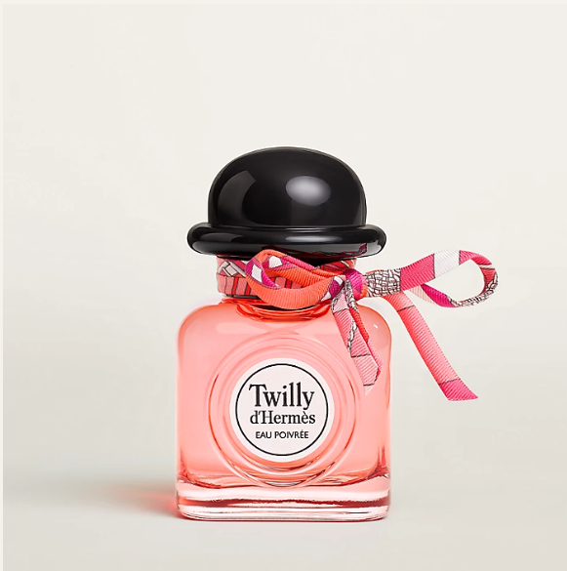

Hermes Un Jardin sur le Nil Eau de Toilette is a refreshing fragrance from the esteemed Hermes brand. This perfume is celebrated for its floral fruity scent, offering a medium longevity that is both vibrant and alluring. The fragrance is presented in a beautifully designed bottle, embodying Hermes' commitment to sophistication and quality.

**History:** Un Jardin sur le Nil Eau de Toilette is an integral part of Hermes' fragrance collection, renowned for its unique and captivating scents. This fragrance was created to capture the essence of a stroll along the Nile River, blending floral and fruity notes to create a scent that is both refreshing and enchanting.

**Design:** The bottle of Hermes Un Jardin sur le Nil Eau de Toilette showcases the brand's dedication to elegance and craftsmanship. The design, with its clean lines and elegant aesthetics, perfectly captures the essence of the fragrance, making it a luxurious addition to any collection.



**General Information:**

* Brand: Hermes
* Origin: France
* Concentration: Eau de Toilette
* Fragrance Group: Floral Fruity
* Longevity: Medium
* Price Range: Luxury
* Suitable for: Day and Night
* Style: Vibrant, Alluring

**About the Fragrance:** Hermes Un Jardin sur le Nil Eau de Toilette combines floral and fruity notes to create a scent that is both vibrant and enchanting. It is ideal for those who enjoy a fragrance that is refreshing and alluring, suitable for both daytime and evening wear. This fragrance is a celebration of nature's beauty and vibrancy.

**Storage:** To maintain the fragrance's quality, store in a cool, dry place away from direct sunlight.