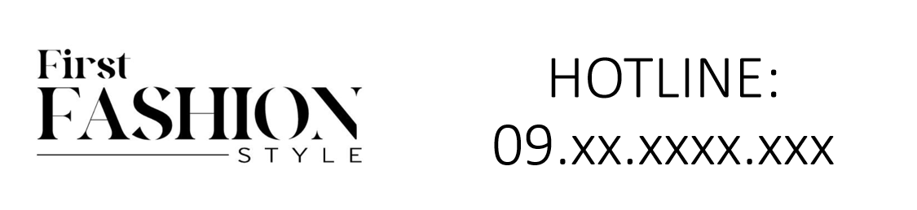

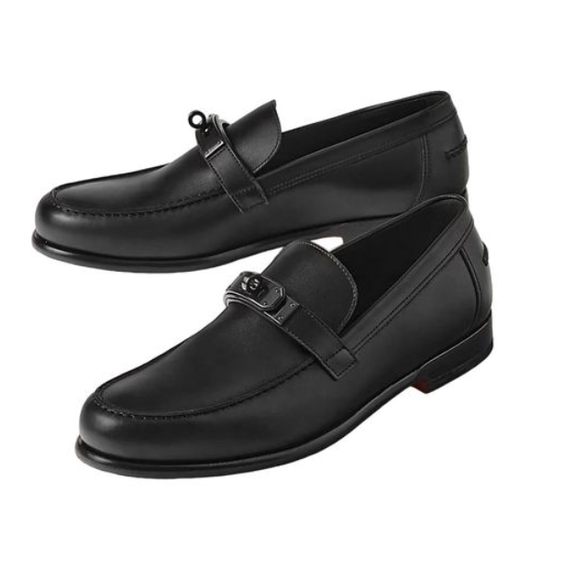

Chanel Parisian Look is an elegant Parisian style attire from the world-renowned brand Chanel. This piece, made from a cotton blend, is suitable for all-season wear and comes in various sizes to accommodate diverse preferences.

**History:** The Chanel Parisian Look is a celebration of Parisian fashion, known for its elegance and sophistication. Chanel, with its deep roots in Parisian style, has crafted this garment to embody the essence of the city's fashion.

**Design:** The Chanel Parisian Look features a design that captures the spirit of Parisian elegance. The cotton blend material ensures both comfort and durability, making it suitable for various occasions. The Parisian style of this piece is both timeless and fashionable.



**General Information:**

* **Brand:** Chanel
* **Material:** Cotton Blend
* **Size:** Various
* **Weather Suitability:** All-Season
* **Special Feature:** Parisian Style
* **Image:** /ao/aocn5.png
* **Price:** $520

**About the Garment:** The Chanel Parisian Look is a tribute to the timeless elegance of Parisian fashion. Suitable for all-season wear, this piece is perfect for those who admire the sophistication and style of Paris. The quality material and Parisian design make it a distinguished choice in fashion.

**Care Instructions:** Machine washable at a moderate temperature. Do not bleach. Tumble dry low and iron on a low setting if needed.