

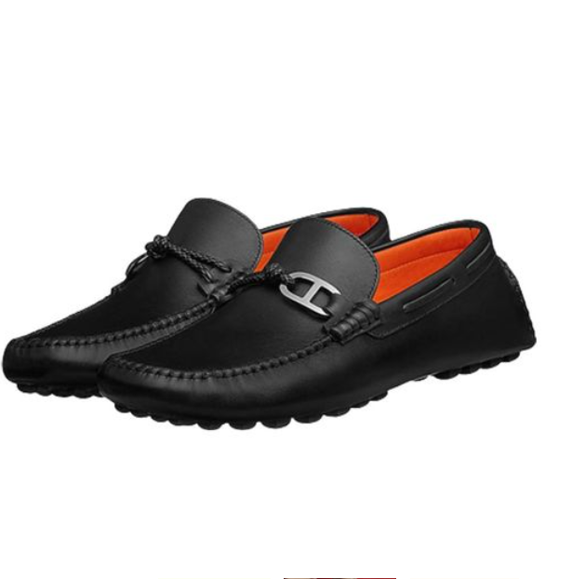

Hermes Loafers are a distinguished addition to the Hermes footwear line, renowned for their luxurious design and superior leather quality. These loafers combine elegance and comfort, making them suitable for a variety of occasions. They are available in multiple sizes, accommodating a wide range of preferences.

**History:** The Hermes Loafers are a reflection of Hermes' longstanding excellence in luxury fashion. They embody the brand's commitment to combining classic style with modern comfort, appealing to discerning customers.

**Design:** The design of the Hermes Loafers is both classic and contemporary. The high-quality leather ensures durability and a comfortable fit, while the refined design adds a touch of sophistication to any attire.



**General Information:**

* Brand: Hermes
* Material: Leather
* Style: Loafers
* Size: Various
* Price: $660
* Image: Hermes Loafers

**About the Product:** The Hermes Loafers are perfect for those who appreciate luxury footwear that is both stylish and practical. The exceptional craftsmanship and timeless design make these loafers a coveted item in any luxury shoe collection. They are ideal for various settings, from formal events to casual outings.

**Storage:** To maintain the quality of the Hermes Loafers, store them in a cool, dry place away from direct sunlight and moisture.