

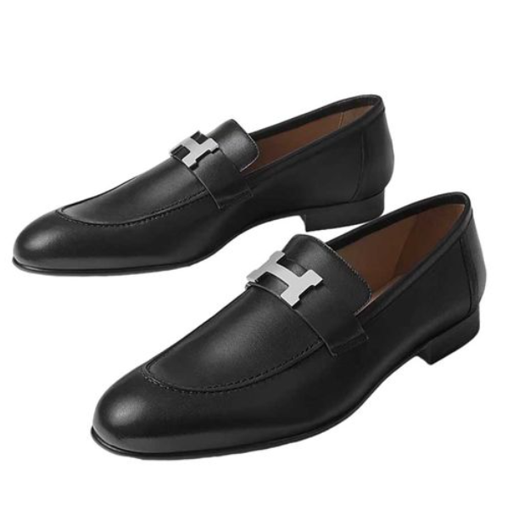

Hermes Quick Sneakers are a dynamic and fashionable footwear choice from the prestigious brand Hermes. These sneakers, made from high-quality fabric, offer a unique blend of style and comfort. They are available in various sizes, appealing to a diverse range of customers.

**History:** The Hermes Quick Sneakers are a modern addition to Hermes' footwear collection, showcasing the brand's ability to blend contemporary design with traditional luxury. They have quickly become a favorite among those who appreciate high-end casual footwear.

**Design:** The design of the Hermes Quick Sneakers is both trendy and practical. The fabric material provides a comfortable fit and breathability, while the stylish design makes them suitable for a variety of casual settings.



**General Information:**

* Brand: Hermes
* Material: Fabric
* Style: Sneakers
* Size: Various
* Price: $660
* Image: Hermes Quick Sneakers

**About the Product:** The Hermes Quick Sneakers are perfect for those who seek a combination of luxury and casual style in their footwear. The high-quality fabric and innovative design make these sneakers a popular choice for fashion-forward individuals.

**Storage:** To maintain the appearance and quality of the Hermes Quick Sneakers, store them in a cool, dry place, away from direct sunlight and moisture.