

Online sales website helps to increase sales and ensure safety when the epidemic season cannot be completely controlled

Supervisors:  
Le Ngoc Thanh

Student name: Trinh Nguyen Huong Huong Kieu

Student ID: tk0099x

Class: TCS2012

**Abstract**

At the present time, the Covid-19 epidemic is gradually expanding across the countries, up to now the business situation is slowly stalled due to the effects of the season but still cannot be controlled. The number of stores to buy and sell is gradually affected because they cannot sell when customers come to buy directly, so the online selling method is gradually popular, it helps to optimize and help a lot. Improve the impact of translation. In fact, FrogTech is a shop specializing in technology equipment business, our project is to build a sales website to enter the online market, helping the number of customers from afar. Customers Easy access improves disease spread when people do not need to transact face-to-face but can transact online to ensure customer safety.

Table of Contents

I. INTRODUCTION 1

1) Background 1

2) Aims 1

3) Objective 2

4) Approach 2

1) Approach to literature searching 3

2) Identifying the problem 3

3) Conclusions 3

III. Product Research 4

IV. Legal, Social, Ethical and Professional Issues and Considerations 4

1) Legal 4

2) Social 4

3) Ethical 4

4) Professional Issues 5

V. Requirements 5

1) Analysis of requirements 5

2) Comparison of systems 6

3) Requirements elicitation 6

VI. Design 15

1. Analysis 16

2. Use case description 16

VII. Prototype 17

Review of technology 17

**a)** **Html** 17

**b)** **Cs** 17

**c)** **JavaSript** 17

**d)** **Visual Studio** 18

**e)** **Database** 19

**f)** **V-Model** 19

VIII. Gantt Chart 21

IX. Reflection 21

X. REFERENCES 22

2. **INTRODUCTION**
3. **Background**

Currently, e-commerce develops like a storm, it gradually goes deep into everyone's life. So what is e-commerce that makes the economy boom?

E-commerce is understood as an online commerce platform, trading products and paid for by credit, e-commerce sites are optimized for use on devices such as computers, phone, tablet.So we will start to point out how the interests of the electricity trade themselves affect people's lives.Starting to talk about is the influence on today's society

Social influence

The e-commerce industry helps all types of customers in all geography to easily access all product items, thereby saving a lot of time and effort of consumers when want a product, and increase the amount of customer pay for the product supplier

Personal influence

For individual consumers, they can choose the amount of product, the store can then refer to many reference information sources of the item and make an objective assessment when making a decision to buy a product.

At the time of the dangerous and complicated Covid-19 translation, in fact they tried to take full control but not completely. The economic industry also influences clearly. Stores had to limit direct transactions, and customers expressed concern when they had to go out and contact face-to-face when performing in-store transactions. The FrogTech store is a consumer electronics store, but in reality the store relies 100% of its sales on in-store sales and it works up until now. when the epidemic progressed. The store lost nearly 70% of its sales because the number of direct visitors to the store was greatly reduced, so the store wanted a direct sales website to improve the current situation and that was the reason for me to do this project

1. **Aims**

* Full display of items in the store
* With the design and creation of a website for sale, we incorporate online payment. It can help increase a large number of customers, Help to save the time and effort of customers and product suppliers, Can make shopping with just one click, shopping is never easy. Easy, convenient and safe to use the website
* Need to have a clear user-friendly interface through a minimal design that allowss customers to view information and compare different products.
* Online payment process is strictly confidential to ensure to avoid disclosing customer information
* Customers' orders after being paid will be transferred to Admin, to process the packaging and delivery of orders to consumers.( The process will be adopted by email)
* Website can be displayed well on devices such as phones, computers, tablets

1. **Objective**

In the case of building a sales website I need to understand the customer needs and design compatibility for users. Develop a compatible website on interfaces like phones, computers and tablets. UI / UX design for customers, product distribution with uncomplicated layout, customer can then select an activity of multiple products and add them to their shopping cart. Finally, make the payment. To complete the aforementioned sections, we need to conduct research to fully understand its features and operating procedures:

* The objective of this research relates to website work accross multiple devices, It helps to explain clearly and effectively
* Next is learning about direct payment security such as Buyer Protection, Seller Protection, Fraud Prevention
* Display product section is categorized according to each category, its features are clear. To help customers easily find products
* All stored information needs to be pushed to the Database and carefully monitored

1. **Approach**

In this part, I choose quantitative research method instead of qualitative research method

So what is quantitative research

Quantitative research is a systematic experiment on phenomena observed through data from which easy conclusions can be drawn, the advantage of quantitative research instead of qualitative research is because. Quantitative research has faster results, is more objective in terms of numbers than qualitative research

Global

By 2020, global e-commerce revenues are projected to hit $ 4.2 trillion, and by 2023, they will have surpassed $ 6.5 trillion. By 2021, more than 2.1 billion people are projected to buy online services and products. By the end of 2020, 1.4 billion people are projected to enter the global middle class, with the majority (approximately 85 percent) living in Europe and Asia Pacific (APAC).By 2021, analysts estimate 53.9% of all e-commerce sales will come from mobile devices. Worldwide, mobile commerce is expected to be even more prevalent.

Thanks to contributions from e-commerce sites (68 percent), social networks / forums (51 percent), and mobile commerce (41 percent), customers' online shopping channels have begun to diversify (figures from the Vietnam E-Commerce Whitepaper 2019). Buyers have several choices, and sellers must be present in many distribution channels to meet customer demand.

The findings of this year's survey show that social media remains the most popular marketing medium for companies. At the same time, 26% of businesses consider selling via social media to be very effective, compared to 28% for selling via websites and 59 percent for selling via mobile applications.

Therefore, from the statistics, we can see that the online sales industry is developing very well and is trending to develop more than that, so implementing the project is extremely reasonable.

1. **LITERATURE REVIEW**
2. **Approach to literature searching**

To get the above objective statistics, I read a lot of articles related to economics, the figures are detailed by articles, from which I can refer to and make conclusions. General

1. **Identifying the problem**

In this section we begin to identify the problems we need to solve in order to complete the project, we need to understand the project's issues and requirements.

1. Understand the web project's features to integrate the checkout step

- Reading the document about the website, for this purpose we need to understand clearly what is displayed on the website

- After understanding what we need to do, we will continue to research the tools that we implement the project.

1. Understand how the code is and how to upload it to github

- Read and understand the literature of asp.net, html, css

- Read literature on how to upload the code to the gitbhub for everyone to have access to

1. Design, develop and test and write a report on how to use each function

-Started the design of ERD, Use case, relation database

user interface (low level-high level), for the system

-Access to use tools learned in literature to build systems

- Check back many times and start writing reports, based on the funtions that the website has done

1. **Conclusions**

After all the things that I have shown above, I have summarized the following extremely important steps:

* Understand the web project's features to integrate the checkout step
* Understand how the code is and how to upload it to github
* Design, develop and test and write a report on how to use each function

From the above, I will do a brief research, comparing those similar products with the project I am about to do.

1. **Product Research**

There are many different forms on the online store platform, but for the website "Maccenter.vn "I feel that there are many similarities with the project that I am about to implement. display products, which can be automatically aligned on many devices with different screen sizes such as phones, computers, tablets. All of them are tailored to different types of screens. This website can feature product details view when you choose to click on the product if you want to display more product information.

Since then, my website will build more features than Maccenter.vn, In addition to the same features as I mentioned above, my website will have more improvement as a guest. Customers can choose the products they want to add to the cart, can perform features (add, delete, edit) products or quantity. From there, customers can pay online for the products they want to buy.

# **Legal, Social, Ethical and Professional Issues and Considerations**

1. **Legal**

In this project, we just use it as a learning material at Greenwich University, for this project we use coding environment like C #, asp.net language, html and css. in which all the data is put into the Sql database section to store data, I use these tools because it is completely free, suitable for students who are still in school. And my project obeys not copying from other projects Moreover, the project is subject to IT laws, including Privacy, Digital Ownership, etc.

1. **Social**

We promise that we will not be affected by, or collide with, religious bigotry, homophobia, or age prejudice in terms of social concerns. When the commodity hits the market, what must happen is rational and objective.

1. **Ethical**

We closely consider ethics when doing research and development for a project (website). First, do not spread malware. Don't send away any confidential information about your clients. No stealing or copying of proprietary software is permitted. We consider and discourage errors by not putting pressure on project members or posing issues that are harmful to their physical and emotional well-being. have an influence on the above ethics issuesProfessional Issues

1. **Professional Issues**

In terms of expertise, this project will first find out the evaluation of the lecturers who are in charge of teaching instruction, and then look for information sources from the internet, which directly this project will collect standard materials. Harvard. The tools used to execute the project are well-verified standard learning tools

1. **Requirements**
2. **Analysis of requirements**

|  |  |  |
| --- | --- | --- |
|  | Requirements | |
| 1 | Classify the similar items into the same category so that customers can easily find them | Interface |
| 2 | There are 1-3 pictures attached to the product and detailed descriptions of each product |
| 3 | Item search toolbar |
| 4 | Show a thorough description of the store (description, information, contact method, specific address) |
| 1 | Manage customer accounts (create, view, edit) | Admin |
| 2 | Add interactive items on the system (create, view, edit) |
| 3 | Receive a customer order notification via (email) and then prepare the order for delivery to the customer |
| 1 | Customers must create an account to make transactions they can interact with their account (view, edit personal information) | Customers |
| 2 | After selecting and reviewing products, customers can click add products to cart, perform operations such as (view, add, edit, delete) |
| 3 | You can choose to pay online or pay on delivery |

Figure Requirement Table

1. **Comparison of systems**

For online sales systems like Maccenter, I feel the level of perfection is very high in this system.There are many similarities and differences between our project and Maccenter, Maccenter is a large website with daily traffic and orders. In terms of display, there are similarities such as: The products are displayed, There is a menu that classifies each product category, classified by their attributes and features so that customers can choose easily. Next, the customer can view product details and add it to the cart and make a payment. Although there will be some not too big difference that in Maccenter customers can log into the system, they have many platforms to register and log into the system such as Gmail, Facebook, Zalo. Due to some restrictions, our system can only log in with Gmail accounts. And the advantage of Maccenter system is that there are regular promotions to reach customers.

1. **Requirements elicitation**

Quantitative research ?

Quantitative method is the collection and analysis of information based on the data collected from the market. The purpose of research in this way is to draw market conclusions through the use of statistical methods, data processing as well as data. Therefore, the quantitative method will be most suitable for the study of the surveyors' attitudes, behaviors and opinions. The resulting portion from a sample group is generalized onto a larger sample population.

Qualitative research ?

Qualitative research method is a form of research often used to find opinions, visit by point of view to find "insight" of problems. Besides, qualitative research also helps to detect customer trends in the future. Currently, the method of data collection in qualitative research is very diverse and there is almost no specific structure. In which there are a number of methods can be mentioned as interviewing individuals, observation or focus group. In particular, the sample portion of this method is usually small and carefully selected.

To start a research survey on interest needs, trends in using customer services and products through Google's form tool to survey market research - this is a very useful tool to Collect information from there to improve weak and flawed parts of the project.Start the survey with simple questions in 2 modes: quantitative research and qualitative research

|  |  |  |  |
| --- | --- | --- | --- |
|  | Quantitative research (đl) |  | Qualitative research(đt) |
| 1 | Average number of Internet hours per day | 1 | What goods / services do you usually buy online |
| 2 | Frequency of using the Internet via Desktop computers, laptops for activities | 2 | The reason why you have not used online shopping |
| 3 | Have you ever participated in online shopping | 3 | How do you usually shop through? |
| 4 | Will you continue to participate in online shopping in the future? | 4 | How often do you pay for products / services ordered online? |
|  |  | 5 | Are you satisfied with your online shopping? |
|  |  | 6 | Which factors are you interested in when shopping online? |
|  |  | 7 | What obstacles do you see online shopping in Vietnam facing? |

Figure Research Table

After collecting the survey results, from people regardless of age and job, we have the following results

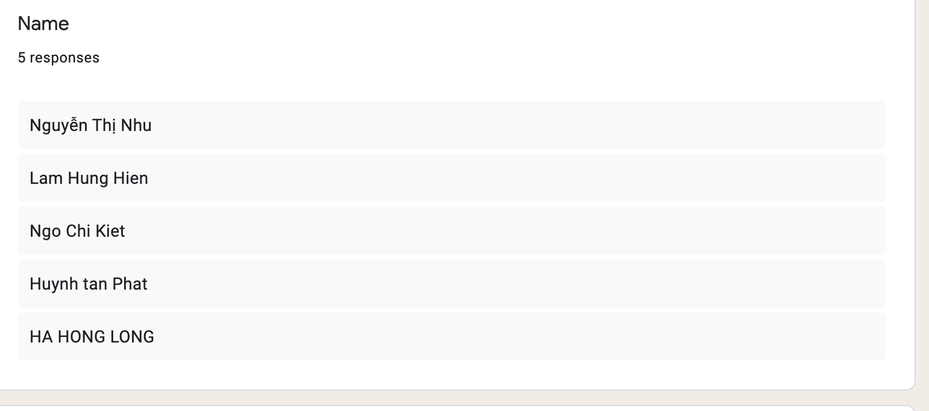

Figure Survey Questions 1 and Results

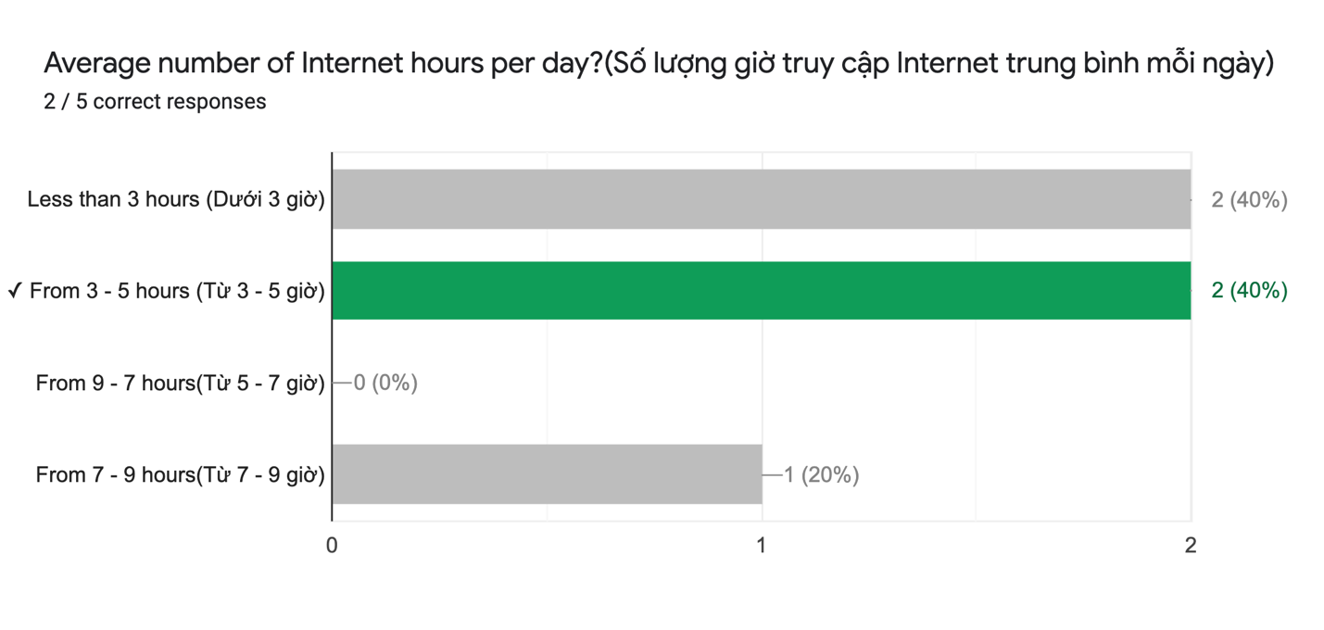

Figure Survey Questions 2 and Results

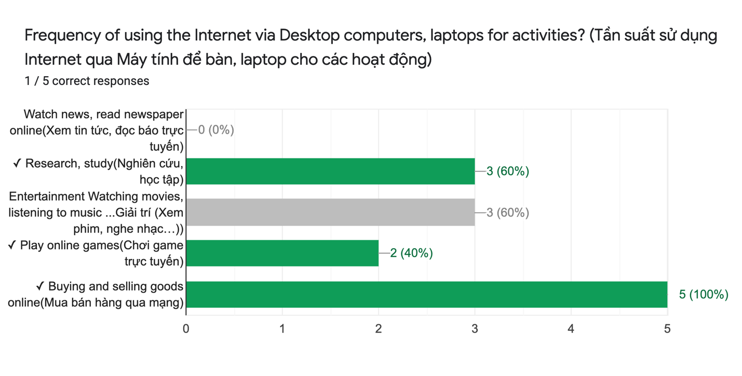

Figure Survey Questions 3 and Results

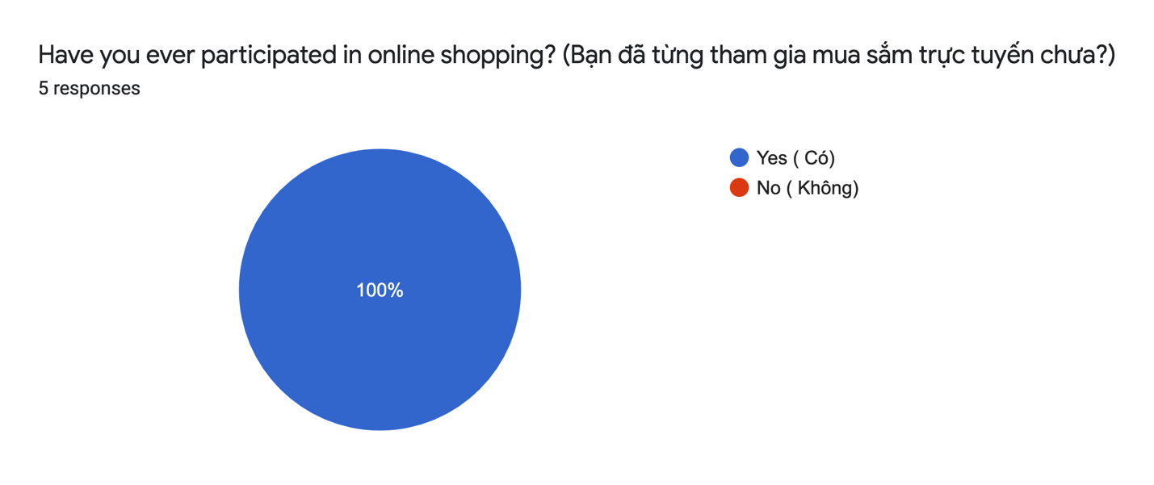

Figure Survey Questions 4 and Results

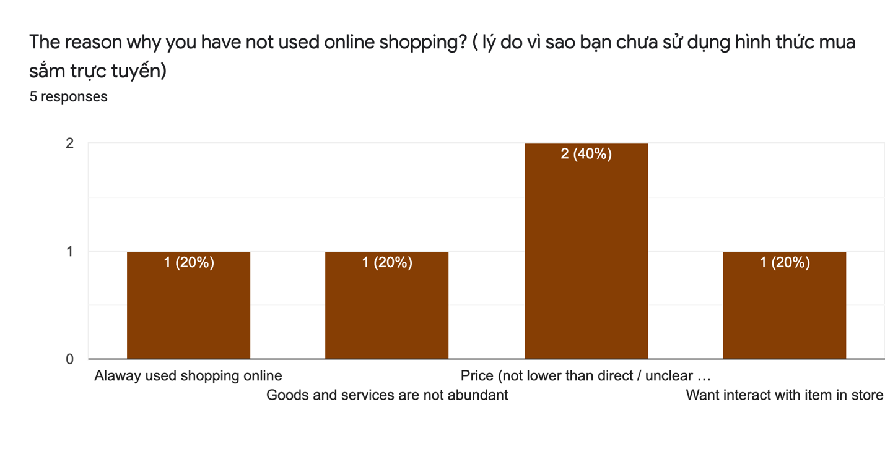

Figure Survey Questions 5 and Results

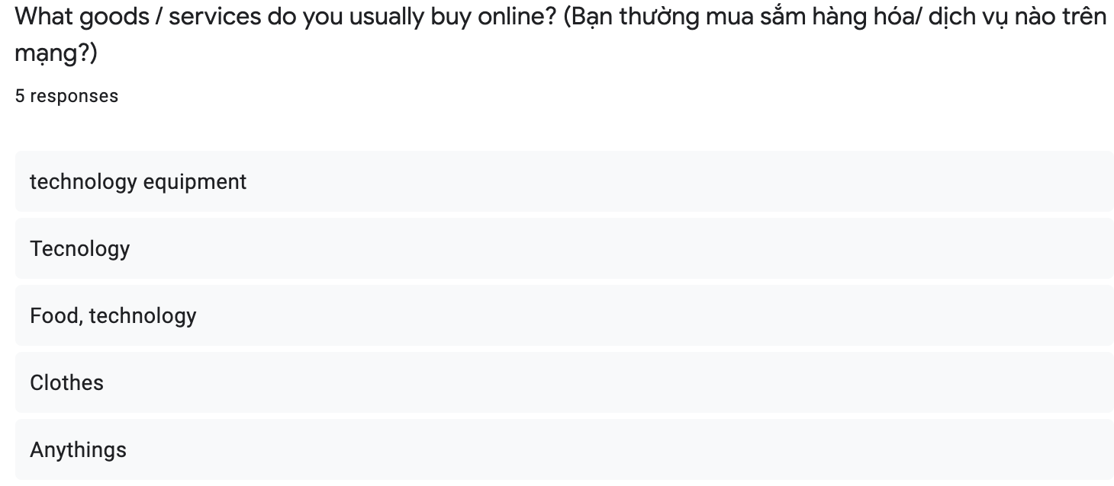

Figure Survey Questions 6 and Results

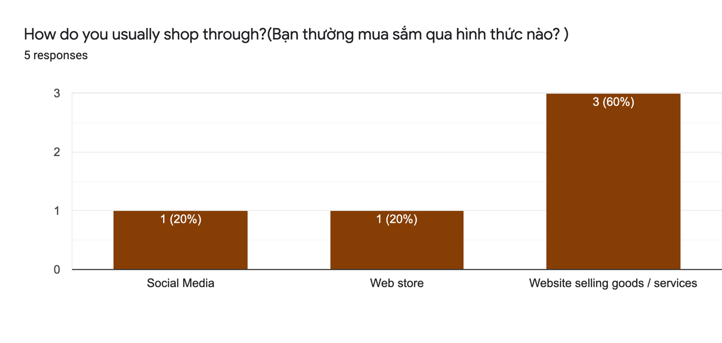

Figure Survey Questions 7 and Results

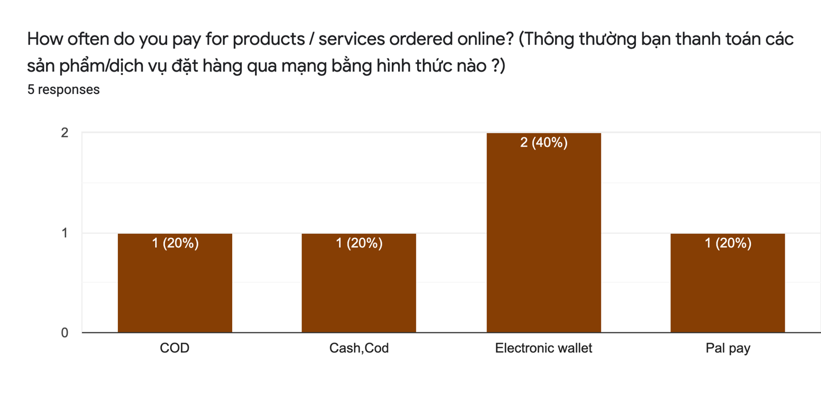

Figure Survey Questions 8 and Results

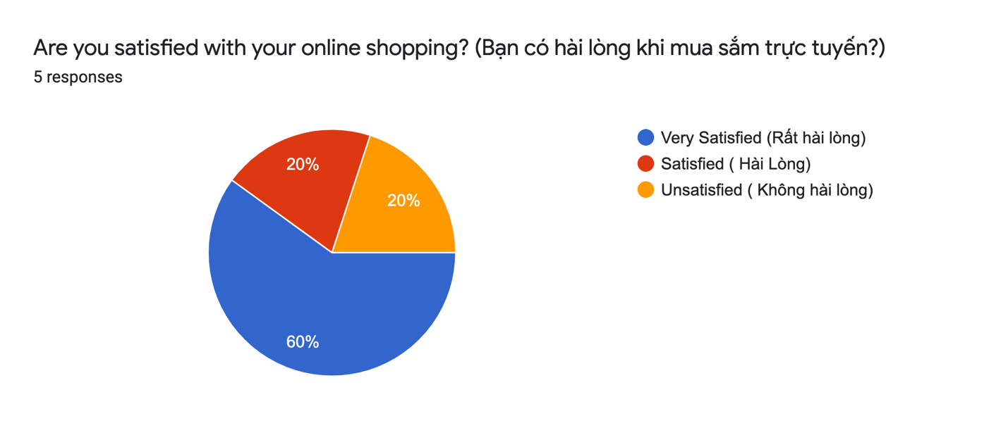

Figure Survey Questions 9 and Results

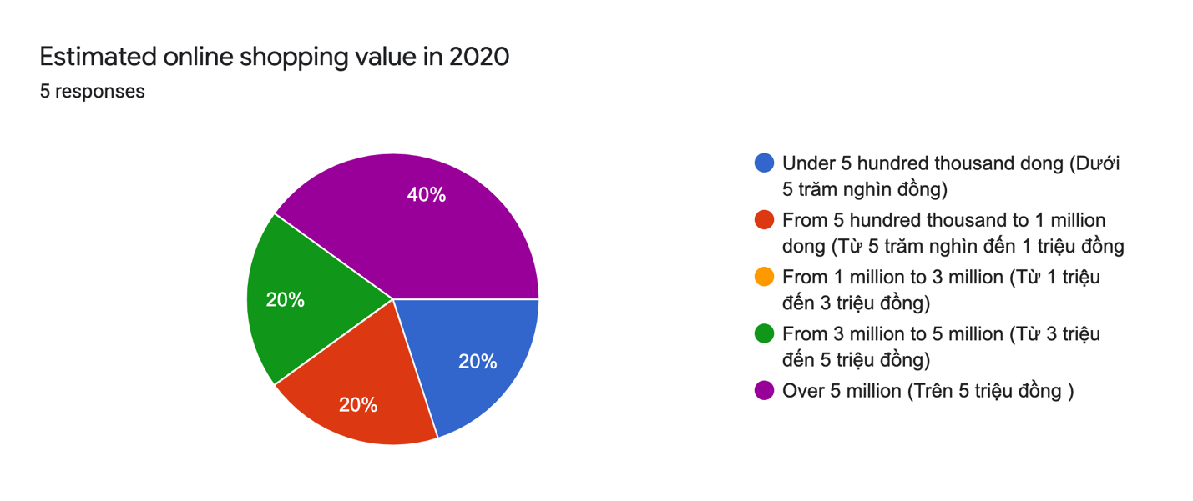

Figure Survey Questions 10 and Results

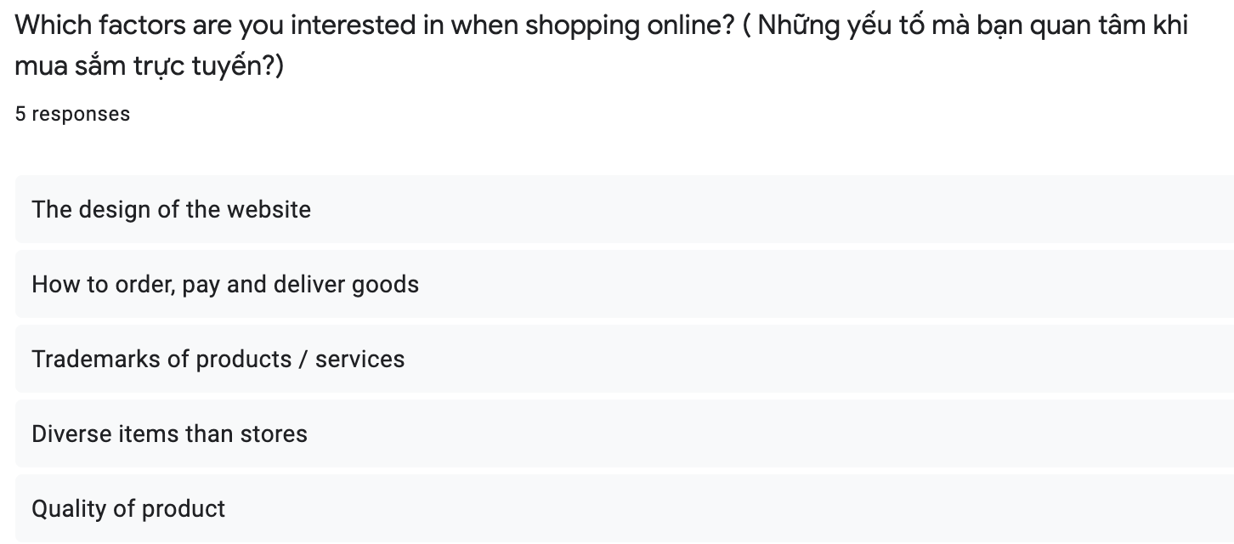

Figure Survey Questions 11 and Results

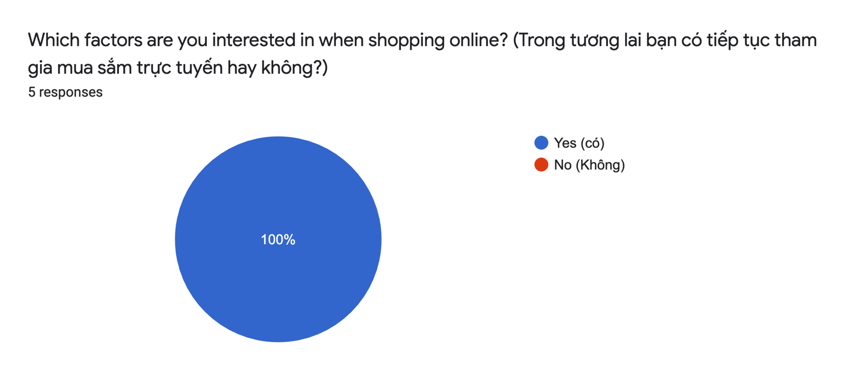

Figure Survey Questions 12 and Results

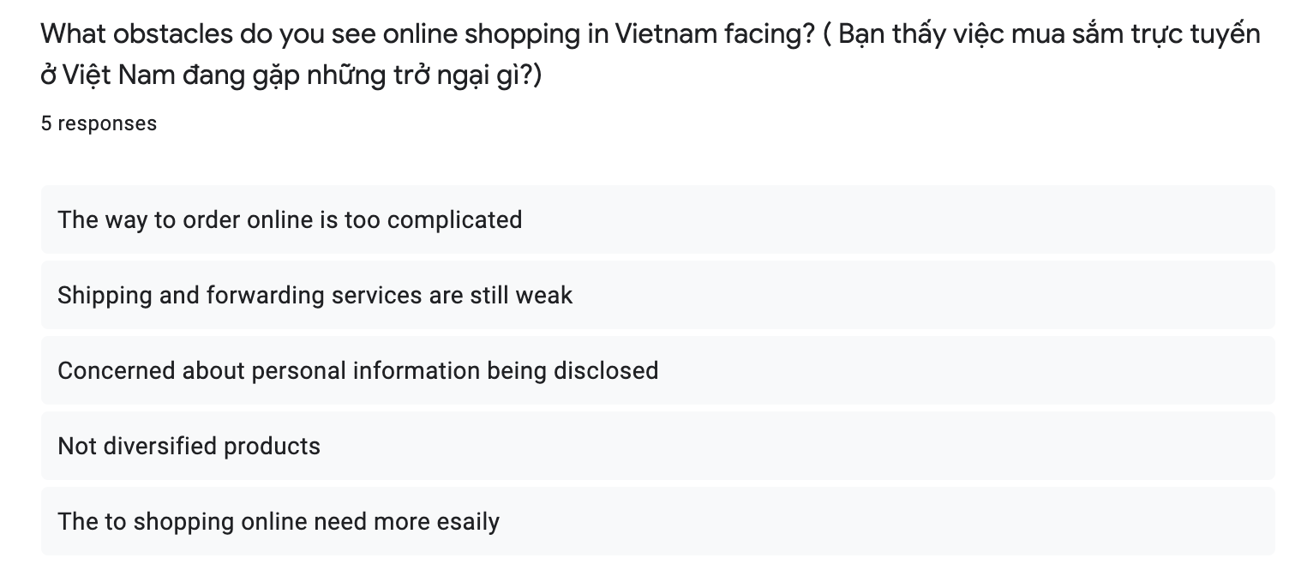

Figure Survey Questions 13 and Results

Conclusions

After a survey of many, I have drawn many conclusions from that survey. Specifically, penny of the people who took the survey regardless of age and job, but mostly "100%" They all use e-commerce. They are very concerned about website quality such as design and security and ease of use.They can buy everything from e-commerce sites, but most of them still choose to buy technology equipment. However, they are also very concerned about many issues such as: identity security, complexity of use, variety of items.

In summary, most of customers use e-commerce which is an abundant source of customers, from which we need to improve the weak sides to exploit this potential customer base.

1. **Functional requirements**

Definition:

A Functional Requirement (FR) is a statement that describes the service that the program must provide. It refers to a software framework or a part of one. A function is nothing more than the inputs, actions, and outputs of a software code. A measurement, data processing, business method, user interaction, or some other basic feature that determines what function a device is likely to perform may all be considered. Functional Specification is another name for Functional Requirements.

Figure Functional Requirement Table

|  |  |  |
| --- | --- | --- |
| Functional requirements | | |
| User | Display | Customers can view all items on the e-commerce page |
| Have responsive on almost display of the tablet, telephone, computer |
| Product search bar |
| Products are categorized and sorted by category |
| Login& Register | Users create accounts by linking to email |
| User must register and log in to make a purchase |
| User must fill in full information (Full name, address, phone number) |
| Password registration must meet the requirements of characters, lower case letters, upper case letters and numbers |
| When users forget their password, they can retrieve the password by linking to the email that was originally registered |
| All customer information is being strictly confidential |
| Cart | Users can choose to add products to the shopping cart and perform functions on the product (add, edit, delete). |
| Users fill in the bank link information to proceed to cart payment |
| The user can customize the desired delivery time |
| Proceed to checkout cart |
| Proceed to checkout cart and notify user of successful payment |
| User can view order status (prepared, delivered, successfully delivered) |
| Admin | Login | Admin must log in to the system to use it |
| Cart | Orders,when successfully paid by the user, will be notified to the admin via email |
| Admin confirms the order and prepares the order |
| Admin confirms the status of the order ( prepared, delivered, successfully delivered ) so that the user can track their order. |

1. **Non-functional requirements**

Definition:

Non-functional specifications (NFR) describes a software system's consistency attributes. They give a software system a score based on responsiveness, usability, security, mobility, and other non-functional criteria that are crucial to its performance. "How quickly does the web page load?" is an example of a non-functional search. If non-functional specifications are not met, the device can fail to satisfy the user's needs.

To make those functions more specific, according to the project evaluation, we need to have requirements such as confidentiality, ethical, social and legal requirements.

In terms of security requirements, the project will be strictly protected, the information of the order and the user for instance: The password when logging in must require numeric characters (length, special characters).

In terms of ethical, social and legal issues, we will comply with the regulations of the state government, not infringe on privacy issues or question other individuals or organizations.

1. 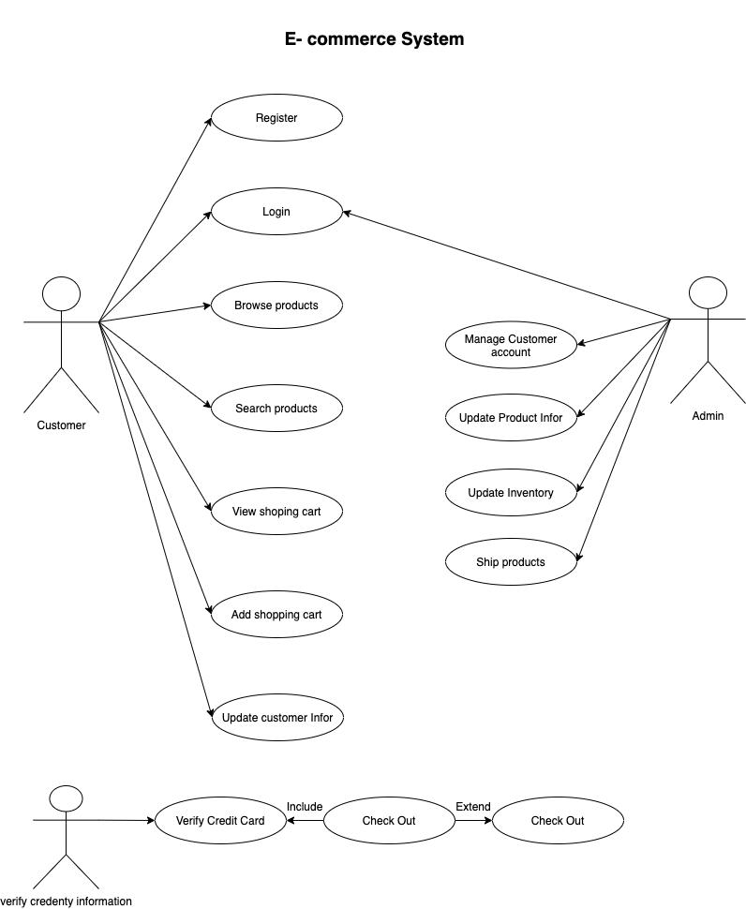**Design**

Figure Use Case Diagram

1. **Analysis**

Browse products: The consumer asks that the product be viewed in the appropriate product category. The device will show product details for the chosen group..

Search product: The customers enter the se arch product parameters and request a search product. The system search through products category in database and gives information. If not matches, gives fail message.

Viewshopping cart: The customer has asked to see his or her shopping cart. The device displays the customer's shopping cart, as well as the price and total price.

Add shopping cart: Add to shopping carts when the customer finds the product he needs. The machine keeps track of product details and stores it.

Update customer info: The customer requested that his name and address be updated. If the information system is up to date, it saves it in a database that is modified. The payment information is saved in current information after you buy a product.

Check out: When the customer is finished with his shopping, he requests to check out. The credit card information is sent to the Credit Verification Company if payment information is available. If the credit card information does not fit, the user is given the option to enter correct information or cancel the order. If the credit card is valid, the machine will process the order form, and the checkout process will be completed. Check your credit card: The credit card information is validated by the credit verification company. Returns to admin if the information is right. If this is not the case, the customer will be asked to enter his payment details again. Update product information admin request to update product information includes price, brand, etc., as well as database system updates. Inventory should be updated.

**Use case description**

1. Register: If a customer is a first-time user, he should go to the registration page. A registration page appears, asking for general information about the customer as well as a login (email address) and password. Customers can log in by entering their name and password. The device double-checks that the username and password are right. If there are any discrepancies, the consumer may receive an error message.

2. Use case Diagram of e-Commerce system Browse products: The consumer asks that the product be shown in the product category. The device will show product details for the chosen group. Search product: Customers request a search product by entering the search product parameters. The system searches the database for items by category and provides details. If no matches are found, a failure message is shown. View shopping cart: The customer request to view the shopping cart. The system returns the shopping cart to customer, the price and total price shows to customer. Add shopping cart: Add to shopping carts when the customer finds the product he needs. The machine keeps track of product details and stores it. Update customer info: The customer request to update customer info about his name, address…. Etc. If updated information system stores in database which is updated. After purchase one product the payment information stores in current information. Check out: The customer completes the shopping he request to checkout. If the payment information exists the credit card information sends to Credit Verification Company. If credit card information not matches it shows enter valid information or cancel order. If the credit card is valid, the order form will be processed by the system and checkout is complete. Verify credit card: The credit card information is being verified by a credit authentication firm. Return to the salesperson if the information is right. If this is not the case, the customer will be asked to enter his payment details again. Product information should be updated: The sales clerk's request to update product information requires price, brand, and database system updates.Update inventory: The sales clerk requests that inventory be updated. The database has been updated with the framework upgrade.

3. Use case Diagram of e-Commerce system Ship product: Within 5 to 6 business days of receiving the order request, the admin delivers the order product to the customer.

Top of Form

1. **Prototype**

**Review of technology**

1. **Html**

For a project developer, the keyword Html is no longer a stranger, Html is a language used to create the structural components of a website easily and quickly, When working with it all code structure becomes simpler.

In addition, this mark up language can be used smoothly on different types of browsersTherefore, when conducting an Html project, it is an indispensable language

1. **Cs**

As for house construction, it can be said that Html helps to form the house while Css helps to define the style, it makes the house more beautiful. Css is a style language for the website, so it is indispensable, it makes the website more eye-catching for users to make everything from the rough become more beautiful.

1. **JavaSript**

JavaScript is considered as a tool to help the website have more powerful and outstanding features.

JavaScript is a logic-based programming language that can be used to change the content of a web page and make it react to user activities in several ways. Confirmation boxes, calls-to-action, and applying new information to existing information are all popular JavaScript applications.

JavaScript, in a nutshell, is a programming language that helps web developers to create dynamic websites. JavaScript, which improves browser default controls and behavior, is responsible for the majority of the operation you'll find on a website.

Since it runs in the client's browser almost instantly, JavaScript is typically very quick. Calls to a backend server do not slow down JavaScript as long as it does not require additional services. In addition, all major browsers support JIT (just-in-time) compilation for JavaScript, which means that the code does not need to be compiled before being executed. JavaScript's success, on the other hand, is one of its advantages, as it is being more widely used on the internet even with the arrival of Node.js. There are various ways to learn JavaScript. Stack Overflow and GitHub also show a growing number of JavaScript projects, which are only predicted to grow in popularity in the coming years.

When using JavaScript, though, there are still some drawbacks. Malicious glitches and surveys can be used since JavaScript programming is run on the client side. Because of this, some users chose to disable JavaScript entirely. Although server-side scripts often produce the same result, different 9|Page browsers can interpret JavaScript code differently. The gaps are minor nowadays, and you can be unconcerned as long as your script is tested in all major browsers.

I'll use JavaScript in the context of the app to bind to the database system and to execute some of the app's operations.

1. **Visual Studio**

One of the most common source code editors for programmers is Visual Studio Code (VS Code or VSC). VS Code's outstanding advantages include speed, lightness, cross-platform support, a wealth of capabilities, and the fact that it is open source.

This platform not only supports professionals, but it also supports a lot of students who are still in school, currently being widely used by all programmers because it meets the needs of the work. episode, it also takes up quite less space than other similar programs. Even better Visual Studio Code supports dragging or copying code directly from GitHub. This code can then be changed and saved in the software, some code can be changed slightly for the convenience of the user. Visual Studio Code will suggest to the programmer alternatives if available. Visual Studio Code supports many web applications. In addition, it also has an editor and website design. So I chose Visual Studio to do my project

Asp.net Mvc

Asp.net MVC is a great famework that brings the benefits and great support for the MVS pattern to Asp.net. This phrase is abbreviated from Model-View-Cotroller, it helps to divide 3 parts: model, controller, view conveniently.

**Advantge**

Control

When you use the ASP.NET MVC framework, you are provided with a very powerful set of controls over JavaScript, HTML and CSS compared to the controls provided by some traditional form on the web.

Integration

When integrating MVC with jQuery, it is possible to write code that runs in web browsers. This will reduce the load on the web servers

Able to test

The ASP.NET MVC framework makes testing web applications very good. So if you want to test web applications before giving them to users, you can simply use ASP.NET MVC.

1. **Database**

Sql Sever

This database environment can make operations easy to use, and databases can be easily managed and initialized.

1. **V-Model**

Within a business enterprise, nearly all software goes into the Software Development Life Cycle (SDLC), which is a follow-up mechanism for a software product. It also provides a blueprint for developing, maintaining, changing, or upgrading complex applications.

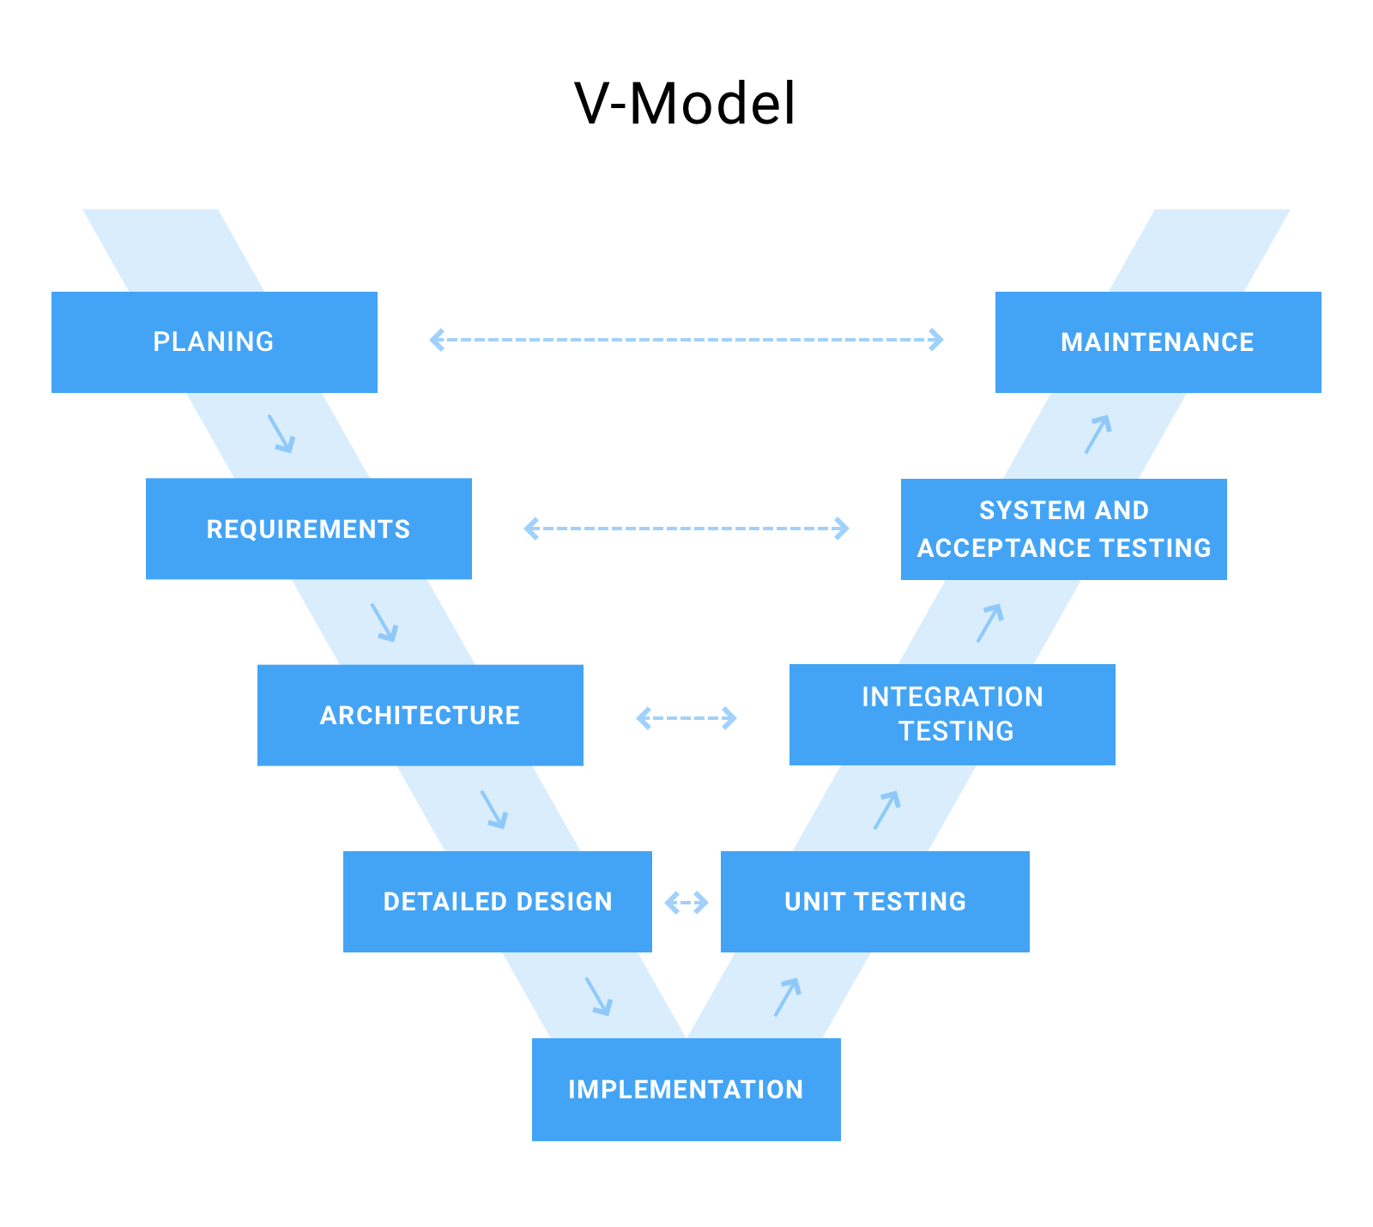

Figure 18 V-Model

Advantage

To optimize and at the same time make things simple but understandable to everyone, the V-model helps to keep abreast of the project's lifecycle. V-Model can help us to be proactive in the work process, so it saves a lot of time

In figure 1 there are 5 pharse include “ Planing - Maintenace” ,“ Requirements - System and acceptance testing” , “Architecture - Integration Testing” , “ Detailed Design - Unit Testing”, “Implementation”. The first plan will be outlined, there will be specific requirements, then sticking to the requirements that conduct the user interface design that is the step. From there, design more details in step "Detailed Design". And finally, proceed to move the project like what the map was planning in the "Implementation" step. from there the project will gradually be completed more thoroughly.

1. **Gantt Chart**

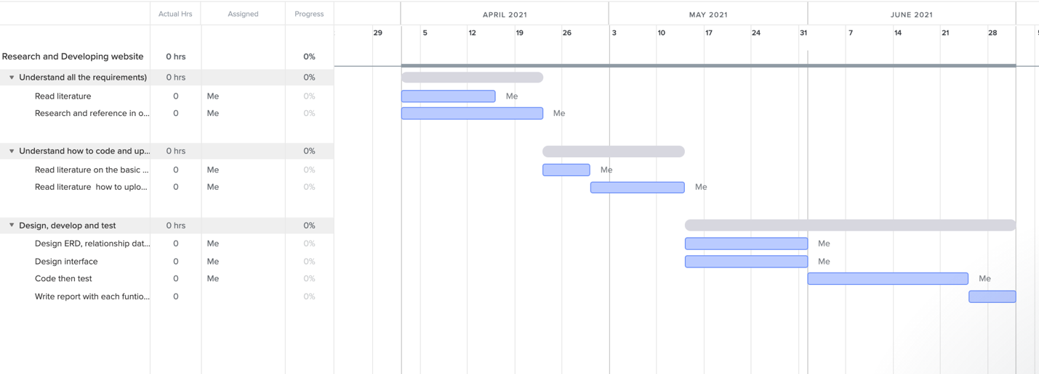

Figure 19 Gantt Chart

Form figure 2 As shown in the picture, we can see that the project lasts a total of 96 days, from this chart we can see that the start date is April 1, 2021 and lasts until the end of 30 / 6/2021. All jobs are added to the timelines, all jobs are assigned a date and the person in charge of the work, which makes it easy to speed up the progress of the work so as not to waste. Time

1. **Reflection**

Summarizing with the full displays in all above sections, I would like to summarize that the project will be implemented based on all presentation to achieve the success of the project.

1. **REFERENCES**
2. Think.storage.googleapis.com. 2021. [online] Available at: <https://think.storage.googleapis.com/intl/ALL_uk/docs/how-make-website-work-across-multiple-devices_articles.pdf> [Accessed 8 March 2021].
3. Think.storage.googleapis.com. 2021. [online] Available at: <https://think.storage.googleapis.com/intl/ALL_uk/docs/how-make-website-work-across-multiple-devices_articles.pdf> [Accessed 8 March 2021].