Họ và tên: Lê Bá Khánh Trình

MSSV: 6151071108

**BUỔI 3A**

a) List full details of all hotels. 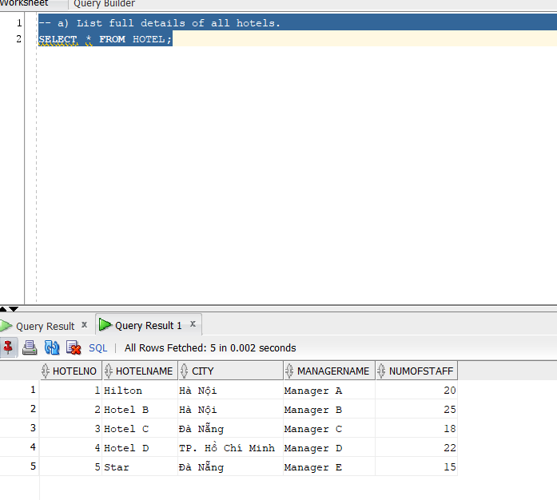

b) List the number of rooms in each hotel that are located in Hanoi. 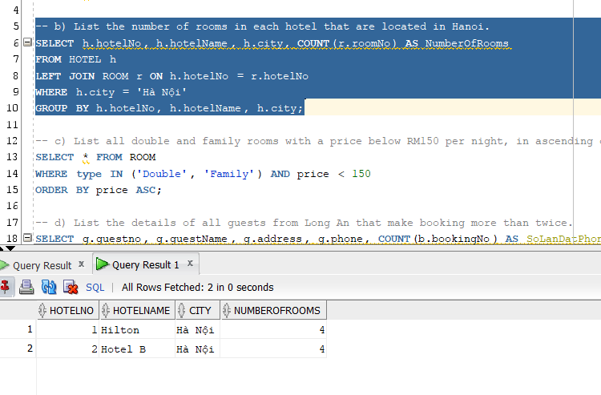

c) List all double and family rooms with a price below RM150 per night, in ascending order of price. 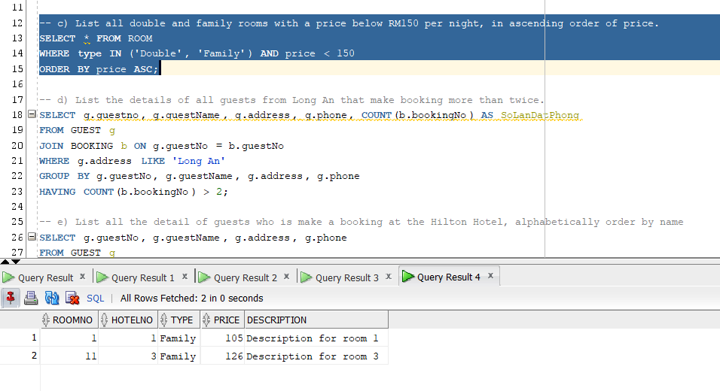

d) List the details of all guests from Long An that make booking more than twice. 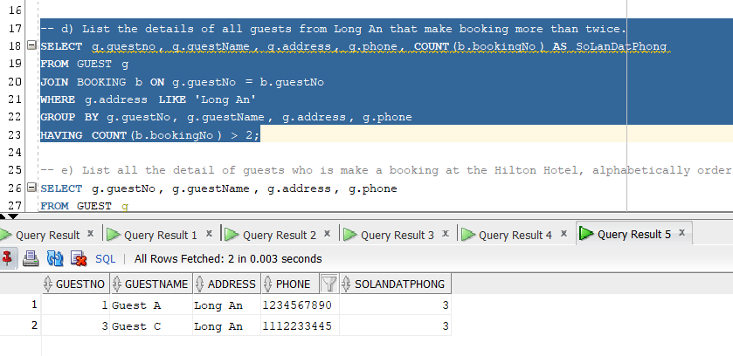

e) List all the detail of guests who is make a booking at the Hilton Hotel, alphabetically order by name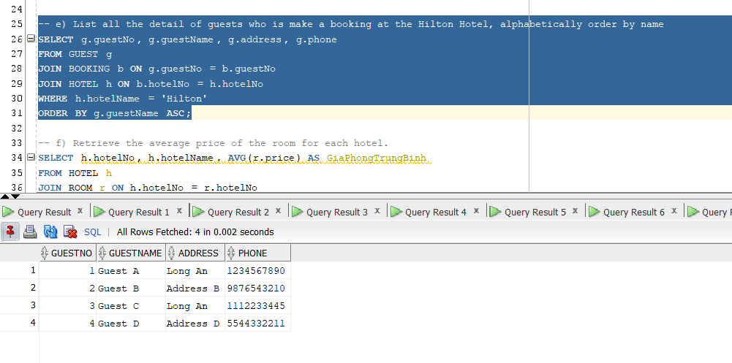

f) Retrieve the average price of the room for each hotel.

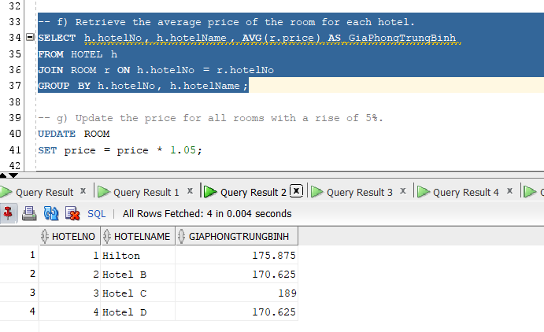

g) Update the price for all rooms with a rise of 5%.

