Họ và tên: Lê Bá Khánh Trình

MSSV: 6151071108

**Buổi 3b**

a) Get the names of employees from department “Information Technology” who are working on the “Database” project. 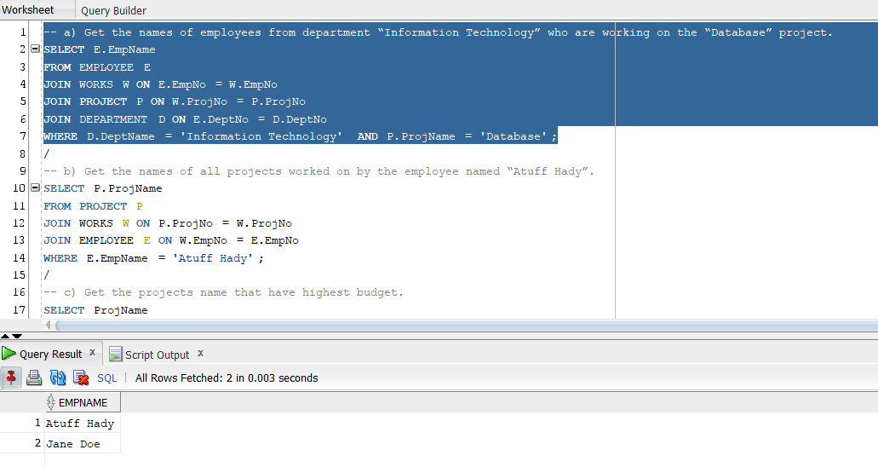

b) Get the names of all projects worked on by the employee named “Atuff Hady”. 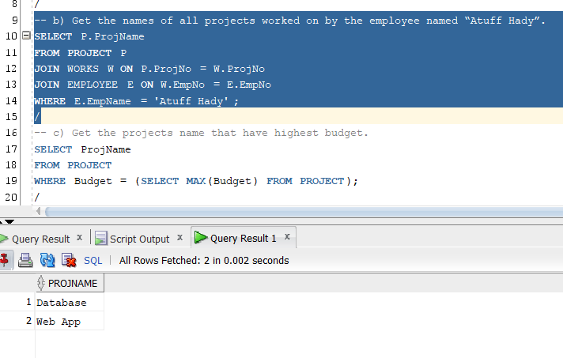

c) Get the projects name that have highest budget. 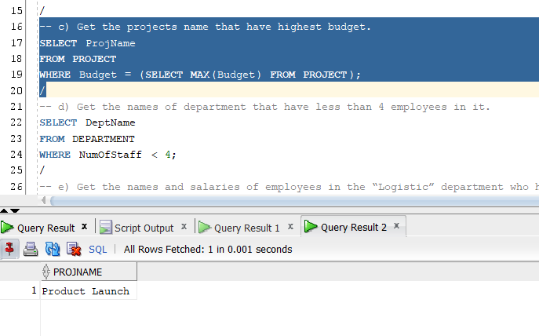

d) Get the names of department that have less than 4 employees in it. 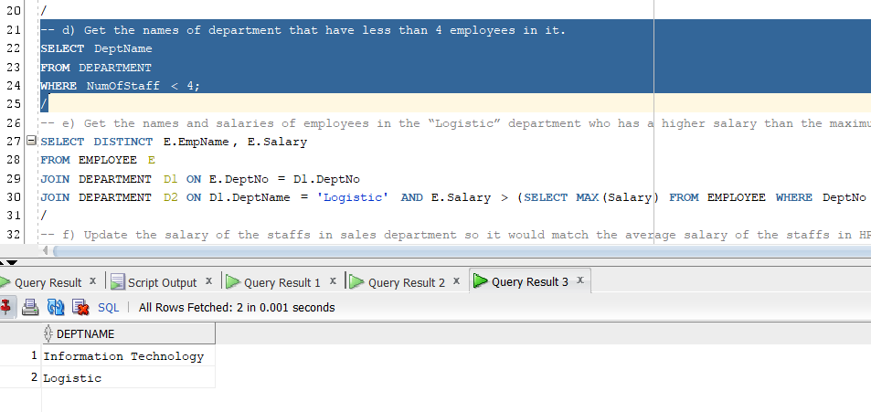

e) Get the names and salaries of employees in the “Logistic” department who has a higher salary than the maximum salary in the “Accounting” department. 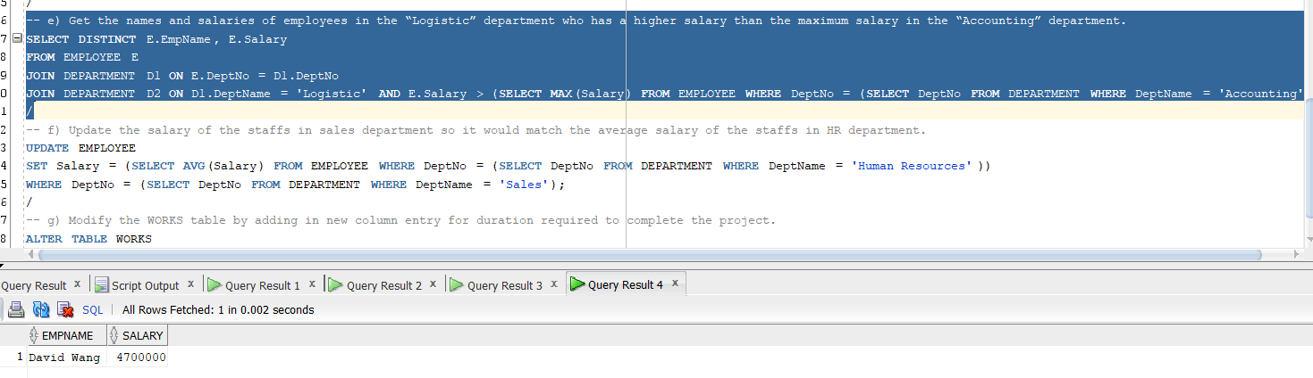

f) Update the salary of the staffs in sales department so it would match the average salary of the staffs in HR department. 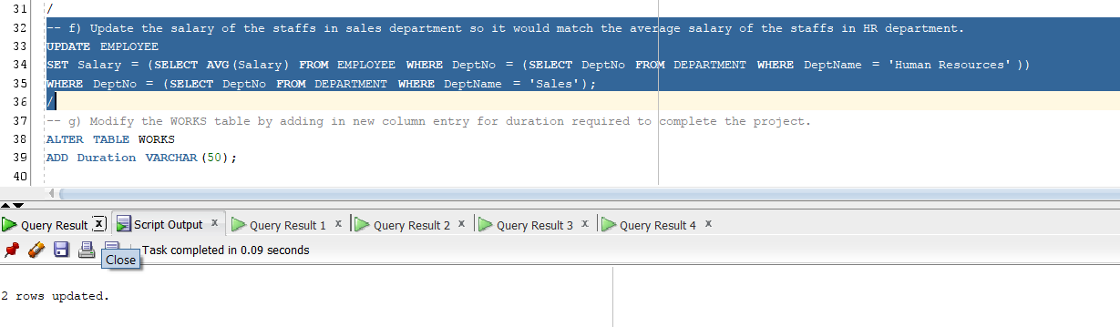

g) Modify the WORKS table by adding in new column entry for duration required to complete the project. 