Software Requirements Specification
Development of an E-learning System for the Faculty of Information Technology

Revision History
Date | Version | Description | Author

Table of contents
Table of Contents
Part I. Introduction 4
4. Glossary 6
5. References 6
Part II. Overall Description 6
1. Product Perspective 6
2. Product Functions 7
2.1 Account Management 8
2.2 Learning Content Access and Navigation 8
2.4 Assessment, Grading, and Progress Tracking 9
2.5 Ranking and Badge Features (Gamification) 9
2.6 Support and User Interaction Features 9
3. User Characteristics 10
4. General Constraints 10
5. Assumptions and Dependencies 11
5.1 Assumptions 11
5.2 Dependencies 12
5.3 Impact of Changes 12
Part III. Requirements 13
1. Functional Requirements 13
1.1 Overall Use Case Diagram 13
1.2 Use Case Diagram Decomposition 14
1.3 Functional Groups 15
2. External Interface Requirements 27
2.1 User Interface 27
2.2 Hardware Interface 28
2.3 Software Interface 29
2.4 Communication Interface 30
3. Performance Requirements 31
4. Data Design 31
5. Design Constraints 31
5.1 Standards Compliance 31
5.2 Hardware Limitations 32
6. Attributes 32
6.1 Usability 32
6.2 Security 32
6.3 Maintainability 33
6.4 Portability 34
7. Other Requirements 35
7.1 Operations 35
7.2 Adaptability 36
Appendixes A 36

Part I. Introduction
1. Purpose
The purpose of this Software Requirements Specification (SRS) document is to clearly and comprehensively describe the functional and non-functional requirements of the E-Learning system for the Faculty of Information Technology. This document provides a common foundation for system analysis, design, development, and testing, helping stakeholders such as lecturers, students, and the development team share a consistent understanding of the system’s scope and functionality.

In addition, the document ensures that the system is developed to meet the practical needs of teaching and learning, especially with features such as lesson-based note-taking and gamification of the learning process. It will serve as the primary reference throughout the software development lifecycle, supporting project management, quality evaluation, and future system expansion.

2. Scope
The software described in this document is an online learning application for the Faculty of Information Technology, supporting online learning activities for both students and lecturers.
The user-side system will provide the following main functionalities:
- User account registration and login
- Personal information management and password changes
- Access to learning content
- Direct note-taking for each lesson to personalize learning
- Learning progress tracking
- Participation in quizzes/tests and assignments
- Receiving scores, rankings, and badges to increase engagement in the learning process
The objectives of the system are:
- To enhance students’ proactiveness in learning
- To help students review materials quickly through context-based notes
- To motivate learning through ranking and badge mechanisms
- To apply knowledge of software development processes, UML modeling, MVC architecture, REST APIs, security, and access control in accordance with the objectives of the SE2 course
3. Overview
This document follows the IEEE 830 standard and consists of three main sections:
- Section 1: Introduction – Provides an overview of the entire document, including the purpose, scope of the product, definitions/abbreviations, and references.
- Section 2: Overall Description – Provides an informal introduction to the product and its usage context. This section includes the product perspective, major functions, user characteristics, general constraints, and assumptions/dependencies.
- Section 3: Specific Requirements – This is the most important section, describing in detail the system’s inputs, outputs, and functional requirements so that designers can build the system and testers can evaluate it..

Glossary

References

Part II. Overall Description

1. Product Perspective
The E-learning system is designed to operate within the existing digital ecosystem of the Faculty of Information Technology. Rather than being a standalone application, this system acts as an interaction bridge between users (Students, Lecturers) and the faculty’s technical infrastructure.
- Position in the system: It serves as the central component for managing online learning activities. The system integrates directly with the existing student database to synchronize information and connects with storage management systems (File Server) to manage learning materials.
- Operational context: The system operates on a web-based platform, built using Java (Spring Boot) and MySQL, allowing remote access through the Internet or the faculty’s Intranet.
- External relationships: The product interacts with hardware (mobile devices, personal computers), software (web browsers, development tools), and standard communication protocols to ensure smooth delivery of video lectures and learning materials.
The E-learning system does not operate independently but must interact with the following components:
- System interfaces: The system must connect with the university’s centralized student database to authenticate access rights and synchronize class lists for each semester.
- User interfaces: The interface must be optimized for users with different technical levels within the faculty, including students, lecturers, and administrators. The interface should display properly on both desktop browsers and mobile devices.
- Software interfaces: The system operates on the Spring Boot platform and interacts with MySQL Workbench for database management. It may also integrate with mathematical libraries to support exercises specific to the IT discipline.
- Communications interfaces: Standard network protocols such as HTTP/HTTPS are used for data transmission, and TCP/IP is used for internal network connections within the faculty.
- Memory: The system must handle large storage capacity for video lectures and PDF materials while optimizing caching mechanisms to ensure fast access when many students log in simultaneously.
- Operations: The system must support multiple operating modes, including: Interactive mode (students completing online exercises), Automatic mode (automatic grading of quizzes, Periodic backup and data recovery mode.
- Site adaptation requirements: The system must be configurable according to specific regulations of the Faculty of Information Technology, such as submission deadlines, passing score thresholds, or internal network safety parameters.

2. Product Functions
This section provides an overview of the main functions performed by the E-Learning system for the Faculty of Information Technology (user side). The functions are organized into logical groups to make system operations clearer and easier to understand for readers unfamiliar with the system.

Overall, the system focuses on supporting the learning process of students and lecturers, from account management and content access to learning activities, progress tracking, and motivational mechanisms. The main functional groups include:
- User account management.
- Learning content access and navigation.
- Lesson-based note-taking.
- Assessment, grading, and progress tracking.
- Ranking and badge features (gamification).
- Support and user interaction features.
These functional groups are closely related. Users must first use account management to register and log into the system. After authentication, they can access learning content and participate in learning activities. During the learning process, users can create notes linked to specific lessons and complete quizzes or assignments. The results of these activities are used to update learning progress, scores, rankings, and badges. Support and interaction features improve the overall user experience and system usability.

2.1 Account Management
This functional group manages user identity and personal information within the system. It includes the following features:
- Allow users to register new accounts with basic information (e.g., name, email, password, role).
- Allow users to log into the system using registered credentials.
- Allow users to log out to end their session.
- Allow users to view and update personal information (e.g., display name, avatar, contact details).
- Allow users to change their password to ensure account security.
- The system performs login verification and protects functions that require authentication.
>> This functional group is a prerequisite for accessing other system functions.

2.2 Learning Content Access and Navigation
This functional group provides the main capabilities for accessing learning materials:
- Allows users to view the list of available courses/subjects.
- Allows users to access individual courses and their corresponding lesson lists.
- Allows users to view detailed lesson content (e.g., text, video, attachments).
- The system records the learning status of users (viewed/not viewed).
- Allows users to continue learning from where they left off.
>> This functional group is the central component of the entire E-Learning system.
2.3 Lesson-Based Note-Taking
This feature set supports personalization of the learning process:
- Allows users to create notes while studying a specific lesson.
- Each note is linked to a specific lesson for contextual reference.
- Allows users to edit or delete created notes.
- Allows users to review all notes by lesson or course.
- The system stores and synchronizes notes with the user's account.
>> This function helps learners organize knowledge and review more effectively.

2.4 Assessment, Grading, and Progress Tracking
This functional group supports testing, evaluation, and learning progress monitoring:
- Allows users to take quizzes or assignments related to lessons or courses.
- The system automatically grades quizzes or suitable assignments.
- Stores test results and scores.
- Allows users to review their learning history and progress.
>> This functional group acts as the data source for the ranking and badge system.

2.5 Ranking and Badge Features (Gamification)
This functional group aims to increase user learning motivation through gamification:
- The system calculates overall user scores based on learning results and course completion.
- Generates leaderboards to compare performance among users.
- Awards badges when users reach certain milestones (e.g., course completion, high scores, consistent learning).
- Allows users to view their rankings and badge collections.
- The system automatically updates rankings and badges when learning results change.
>> This group is closely related to the assessment and progress tracking functions.

2.6 Support and User Interaction Features
This functional set aims to improve the overall user experience:
- Displays notifications about important events (e.g., lesson completion, badge awards, score updates).
- Supports searching for courses or lessons.

3. User Characteristics
The E-Learning system serves multiple user groups, each with different roles, goals, and usage levels.
Guest
- Users who have not logged into the system.
- Can register accounts, log in, reset passwords, and view course information.
- Cannot access detailed learning content.
Student
- The main learners in the system.
- Have the ability to use computers and web applications.
- Perform functions such as managing personal information, searching and enrolling in courses, completing and submitting assignments, viewing scores, and commenting.
Lecturer
- Responsible for creating and managing learning content..
- Have domain expertise and good system usage skills..
- Perform functions such as creating and editing courses, managing students, creating assignments, grading, and providing comments.
Administrator
- Responsible for system management and operation.
- Manages students, lecturers, news, and comments.
- Has the highest access privileges in the system.

4. General Constraints
The development of the E-Learning system is carried out under several technical and organizational constraints to ensure project feasibility. The system must comply with university policies regarding data security, user account management, and information privacy. The application is developed using Java and Spring Boot, therefore the development team must use technologies, libraries, and frameworks compatible with this environment. The system must operate reliably on common web browsers and should not require specialized hardware beyond standard servers and personal computers.
The system is built using the MVC architecture, therefore services must communicate through standard REST APIs and be capable of operating independently and concurrently. Requirements related to reliability, security, and access control are mandatory, including: User authentication, Role-based authorization, Activity logging (audit log). The application must ensure high availability, scalability, and information security, as it directly supports the teaching and learning activities of the Faculty of Information Technology.

5. Assumptions and Dependencies

5.1 Assumptions

5.1.1 User Availability and Roles
Students, lecturers, and administrators are assumed to have valid accounts provided by the Faculty of Information Technology or created by system administrators. Users are assumed to have basic knowledge of online learning systems.

5.1.2 Learning Process Assumptions
Courses are organized into lessons, and each lesson may generate measurable learning events (e.g., lesson completion, quiz submission, assignment completion). These events are assumed to be sufficient to support progress tracking, ranking calculations, and badge awarding.

5.1.3 Gamification Assumptions
The ranking and badge system assumes that students are motivated by competitive and achievement-based learning features. Rules for ranking scores and badge criteria are assumed to be defined by lecturers or administrators and remain relatively stable during a learning period.

5.1.4 System Usage Assumptions
Users access the system through modern web browsers with stable internet connections. The system is primarily used online, and offline functionality is not required.

5.1.5 Development and Academic Context
The system is developed as part of the Software Engineering 2 (SE2) course, following academic standards related to: Requirements analysis, UML modeling, Architectural design, Software quality. The scope and depth of features are adjusted to fit a 12-week development period.

5.2 Dependencies

5.2.1 Backend and Frontend Integration
The frontend application and backend services are developed as separate components and depend on well-defined RESTful APIs for integration. Changes to API contracts may require updates on both frontend and backend sides.

5.2.2 Event-Driven Mechanisms
Progress tracking, ranking updates, and badge assignments depend on the correct generation and processing of learning-related events. Any failure in event publishing or consumption may lead to delayed or inconsistent gamification results.

5.2.3 Infrastructure and Hosting
The system assumes the availability of hosting environments supporting: Java-based backend services (e.g., Spring Boot), Relational databases, Secure HTTPS communication. Performance and scalability requirements depend on sufficient server resources and network bandwidth.

5.2.4 Third-Party Libraries and Frameworks
The system depends on standard frameworks and libraries such as: Spring Boot, Spring Security, ORM frameworks and Frontend UI libraries. Updates or incompatibilities in these libraries may affect system operation or require code modifications. The system also depends on faculty or university policies related to data privacy, security, and user data retention. Changes in these policies may affect authentication, authorization, logging, or data storage requirements..

5.3 Impact of Changes
Any changes to the assumptions or dependencies listed above may:
- Require updates to the functional requirements in Section 3.
- Affect system architecture or design decisions.
- Influence development effort, testing scope, or project schedule.

Part III. Requirements

1. Functional Requirements
The system includes four main actors: Guest, Student, Lecturer, and Administrator. Guest represents users who have not yet logged into the system. Students are users who log into the system to participate in learning activities. Lecturers are provided with functions to support teaching and guide students in the learning process. Administrators are responsible for managing and maintaining the overall operation of the system.

1.1 Overall Use Case Diagram
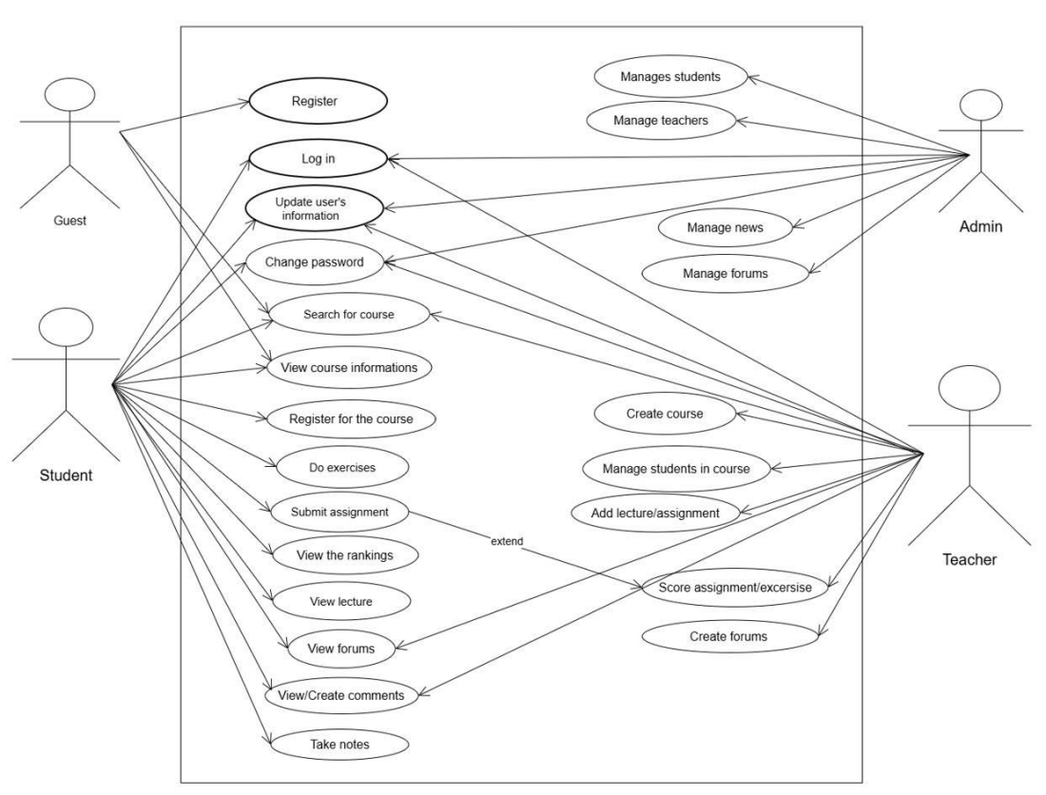

1.2 Use Case Diagram Decomposition

1.2.1 Administrator Use Case Diagram
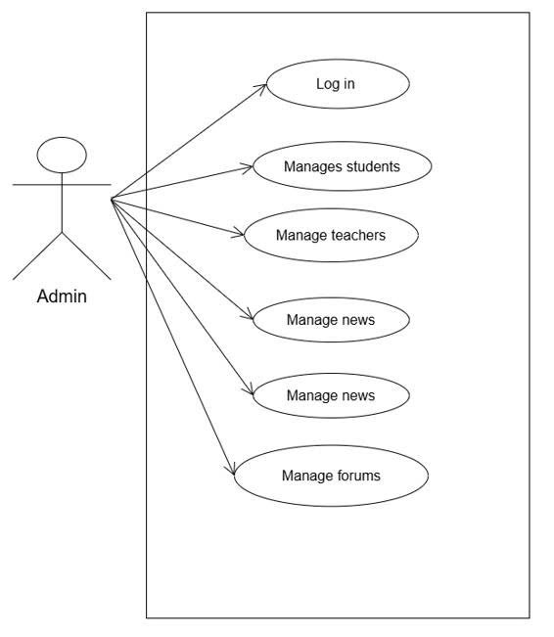

1.2.2 Guest Use Case Diagram
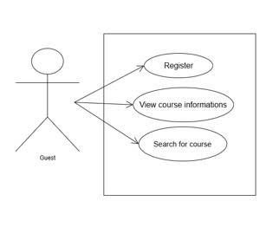

1.2.3 Student Use Case Diagram
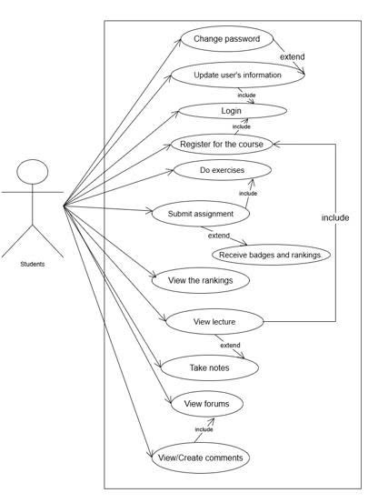

1.2.4 Lecturer Use Case Diagram

1.3 Functional Groups

1.3.1 General System Functions

a. Registration
Name | FR-01: Register an Account
Description | Users create a new account on the system by providing the required information.
Actor | User
Triggering Event | Click the “Register” button..
Preconditions | The user does not have an account and is currently on the registration page
Postconditions | - If the registration is successful: A new account is created in the system and the user can log in using that account.  - If it fails: The account is not created and the system displays an appropriate error message.
Main Flow | 1.The user accesses the registration page.  2.The system displays the registration form** (name, email/username, password, confirm password).  3.The user enters the required information:** name, email/username, password, confirm password.  4.The user clicks the “Register” button.  5.The system validates:  - Fields must not be left empty.  - Email/username must be in the correct format.  - The password must meet security requirements (minimum length, special characters, uppercase and lowercase letters, etc.).  6.The system checks whether the email/username already exists in the database.  7.If valid, the system encrypts the password and stores the user information in the database.  8.The system displays the message “Registration successful” and redirects the user to the homepage.
Alternative Flow | 5a. If the entered data is invalid, the system displays specific error messages for each field and asks the user to re-enter the information.  6a. If the email/username already exists, the system displays a duplicate account message and asks the user to choose different information.
Exception | 1. Database connection error..  2. System error during the account creation process.
Exception Handling | The system does not create the account, logs the error, and displays the message:“The system is experiencing an issue. Please try again later.”.
Priority | High

b. Login
Name | FR-02: Login
Description | Allows users to log in to the system using their email/username and password. The system authenticates the information, checks the account status, and creates a login session.
Actor | User
Triggering Event | Click the “Login” button.
Preconditions | The user already has an account and is on the login page.
Postconditions | If successful: The user is redirected to the main page of the system.  If unsuccessful: An error message is displayed and the user remains on the login page
Main Flow | 1. The user opens the login page.  2. The system displays the login form.  3. The user enters the email/username and password.  4. The user clicks the **“Login”** button.  5. The system validates the entered data.  6. The system checks whether the account exists.  7. The system compares the encrypted password.  8. The system creates a login session and grants the user access to the system.
Alternative Flow | 5a. If the data is empty or incorrectly formatted, the system asks the user to re-enter the information.  6a. If the account does not exist, the system displays an error message.  7a. If the password is incorrect, the system displays an error message.
Exception | 1. The account is locked or disabled.  2. System error while querying the database.
Exception Handling | If the account is locked: display a notification and deny login.  If a system error occurs: display the message **“Unable to log in at this time. Please try again later.”** and log the error..
Priority | High

c. Change Password
Name | FR-03: Change Password
Description | Allows users to change their current password to enhance account security or when they forget their password. The system validates the information before updating the new password..
Actor | User
Triggering Event | Click the “Change Password” button on the profile page or the “Forgot Password” button on the login page
Preconditions | The user is logged in and is on the personal information page or the user is not logged in, has forgotten the password, and has verified their email..
Postconditions | If successful: The new password is updated.  If unsuccessful: The old password remains unchanged and an error message is displayed
Main Flow | Case (1): Change Password while Logged In  1. The user selects the “Change Password” function on the profile page.  2. The system navigates to the change password page or displays the change password form.  3. The user enters the current password, new password, and confirms the new password.  4. The user clicks the “Confirm” button  5. The system verifies the current password.  6. The system checks whether the new password meets security requirements.  7. The system encrypts and updates the new password in the database.  8. The system displays a message indicating that the password has been successfully changed..  Case (2): Forgot Password / Reset Password  1.The user selects “Forgot Password” on the login page.  2. The system displays a form to enter the user’s email for verification.  3. The user enters the registered email address.  4. The system sends a verification link or code to the user’s email.  5. The user accesses the link or enters the verification code.  6. The system verifies the information and displays the password reset form.  7. The user enters the new password and confirms the new password.  8. The system checks whether the new password meets security requirements.  9. The system encrypts and updates the new password in the database.  10. The system displays a message indicating that the password has been successfully reset.
Alternative Flow | Case (1):  5a. If the current password is incorrect, the system displays an error message and asks the user to re-enter it.  6a. If the new password does not meet security requirements, the system displays guidance for correction.  Case (2):  3a. If the email does not exist in the system, the system displays an error message.  5a. If the verification link or code is invalid or expired, the system asks the user to repeat the process.
Exception | 1. System error while updating the password in the database.  2. The login session or verification session expires during the process.
Exception Handling | The system does not update the password, logs the error, and displays the message:  “Unable to update the password at this time. Please try again later..  If the session has expired, the system requires the user to log in again or repeat the verification process..
Priority | High

d. Tìm kiếm khóa học
Name | FR-04: Course Search
Actor | User
Description | The user enters the course name or course code to search for a course
Triggering Event | Click the “Search Course” button and enter the course name or course code
Preconditions | The system is operating normally and has an internet connection
Postconditions | The system displays a list of courses or a message indicating that no results were found
Main Flow | - The user accesses the course search bar  - The user enters the course name or course code  - The system suggests related keywords while the user is typing  - The user presses the Enter key or clicks the search icon  - The system returns a list of courses  - The user views the list of results
Alternative Flow | 3a. The system does not find any matching results  3b. The user returns to step 2
Exception | - No Results Found  - The system displays the message “No matching results found.”  - The system suggests other popular courses  - Invalid Keyword  2.1 The user enters only special characters or leaves the field blank but still clicks search.  2.2 The system displays a warning asking the user to re-enter the keyword
Priority | High (P1)

1.3.2 Functions for Students

a. Update Information
Name | FR-05: Update Information
Description | Allows users to update their personal information
Triggering Event | The student clicks the “Save” button after editing profile information
Preconditions | The student is logged into the system and is on the “Profile” page
Postconditions | The student’s profile information is successfully updated or an error message is displayed
Main Flow | 1. The student opens the profile page  2. The student edits the allowed information fields  3. The student clicks the “Save” button  4. The system validates the input data  5. The system updates the student’s profile  6. The system displays a success message
Alternative Flow | 4a. The system notifies which fields contain invalid information  4b. The user returns to step 2
Exception | 1. Invalid input data  2. One or more fields are empty or incorrectly formatted
Exception Handling | The system displays an error message and requests the student to correct the information
Priority | High

b. Course Registration
Name | FR-06: Course Registration
Description | Students search for and register for desired courses in the E-Learning system.
Triggering Event | Click the “Register Course” button and enter the course password
Preconditions | The user has an account in the system, The course is valid in the current semester.
Postconditions | A new registration record is created in the database
Main Flow | 1. The user searches for the list of courses  2. The system returns the list of courses  3. The user selects the desired course  4. The system displays general and detailed information about the course  5. The user clicks “Register”  6. The system requests the course password  7. The user enters the password  8. The system verifies the password  9. The system displays a success notification
Alternative Flow | 4.a The student selects “View Details” to see course information  4.b The system displays detailed course information  8.a The system detects an incorrect password  8.b The student returns to step 7
Exception | 1. System overload (e.g., 1000 students registering simultaneously)  1.1 Apply request rate limiting for each registration attempt
Priority | High

c. Learning and Completing Assignments
Name | FR-07: Learning and Completing Assignments
Description | Allows students to view lecture content and complete assignments for registered courses.
Triggering Event | The student scrolls using the mouse wheel, navigation buttons, or scrollbar to view learning materials and clicks the “Do Assignment” button to practice.
Preconditions | The student is logged in and is on the course lecture page.
Postconditions | The system displays the course content and assignments. After completion, the student can view the assignment scores.
Main Flow | 1. The user accesses the search bar  2. The user enters the course name or course code  3. The system suggests relevant courses  4. The user presses Enter or clicks the search icon  5. The system returns a list of courses
Alternative Flow | 3.1 The system does not find matching results  3.2 The user returns to step 2
Exception | 1. No results found  2. Invalid keyword
Priority | High

d. Tracking Results
Name | FR-08: Tracking Results
Description | Allows students to submit completed assignments, track submission status, and view scores and feedback after grading.
Triggering Event | Click the “Submit Assignment” button or select “View Score” on the assignment page.
Preconditions | The student is logged in.  The student has completed the assignment.  The assignment is within the submission deadline.
Postconditions | If successful: The assignment is recorded as submitted, and the student can view the score after grading.  If unsuccessful: The assignment is not submitted, and an error message is displayed.
Main Flow | 1.The student opens the completed assignment detail page.  2.The student clicks the “Submit Assignment” button.  3.The system checks the submission deadline.  4.The system records the submission time.  5.The system saves the submission and updates the status to “Submitted”.  6.After grading, the system updates the score and feedback.  7.The student revisits the assignment to view the score and feedback.
Alternative Flow | 3a. If the deadline has passed, the system displays a message and requests confirmation for late submission (if allowed).  5a. If the connection is interrupted during submission, the system asks the student to retry.  7a. If the assignment has not been graded, the system displays the status “Pending Grading”.
Exception | - The student submits after the allowed deadline.  - System error while saving the submission.  - The student attempts to resubmit when not permitted.
Exception Handling | - If late submission is not allowed: the system rejects the submission and displays “Submission deadline has passed”.  - If a system error occurs: the system displays “Unable to submit at this time. Please try again later.” and logs the error.  - If resubmission is not allowed: the system rejects the action and displays an appropriate message.
Priority | High

e. Interaction
Name | FR-09: Interaction
Actor | Student, Lecturer
Description | Users can create new posts (questions/discussions), reply to existing posts, or respond to other users’ comments.
Triggering Event | The user clicks “Forum” in a course and clicks “Post” to submit content.
Preconditions | The user is logged into the system.
Postconditions | The interaction content is stored, publicly displayed, and notifications are sent to relevant users.
Main Flow | 1. The user accesses the “Forum” section of a specific course.  2. The system displays a list of topics.  3. The user selects “Ask a Question” or opens an existing discussion.  3.1 If creating a new post, the user enters the title and content.  3.2 If replying/commenting, the user clicks “Reply” and enters content in the reply box under each post.  4. The user clicks the “Post” button.  5. The system validates and stores the content in the database.  6. The system displays the content and a success message.
Alternative Flow | 3.2.a. The user replies directly to another user’s comment.  3.2.b. The system displays an input field.  3.2.c. Continue to step 5.
Exception | 1. Title or content is empty.  1.1 Display a message requesting complete input.  2. Attachment exceeds allowed size.  2.1 Reject the upload and display a warning.  3. The user does not have permission to create a topic.  3.1 Display an access error and prevent topic creation.
Priority | Medium (P2)

f. Create Notes
Name | FR-10: Create Notes
Description | Students can highlight a text segment and click “Create Note” to highlight and add notes.
Triggering Event | Click the “Create Note” icon after selecting text.
Preconditions | The student is logged in and viewing lesson content in text format.
Postconditions | A new note is saved in the system, and a note icon is created
Main Flow | - The student highlights a text segment.  - The system displays a small toolbar above the selected text with options like “Highlight” and “Add Note”.  - The student clicks “Add Note”.  - The system opens a small input box below the text.  - The student enters note content.  - The student clicks “Save”.  - The system stores:  7.1 The highlighted text.  7.2 The note content.  7.3 The position of the highlighted text  - The system creates a small icon at the marked location.
Alternative Flow | 2.a The user only highlights content without adding a note.  2.b The system saves the highlighted area without content.
Exception | - The text is not in a supported format  1.1 The text is within an image (cannot be highlighted).
Priority | Medium (P2)

g. View Leaderboard
Name | FR-11: View Leaderboard
Actor | Student, Lecturer, Administrator.
Description | The system compiles and displays a list of top-performing students based on criteria such as scores and completion time.
Preconditions | The system has data on learning progress and student scores
Postconditions | Displays the current user’s ranking and the leaderboard.
Main Flow | 1. The student selects the “Leaderboard” section from the main menu or within a course.  2. The system displays the default leaderboard for the current month.  3. The system performs:  - Retrieve total accumulated points (XP/Points) of all students.  - Sort in descending order.  - Identify the current user’s ranking.  4. The system displays the Top 10 users with names and total points.  5. The system shows a separate row indicating the current user’s rank
Alternative Flow
Exception | 1. No ranking data available:  1.1 If the system or course is new with no participants.  1.2 The system displays: “No ranking data available.”
Priority | Low (P3)

1.3.3 Functional Group for Lecturers

1.3.3 Functional Group for Administrators

2. External Interface Requirements

2.1 User Interface
a. Configuration Characteristics
The system must establish the necessary interface characteristics to fulfill the software requirements:
- Screen format: The interface must be designed using Responsive Web Design, allowing the layout to automatically adapt to different screen sizes such as desktops, laptops, and mobile devices.
- Page/Window layout: Functional areas such as the Navigation Bar, course list, and lecture content display area must be consistently arranged across all pages.
- Menus and reports: The system must provide intuitive functional menus for each user role (e.g., lecturers see grade management menus, students see assignment submission menus) and clearly formatted academic performance reports.
b. Interaction Optimization
To ensure the best user experience for users in the Faculty of Information Technology, the interface must follow these principles:
- Design language: Use standard and intuitive interface components to minimize the time required for users to become familiar with the system.
- Error messages: The system must provide concise error messages for general users or detailed error descriptions (including technical codes) for administrators or IT students when debugging is required.
- Function keys: Support shortcut keys or programmable function keys to increase operation efficiency for advanced users.
c. Verification and Validation
Similar to all other requirements in the SRS, the user interface descriptions must ensure:
- Verifiability: All interface requirements (such as font size, colors aligned with the faculty’s branding, or page loading time) must be clearly specified so they can be measured and verified by testers.
- Usage guidelines: The system may include lists of do’s and don’ts describing how the system should appear to users in order to ensure interface consistency.

2.2 Hardware Interface
The E-Learning system is a web-based software system and does not require specialized hardware devices. Users can access the system using common devices such as personal computers, laptops, tablets, or smartphones.
Minimum hardware requirements include:
- Devices capable of connecting to the Internet.
- A modern web browser
- For lecturers uploading materials or video lectures, the device must support basic functions such as file uploading and multimedia playback.
The system does not depend on any specific hardware architecture and does not require the installation of special peripheral devices.

2.3 Software Interface
The E-Learning system interacts with multiple software components to ensure stable and efficient operation. The main software interfaces include:
a. Web Browser Interface
The system must support access through common web browsers such as Google Chrome, Mozilla Firefox, and Microsoft Edge. The user interface is implemented as a web application, allowing students and lecturers to access the system without installing additional software.
b. Database System Interface
The system must communicate with the database to store and manage information related to users, courses, assignments, submissions, and grades. Database access is performed through standard Spring Boot frameworks, such as: Spring Data JPA, JDBC. All database operations must comply with data security and integrity rules.
c. Interface Between Internal System Components
Since the system is built using MVC architecture and follows a microservices-oriented approach, functional modules must communicate via standard RESTful APIs. Requests and responses between system components are transmitted in JSON format.
d. Authentication and Security Interface
The system must integrate with Spring Boot security libraries (e.g., Spring Security) to implement: User authentication, Role-based authorization, Session management. This software interface ensures that only authorized users can access corresponding system functions.
e. File Upload and Storage Interface
The system must provide a software interface that allows students to upload assignments as files. Uploaded files are stored on the server or a configured storage system and must be managed through the application’s APIs.
f. System Notification Interface
The system must provide software interfaces for sending and displaying notifications such as: Grading results, Submission status, Announcements from lecturers. These notifications are handled through internal services within the application.

2.4 Communication Interface
a. Network and Communication Protocols
This section specifies the protocols used for communication between the server and clients:
- Web Protocol: The system must support HTTP/HTTPS to ensure secure data transmission between the student’s browser and the faculty’s server.
- Data Transmission: TCP/IP must be used as the foundation for all network connections within the faculty’s LAN or via the Internet.
b. Communication Technical Requirements
To ensure system stability, the system must comply with the following standards:
- Data synchronization: Interfaces must support signal handshake protocols (e.g., ACK–NACK) to ensure that exam submissions or documents are not lost during transmission.
- Network standards: The system must be compatible with existing local network protocols within the Faculty of Information Technology to optimize on-campus access speed.
c, Communication Security and Control
To protect educational resources, the communication interface must support:
- Access restrictions: The system must be able to restrict communication between certain areas of the application (e.g., the grade management area may only be accessible from the internal network).
- Encryption: Standard cryptographic techniques must be used to protect data transmitted through public communication channels.
d, Verifiability
Communication interface requirements must be presented in a measurable and testable form.

3. Performance Requirements
The E-Learning system must satisfy the following performance requirements:
a. Response Time
Response time for basic functions such as login, viewing course lists, viewing lectures, and viewing assignments must not exceed 3 seconds under normal load conditions. Processing time for heavier operations such as assignment submission, document uploading, or comment submission must not exceed 5 seconds.
b. Concurrent Users
The system must support at least 100 concurrent users without significant performance degradation. When the number of users increases, the system must still ensure that core functions such as login, viewing lectures, and assignment submission operate reliably.
c. System Throughput
The system must be capable of processing at least 50 requests per second for data retrieval operations such as: Viewing courses, Viewing lectures, Viewing leaderboards. For data-writing operations (course registration, assignment submission, comments), the system must operate stably under normal system load conditions.
d, Availability
The system must achieve at least 99% availability during working hours and peak learning periods. Any service interruptions for maintenance or upgrades must be announced in advance to users.
e, Scalability
The system must be designed to scale when the number of users and courses increases, for example by: Upgrading server resources, Deploying the system across multiple servers. Scaling operations must not cause significant disruption to system operations..
f, Resource Utilization
The system must efficiently utilize CPU, memory, and network bandwidth to ensure a smooth user experience. Resource-intensive tasks such as video streaming or assignment uploads must be optimized so that they do not significantly affect other system functions.
- Data Design
4.1Entity Relationship Diagram (ERD)
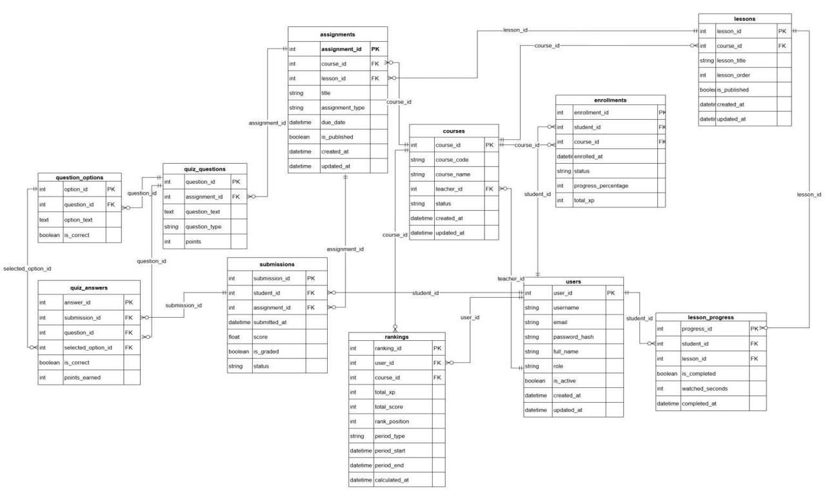
IT-e learning system ERD

5. Design Constraints

5.1 Standards Compliance
The system must comply with established software development standards and best practices. The development process should follow widely accepted standards such as IEEE standards for Software Requirements Specification (SRS) and RESTful API design principles. The system architecture must adhere to the MVC (Model–View–Controller) pattern, ensuring clear separation between presentation, business logic, and data access layers. Security standards and best practices, including those provided by Spring Security, must be followed to ensure proper authentication, authorization, and secure data handling.

5.2 Hardware Limitations
The E-Learning system must operate on standard computing infrastructure without requiring specialized hardware. The server infrastructure should be capable of supporting the backend services built with Java Spring Boot and the relational database system. Client devices used by students, lecturers, and administrators may include desktop computers, laptops, tablets, or smartphones, provided that they support modern web browsers and internet connectivity.

6. Attributes

6.1 Usability
The system must be designed to provide an intuitive and user-friendly experience for all user groups, including students, lecturers, and administrators. The interface should follow consistent design principles and minimize the learning curve for users. Navigation must be clear, and essential actions such as accessing courses, submitting assignments, and viewing grades should be easily accessible. The system should support responsive design to ensure usability across multiple devices, including desktop computers and mobile devices.

6.2 Security
Purpose: To ensure secure external communication and integrations, protect personally identifiable information (PII), prevent common attacks, and record critical system activities.
Key Requirements
- Secure Communication: HTTPS/TLS (version ≥1.2) is mandatory; HTTP connections are not accepted.
- Authentication and Authorization: SSO/JWT must be used as the authentication source. Tokens must have expiration and refresh mechanisms. RBAC must verify roles or claims for every API request.
- Secret Management: Secrets must not be hard-coded. They must be managed using vault services or environment variables.
- Data Protection: Sensitive data must be encrypted according to security policies both in transit and at rest.
- Validation and Sanitization: Server-side validation and escaping must be implemented to prevent XSS and SQL injection attacks.
- Audit and Logging: Logs must include timestamp, actor, action, IP address, and request_id, and must be stored according to policy (for example, ≥ 3 years).
- Rate Limiting: Requests must be limited per IP address or user, with CAPTCHA mechanisms applied when necessary to prevent brute-force attacks.
- Third-Party Integration Security: Integrations with SSO, Email, or Storage services must use OAuth2, mTLS, API keys, and TLS encryption.
Acceptance Criteria
- All endpoints must redirect to or enforce HTTPS, and TLS scanning must pass security checks.
- APIs must return 401 (Unauthorized) when tokens are missing and 403 (Forbidden) when permissions are insufficient.
- The code repository must not contain secrets; secrets must be injected during runtime.
- Test cases with malicious script payloads must return escaped output.
- When overload is simulated, the system must return HTTP 429 (Too Many Requests).
- The email verification flow must continue functioning even when external services fail (graceful degradation).

6.3 Maintainability
Purpose: To ensure interfaces remain understandable, testable, versionable, and maintainable throughout the system lifecycle, aligned with the 12-week development period and future maintenance.
Key Requirements:
- API Specification: All APIs must be documented using OpenAPI/Swagger.
- Versioning and Backward Compatibility: APIs must use versioning such as /api/v1/ or version headers, maintaining backward compatibility for at least one release cycle.
- Automated Testing and CI: Unit tests, integration tests, and contract tests must run in the CI pipeline. The build must fail if tests fail.
- Logging and Observability: Use structured logs, correlation IDs, and monitoring metrics with dashboards (e.g., Prometheus and Grafana).
- Dependency Management: Dependencies must be managed using Maven, Gradle, or npm, with controlled updates.
- Documentation and Runbooks: Documentation must include README files and runbooks for deployment, rollback, and incident handling.
- Modular Contracts: Use adapter or facade patterns to isolate integration points.
Acceptance Criteria
- An OpenAPI specification file must exist and match system behavior.
- The CI pipeline must fail when tests do not pass.
- Monitoring dashboards must display latency and error metrics for major endpoints.
- Runbooks must exist for critical incidents.
- Changing external providers should only require modifying adapters, not business logic.

6.4 Portability
Purpose: To ensure the application can be deployed or migrated across different environments (OS, database, or cloud platforms) with acceptable effort.
Key Requirements:
- Portable Technologies: Backend implemented using Java (Spring Boot) and frontend using React, with Docker containerization.
- Host Dependency Isolation: Host-specific code must be isolated in configuration or adapter layers.
- Database Portability: Use standard SQL when possible and maintain migration scripts using Flyway or Liquibase. Support ETL/export/import in CSV or JSON formats.
- Data Exchange Standards: Data exports must include metadata such as schema version and timestamp.
- Platform Support: Primary deployment platform is Linux x86_64, with Docker enabling deployment on Windows if necessary.
- API Versioning and Compatibility: Use semantic versioning, and deprecated endpoints must remain available for one release cycle.
- Migration and Rollback Plans: Migration procedures must include backup, validation tests, rollback steps, and defined RPO/RTO targets.
Acceptance Criteria
- The project must include Dockerfile and docker-compose or Kubernetes manifest examples.
- Migration from development to staging must succeed in a dry-run.
- Sample exported data must validate against defined schemas and allow successful import.
Deployment guides must support installation on a clean Linux host using Docker. A rollback plan must exist and be testable in a dry-run scenario.

7. Other Requirements

7.1 Operations
The E-Learning system is designed to operate within the training environment of the Faculty of Information Technology under multiple operational modes. The system must support concurrent access by multiple users—including students, lecturers, and administrators—without significantly affecting overall performance.
The system must operate continuously during learning periods, allowing users to perform tasks such as accessing courses, completing assignments, submitting work, and viewing grades at any time. Critical operations such as user authentication, assignment storage, and grade updates must be executed reliably and accurately. All user activities involving important data must be recorded in system audit logs for monitoring and auditing purposes.
System maintenance includes periodic data backups, software updates, and server health monitoring. Maintenance operations should be performed without causing significant disruption to learning activities. In the event of system errors or failures, the system must provide recovery mechanisms and notify administrators so that issues can be resolved promptly.

7.2 Adaptability
The E-Learning system must be capable of flexible deployment within the existing IT infrastructure of the Faculty of Information Technology. Since the application is developed using Java and Spring Boot, it can be deployed on servers running common operating systems such as Windows or Linux without requiring changes to the source code.
The system must allow configuration of environment parameters—such as server addresses, database connections, network ports, and security settings—through configuration files without modifying the application code. Deployment may be performed either as a standalone application or within a containerized environment, depending on the infrastructure conditions of the organization.
Additionally, the system must be adaptable to different usage requirements, including variations in number of users, course sizes, and grading methods. User interfaces must support Vietnamese language and allow customization to align with the university’s academic regulations and procedures without affecting the overall system architecture.

Appendixes A
Members | Functional Requirements
Trịnh Văn Nam | Course Registration, Course Search
Chu Minh Hiếu | Learning and Completing Assignments, Tracking Results
Kiều Minh Tiến | Update Information, Interaction
Trần Thị Minh Nguyệt | Registration, Login, Change Password
Nguyễn Xuân Phú | Notes, Leaderboard

