

***Front-end React***

**Training Assignment**

|  |  |
| --- | --- |
| Document Code | 25e-BM/HR/HDCV/FSOFT |
| Version | 1.1 |
| Effective Date | 20/11/2012 |

**Hanoi, mm/yyyy**

RECORD OF CHANGES

|  |  |  |  |  |  |
| --- | --- | --- | --- | --- | --- |
| No | Effective Date | Change Description | Reason | Reviewer | Approver |
|  |  |  |  |  |  |
|  |  |  |  |  |  |
|  |  |  |  |  |  |
|  |  |  |  |  |  |
|  |  |  |  |  |  |
|  |  |  |  |  |  |
|  |  |  |  |  |  |
|  |  |  |  |  |  |
|  |  |  |  |  |  |
|  |  |  |  |  |  |

Contents

Day 1. Unit 2: Todo App 4

Objectives: 4

Requirements: 4

Functionalities: 5

Technical Requirements: 5

|  |  |
| --- | --- |
|  | **CODE: FEFW_React.M.A0201**  **TYPE: Medium**  **LOC: 100**  **DURATION: 120** |

# Day 1. Unit 2: Todo App

Objectives:

* Understand Overview Architecture of React
* Understand standard React project
* Understand React Props and State
* Able to add class to HTML/React element
* Able to add and implement React Bootstrap
* Form Validation and Handling Form Data in React

Requirements:

Your task is to implement a web app like figure below:

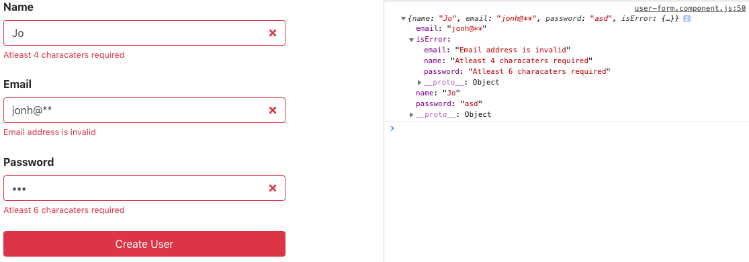

Functionalities:

The app must fulfill below functionalities:

* User can type into an input text: name, email, and password.
* When user press Create User:
  + Validate Name, Email and Passworld
  + Display an error message below the corresponding input's element if any

Technical Requirements:

* Must use React.