**ASSIGNMENT 1 FRONT SHEET**

|  |  |  |  |
| --- | --- | --- | --- |
| **Qualification** | **BTEC Level 5 HND Diploma in Computing** | | |
| **Unit number and title** | Unit 2: Networking Infrastructure | | |
| **Submission date** |  | **Date Received 1st submission** |  |
| **Re-submission Date** |  | **Date Received 2nd submission** |  |
| **Student Name** | Nguyen Anh Trinh | **Student ID** | GCC210105 |
| **Class** | GCC1001 | **Assessor name** |  |
| **Student declaration**  I certify that the assignment submission is entirely my own work and I fully understand the consequences of plagiarism. I understand that making a false declaration is a form of malpractice. | | | |
|  |  | **Student’s signature** |  |

**Grading grid**

|  |  |  |  |  |  |  |
| --- | --- | --- | --- | --- | --- | --- |
| P1 | P2 | P3 | P4 | M1 | M2 | D1 |
|  |  |  |  |  |  |  |

|  |  |  |
| --- | --- | --- |
| **❒ Summative Feedback: ❒ Resubmission Feedback:** | | |
| **Grade:** | **Assessor Signature:** | **Date:** |
| **Lecturer Signature:** | | |

# Assignment Brief 1 (RQF)

## Higher National Certificate/Diploma in Computing

|  |  |
| --- | --- |
| **Student Name/ID Number:** |  |
| **Unit Number and Title:** | **Unit 2: Networking** |
| **Academic Year:** | **2021 – 2022** |
| **Unit Assessor:** | **Van Ho** |
| **Assignment Title:** | **Networking Infrastructure** |
| **Issue Date:** | **April 1st, 2021** |
| **Submission Date:** |  |
| **Internal Verifier Name:** |  |
| **Date:** |  |

|  |
| --- |
| **Submission Format:** |
| *Format:*   * The submission is in the form of an individual written report. This should be written in a concise, formal business style using single spacing and font size 12. You are required to make use of headings, paragraphs and subsections as appropriate, and all work must be supported with research and referenced using the Harvard referencing system. Please also provide a bibliography using the Harvard referencing system.   *Submission*   * Students are compulsory to submit the assignment in due date and in a way requested by the Tutor. * The form of submission will be a soft copy posted on <http://cms.greenwich.edu.vn/>. * Remember to convert the word file into PDF file before the submission on CMS.   *Note:*   * The individual Assignment *must* be your own work, and not copied by or from another student. * If you use ideas, quotes or data (such as diagrams) from books, journals or other sources, you must reference your sources, using the Harvard style. * Make sure that you understand and follow the guidelines to avoid plagiarism. Failure to comply this requirement will result in a failed assignment. |
| **Unit Learning Outcomes:** |
| **LO1** Examine networking principles and their protocols.  **LO2** Explain networking devices and operations. |
| **Assignment Brief and Guidance:** |
| **Assignment scenario**  You are employed as a network engineer by Nguyen Networking Limited, a high-tech networking solution development company, which has branches in Ho Chi Minh City, Hanoi, Da Nang and Can Tho. The company has been contracted to implement a networking project from a local educational institute. The specification of the project is given below:   * People: 200 students, 15 teachers, 12 marketing and administration staff, 5 higher managers including the academic heads and the programme managers, and 3 computer network administrators. * Resources: 50 student lab computers, 35 staff computers, and 3 printers. * Building: 3 floors, all computers and printers are on the ground floor apart from the IT labs – one lab located on the first floor and another located on the second floor.   **Task 1**  The CEO of the company, Mr. Nguyen, has asked you to investigate and explain networking principles, protocols and devices and submit a report.  You will need to produce a report that includes the following:   * An introduction to provide an overview of your report. * Benefits and constraints of different types of networks and networking standards. * The impact of network topology, speed of communication and bandwidth requirements. * Effectiveness of networking systems. * Discussion on operating principles of networking devices and server types and networking software. * Discuss the relationship of workstation hardware with networking software. * Explore a range of server types and justify the selection of a server, considering a given scenario regarding cost and performance optimization. * For the given specification, identify the topology protocol for the efficient utilization of a networking system. |

|  |  |  |  |
| --- | --- | --- | --- |
| **Learning Outcomes and Assessment Criteria (Assignment 1):** | | | |
| Learning Outcome | Pass | Merit | Distinction |
| **LO1** | **P1** Discuss the benefits and constraints of different network types and standards.  **P2** Explain the impact of network topology, communication and bandwidth requirements. | **M1** Compare common networking principles and how protocols enable the effectiveness of networked systems. | **D1** Considering a given scenario, identify the topology protocol selected for the efficient utilization of a networking system. |
| **LO2** | **P3** Discuss the operating principles of networking devices and server types.  **P4** Discuss the inter-dependence of workstation hardware with relevant networking software. | **M2** Explore a range of server types and justify the selection of a server, considering a given scenario regarding cost and performance optimisation. |

|  |  |  |  |
| --- | --- | --- | --- |
| **Learning Outcomes and Assessment Criteria (Assignment 1):** | | | |
| Learning Outcome | Pass | Merit | Distinction |
| **LO1** | **P1** Discuss the benefits and constraints of different network types and standards.  **P2** Explain the impact of network topology, communication and bandwidth requirements. | **M1** Compare common networking principles and how protocols enable the effectiveness of networked systems. | **D1** Considering a given scenario, identify the topology protocol selected for the efficient utilization of a networking system. |
| **LO2** | **P3** Discuss the operating principles of networking devices and server types.  **P4** Discuss the inter-dependence of workstation hardware with relevant networking software. | **M2** Explore a range of server types and justify the selection of a server, considering a given scenario regarding cost and performance optimisation. |

Table of Contents

Assignment Brief 1 (RQF) 2

Higher National Certificate/Diploma in Computing 2

I. Discuss the benefits and constraints of different network types and standards (P1): 8

1. What is a network: 8

2. Types of networks: 8

3. Network protocol 14

II. Explain the impact of network topology, communication and bandwidth requirements (P2) 17

1. Network topology 17

2. Physical topology 17

3. Logical topology 17

4. Difference between physical topology and logical topology: 18

5. Communication and bandwidth requirements 26

6. Define what network communication 27

7. Explain the rules in the network and why these rules are needed 27

8. Why bandwidth requiredment is needed 29

III. Discuss the operating principles of networking devices and server types 29

1. How dose router work 29

2. How does switch work 30

3. Some common network device: 31

4. some common types of servers 35

IV. Discuss the inter-dependence of workstation hardware with relevant networking software 38

1. Interdependence 38

2. Network hardware 39

3. Network software 39

4. The relationship between hardware and network software 39

References 40

# Discuss the benefits and constraints of different network types and standards (P1):

## What is a network:

A network is a collection of computers, servers, mainframes, network devices, peripherals, or other devices connected to allow data sharing.

(computerhope.com)

## Types of networks:

Local Area Network (LAN): A LAN is a proprietary computer network that enables designated users to have exclusive access to the same system connection at a common location, always within an area of less than a mile and most often within the same building. By doing so they’re able to share devices, share resources such as printers, and exchange information as if they were all working from the same system. Resource sharing is possible with a network-aware operating system.

* **Advantages of local area network (LAN)**

-Sharing of resources: All the resources are attached to one network and if any computer needs any resources then it can be shared with the required computer. Types of resources are the DVD drive, printers, scanners, modems and hard drives. So there is no need to purchase separate resources for each computer and it saves money.

-Client and server relationship: All the data from attached computers can be stored in one server. If any computer (Client) needs data then that computer user can simply log in and access the data from the server. For example movies and songs can be stored on the server and can be accessed by any authorized user (Client computer).

-Sharing of the internet: In offices and net cafes, we can see that one internet connection is shared between all computers. This is also the type of LAN technology in which main internet cable is attached to one server and distributed amoung attached computers by the operating system.

-Software program sharing: Software programs can also be shared on the LAN. You can use single licensed software and any user can use it in the network. It is expensive to buy a license for each user in the network so sharing software program is easy and cost-effective.

-Securing of data: Keeping data on the server is more secure. And if you want to change or remove any data you can do it easily on one server computer and other computers can access updated data. You can also give access or revoke access to specific users so that only authorized users can access the data in the network.

-Communication is easy, fast, and time-saving: In LAN computers can exchange data and messages in the easy and fast way. It also saves time and makes our work fast. Every user can share messages and data with any other user on LAN. The user can log in from any computer on the network and access the same data placed on the server.

-Computer identification: Each computer is given a MAC address and is temporarily stored in the switch or router during communication. All computers on the LAN are identified by MAC addresses which are used to send and receive messages and data. Note that MAC address is stored in the network adapter that is attached in the motherboard of each computer. In old computers, network adapters were not built in with motherboards but in modern computers, they come built-in with motherboards.

(itrelease.com)

* **Disadvantages of LAN**
* **Implementation Cost**

Even though LAN saves lots of money in terms of resource sharing, the initial cost involved in setting up the network is quite high. This is mainly due to the requirement of a special software that is needed to make a server. In addition to that purchasing of hardware equipments such as routers, hubs, switches and cables are required for the first time setup.

* **Policy Violations**

Since all the data of the connected computers are stored inside a central server, unauthorized users can view all the browsing history and downloads of all the connected computers. Especially the LAN administrator has the authority to check personal data of each and every LAN user. Therefore, this can lead to Policy violations.

* **Security**

Since it is rather easy to gain access to programs and other types of data, security concerns are a big issue in LAN. The sole responsibility to stop unauthorized access is in the hands of LAN administrators. The LAN administrator has to make sure that the centralized data is properly secured by implementing correct set of rules and privacy policies on the server.

Personal Area Network (PAN): PANs can also be connected to LAN and higher level network types where one device acts as a gateway. An everyday example of PAN is a Bluetooth keyboard that’s connected to a smart TV, where the interface allows you to surf the internet, view recorded programs, and configure personal preferences. Personal area networks can either be wireless or wired. Wireless PANs are called WPANs and use close-range connectivity protocols such as Wi-Fi, ZigBee, infrared, and Bluetooth for data-centric applications.

* **Advantages of personal area network**
* **No extra space requires:**

Personal area network does not require extra wire or space. For connecting two devices you only need to enable Bluetooth in both devices to start sharing data among them. For example, connecting wireless keyboard and mouse with the tablet through Bluetooth.

* **Connect to many devices at a time:**

Many devices can be connected to one device at the same time in a personal area network. You can connect one mobile to many other mobiles or tablets to share files.

* **Cost effective:**

No extra wires are needed in this type of network. Also, no extra data charges are involved so PAN is an inexpensive way of communication.

* **Easy to use:**

It is easy to use. No advanced setup is required.

* **Reliable:**

If you use this type of data connection within 10 meters then your network is stable and reliable.

* **Secure:**

This network is secured because all the devices are authorized before data sharing. Third party injection and data hacking are not possible in PAN.

* **Used in office, conference, and meetings:**

Infrared is the technology used in TV remotes, AC remotes, and other devices. Bluetooth, infrared and other types of PAN is used to interconnect digital devices in offices, meetings, and conferences.

* **Synchronize data between different devices:**

One person can synchronize several devices i.e. download, upload and exchanging data among devices.

* **Portable:**

A person can move devices as it is a wireless network and data exchange is not affected. That mean PAN is portable as well.

* **Disadvantages of personal area network**
* **Less distance range:**

Signal range is maximum 10 meters which makes limitation for long distance sharing.

* **Interfere with radio signals:**

As personal area network also use infrared so it can interfere with radio signals and data can be dropped.

* **Slow data transfer:**

Bluetooth and infrared have a slow data transfer rate as compared to another type of networks like LAN (local area network).

* **Health problem:**

In some cases, PAN uses microwave signals in some digital devices which have a bad effect on the human body like brain and heart problems may occur.

* **Costly in terms of communication devices:**

Personal area network is used in digital devices which are costly so it is another disadvantage of PAN. Examples are smartphones, PDA, laptops, and digital cameras.

* **Infrared signals travel in a straight line:**

TV remote use infrared signals which have a problem that they travel in straight line. So this counts another disadvantage of PAN.

Wide Area Network (WAN): WANs can be basic or hybrid with point-to-point or packet-switched networks over shared circuits. In the case of a hybrid WAN and SD-WAN, different connection types are used that can range from virtual private networks (VPNs) and multiprotocol label switching (MPLS). Communication channels within a WAN often feature a wide range of different technologies, ranging from routers, FSO links, and I/O interfaces to fiber optics.

**Advantages of WAN:**  
➨WAN covers larger geographical area. Hence business offices situated at longer distances can easily communicate.  
➨Like LAN, it allows sharing of resources and application softwares among distributed workstations or users.  
➨The software files are shared among all the users. Hence all will have access to latest files. This avoids use of previous versions by them.  
➨Organizations can form their global integrated network through WAN. Moreover it supports global markets and global businesses.  
➨The emergence of IoT (Internet of Things) and advanced wireless technologies such as LAN or LAN-Advanced have made it easy for the growth of WAN based devices. Messages can be sent very quickly across the globe with the help of applications such as whatsApp, facebook messenger etc.

Metropolitan Area Network (MAN): MANs covers an area larger than a LAN, but smaller than a WAN. They consist of different LANs interconnected with point-to-point high-capacity backbone technology and can span several buildings or a metropolis. Through shared regional resources, MANs can take the form of cable TV network, or even telephone networks that provide high-speed DSL lines.

#### ****Advantages of a metropolitan area network (MAN)****

* **Less expensive:**

It is less expensive to attach MAN with WAN. MAN gives the good efficiency of data. In MAN data is easily managed in a centralized way.

* **Sending local emails:**

On MAN you can send local emails fast and free.

* **High speed than WAN:**

MAN uses fiber optics so the speed of data can easily reach upon 1000 Mbps. Files and databases can be transferred fast.

* **Sharing of the internet:**

In some installation of MANs, users can share their internet connection. So multiple users can get the same high-speed internet.

* **Conversion from LAN to MAN is easy:**

MAN is a faster way to connect two fast LANs together. This is due to the fast configuration of links.

* **High Security:**

MAN has a high-security level than WAN.

#### ****Disadvantages of metropolitan area network (MAN)****

* **Difficult to manage:**

If MAN becomes bigger then it becomes difficult to manage it. This is due to a security problem and other extra configuration.

* **Internet speed difference:**

MAN cannot work on traditional phone copper wires. If MAN is installed on copper wires then there will be very low speed. So it required the high cost to set up fiber optics for the first time.

* **Hackers attack:**

In MAN there are high chances of attacking hackers on the network compared to LAN. So data may be leaked. Data can be secured but it needs high trained staff and security tools.

* **Technical people required to set up:**

To setup MAN it requires technical people that can correctly setup MAN. The technical people are network administrators and troubleshooters.

* **More wires required:**

In MAN additional cables are required to connect two LAN which is another problem.

## Network protocol

**a. What is network protpcal?**

A network protocol is an established set of rules that determine how data is transmitted between different devices in the same network. Essentially, it allows connected devices to communicate with each other, regardless of any differences in their internal processes, structure or design. Network protocols are the reason you can easily communicate with people all over the world, and thus play a critical role in modern digital communications. (Anon., 2022)

**b. Purpose**

In the area of networking, protocols are defined as a set of standard, pre-determined rules and regulations for computers to communicate with each other. These protocols define how a computer should establish a connection, how it should be addressed, and how it should transfer the data to the recipient. Currently, many networking protocols are used over computer networks for different purposes. Among all of them, IP (Internet protocol) is the most widely used networking protocol in today's networking scenarios. Much of today's global networking scene is based on the addressing techniques provided by IP. (Abdullah, 2022)

**c.Common protocol**

* TCP/IP

TCP/IP stands for Transmission Control Protocol/Internet Protocol and is a suite of communication protocols used to interconnect network devices on the internet. TCP/IP is also used as a communications protocol in a private computer network (an [intranet](https://www.techtarget.com/whatis/definition/intranet) or extranet).

The entire IP suite -- a set of rules and procedures -- is commonly referred to as TCP/IP. [TCP](https://www.techtarget.com/searchnetworking/definition/TCP) and [IP](https://www.techtarget.com/searchunifiedcommunications/definition/Internet-Protocol) are the two main protocols, though others are included in the suite. The TCP/IP protocol suite functions as an abstraction layer between internet applications and the routing and switching fabric.

TCP/IP specifies how data is exchanged over the internet by providing end-to-end communications that identify how it should be broken into packets, addressed, transmitted, routed and received at the destination. TCP/IP requires little central management and is designed to make networks reliable with the ability to recover automatically from the failure of any device on the network.

The two main protocols in the IP suite serve specific functions. TCP defines how applications can create channels of communication across a network. It also manages how a message is assembled into smaller packets before they are then transmitted over the internet and reassembled in the right order at the destination address.

IP defines how to address and route each packet to make sure it reaches the right destination. Each gateway computer on the network checks this IP address to determine where to forward the message.

A subnet mask tells a computer, or other network device, what portion of the IP address is used to represent the network and what part is used to represent hosts, or other computers, on the network.

Network address translation (NAT) is the virtualization of IP addresses. NAT helps improve security and decrease the number of IP addresses an organization needs.

* HTTP

The Hypertext Transfer Protocol (HTTP) is the foundation of the World Wide Web, and is used to load web pages using hypertext links. HTTP is an application layer protocol designed to transfer information between networked devices and runs on top of other layers of the network protocol stack. A typical flow over HTTP involves a client machine making a request to a server, which then sends a response message. (Anon., 2022)

* DNS

The Domain Name System (DNS) is the phonebook of the Internet. Humans access information online through domain names, like nytimes.com or espn.com. Web browsers interact through Internet Protocol (IP) addresses. DNS translates domain names to IP addresses so browsers can load Internet resources.

Each device connected to the Internet has a unique IP address which other machines use to find the device. DNS servers eliminate the need for humans to memorize IP addresses such as 192.168.1.1 (in IPv4), or more complex newer alphanumeric IP addresses such as 2400:cb00:2048:1::c629:d7a2 (in IPv6). (Anon., 2022)

# Explain the impact of network topology, communication and bandwidth requirements (P2)

## Network topology

Network topology refers to the manner in which the links and nodes of a network are arranged to relate to each other. Topologies are categorized as either physical network topology, which is the physical signal transmission medium, or logical network topology, which refers to the manner in which data travels through the network between devices, independent of physical connection of the devices. Logical network topology examples include twisted pair Ethernet, which is categorized as a logical bus topology, and token ring, which is categorized as a logical ring topology.

Physical network topology examples include star, mesh, tree, ring, point-to-point, circular, hybrid, and bus topology networks, each consisting of different configurations of nodes and links. The ideal network topology depends on each business’s size, scale, goals, and budget. A network topology diagram helps visualize the communicating devices, which are modeled as nodes, and the connections between the devices, which are modeled as links between the nodes.

(Anon., 2022)

## Physical topology

Physical topology refers to the interconnected structure of a local area network (LAN). The method employed to connect the physical devices on the network with the cables, and the type of cabling used, all constitute the physical topology. This contrasts with logical topology, which describes a network's media signal performance and how it exchanges divice data. (Anon., 2017)

## Logical topology

A logical topology is a concept in networking that defines the architecture of the communication mechanism for all nodes in a network. Using network equipment such as routers and switches, the logical topology of a network can be dynamically maintained and reconfigured.

Logical topologies contrasts with physical topologies, which refer to the physical interconnections of all devices in the network. (Anon., 2012)

## Difference between physical topology and logical topology:

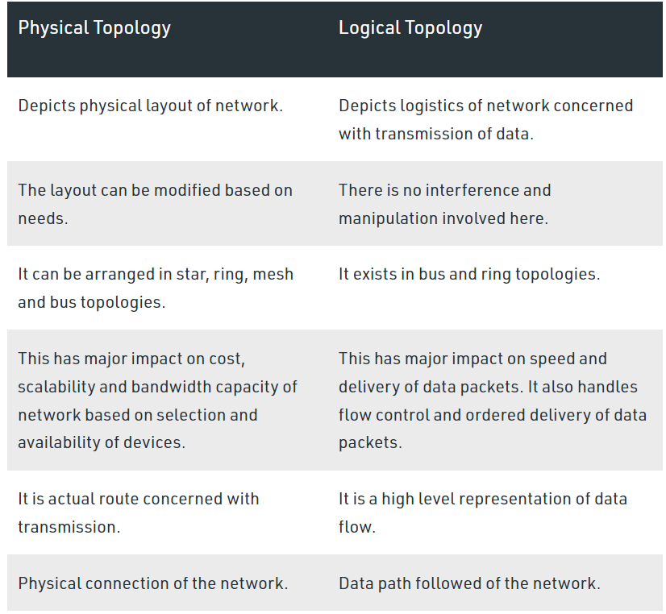

(Anon., 2020)

* **Mesh**

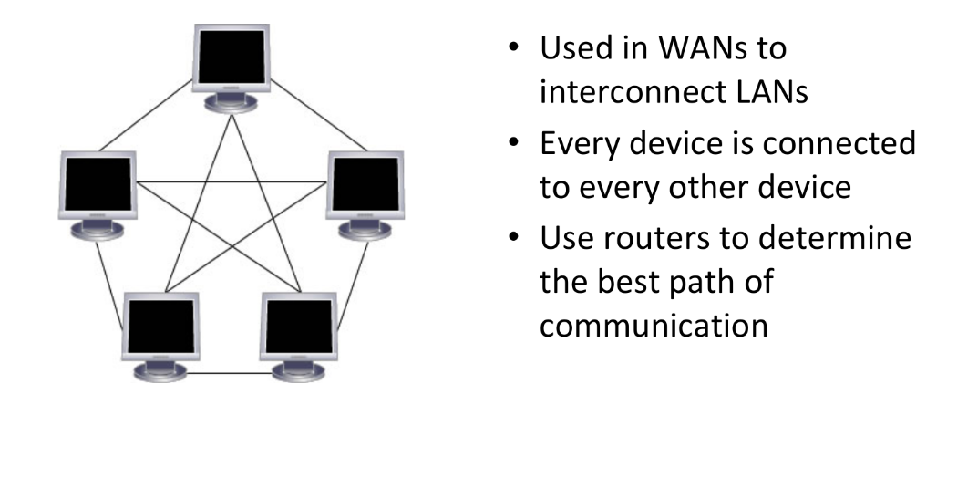

* **Advantages of a mesh topology**

Manages high amounts of traffic, because multiple devices can transmit data simultaneously.

A failure of one device does not cause a break in the network or transmission of data.

Adding additional devices does not disrupt data transmission between other devices.

* **Disadvantages of a mesh topology**

The cost to implement is higher than other network topologies, making it a less desirable option.

Building and maintaining the topology is difficult and time consuming.

The chance of redundant connections is high, which adds to the high costs and potential for reduced efficiency (Hope, 2018)

* **Star**

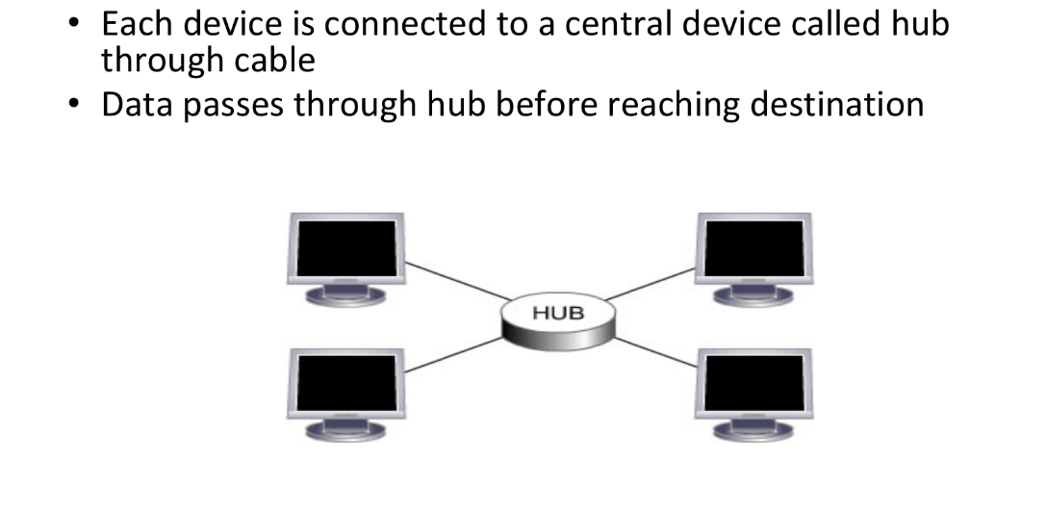

* **Advantages of star topology**

Centralized management of the network through the use of the central computer, hub, or switch.

Easy to add another computer to the network.

If one computer on the network fails, the rest of the network continues to function normally.

* **Disadvantages of star topology**

It may have a higher cost to implement, especially when using a switch or router as the central network device.

The central network device determines the performance and number of nodes the network can handle.

If the central computer, hub, or switch fails, the entire network goes down, and all computers are disconnected from the network. (computerhope, 2018)

* **Bus**

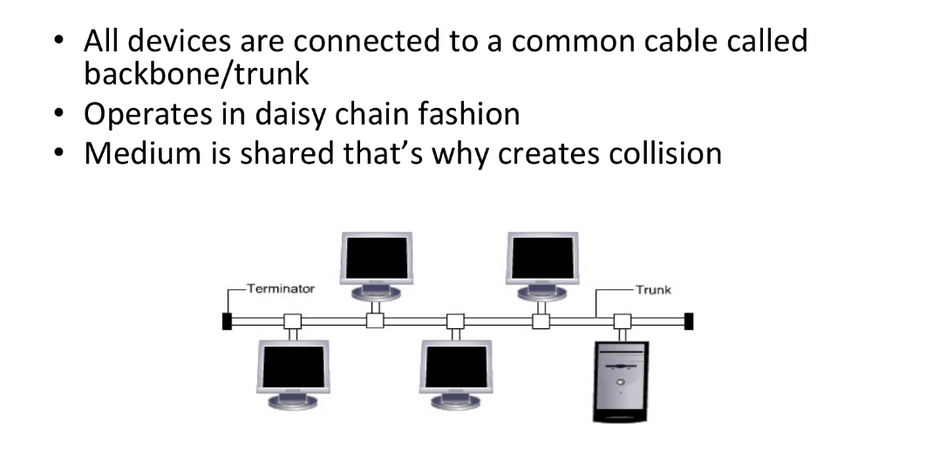

* **Advantages of bus topology**

It works well when you have a small network.

It's the easiest network topology for connecting computers or peripherals in a linear fashion.

It requires less cable length than a star topology.

* **Disadvantages of bus topology**

It can be difficult to identify the problems if the whole network goes down.

It can be hard to troubleshoot individual device issues.

Bus topology is not great for large networks.

Terminators are required for both ends of the main cable.

Additional devices slow the network down.

If a main cable is damaged, the network fails or splits into two.

* **Ring**

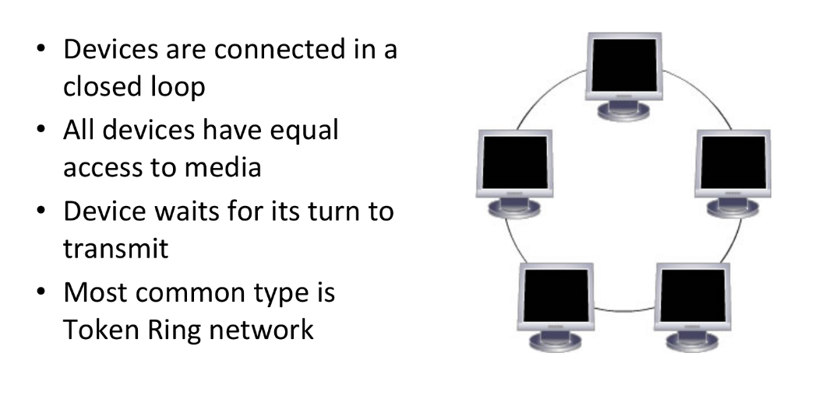

* **Advantages of a ring topology**

All data flows in one direction, reducing the chance of packet collisions.

A network server is not needed to control network connectivity between each workstation.

Data can transfer between workstations at high speeds.

Additional workstations can be added without impacting performance of the network.

* **Disadvantages of a ring topology**

All data being transferred over the network must pass through each workstation on the network, which can make it slower than a star topology.

The entire network will be impacted if one workstation shuts down.

The hardware needed to connect each workstation to the network is more expensive than Ethernet cards and hubs/switches (computerhope, 2018)

* **Tree**

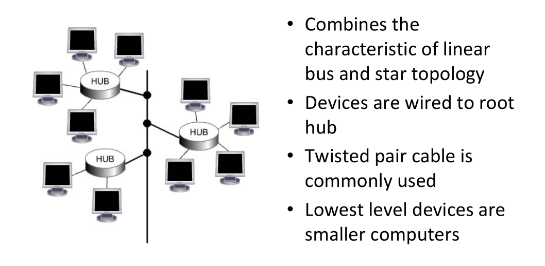

* **Advantages of Tree Topology :**

This topology is the combination of bus and star topology.

This topology provides a hierarchical as well as central data arrangement of the nodes.

As the leaf nodes can add one or more nodes in the hierarchical chain, this topology provides high scalability.

The other nodes in a network are not affected if one of their nodes gets damaged or does not work.

Tree topology provides easy maintenance and easy fault identification can be done.

A callable topology. Leaf nodes can hold more nodes.

Supported by several hardware and software vendors.

Point-to-point wiring for individual segments.

Tree Topology is highly secure.

It is used in WAN.

Tree Topology is reliable.

* **Disadvantages of Tree Topology :**

This network is very difficult to configure as compared to the other network topologies.

The length of a segment is limited & the limit of the segment depends on the type of cabling used.

Due to the presence of a large number of nodes, the network performance of tree topology becomes a bit slow.

If the computer on the first level is erroneous, the next-level computer will also go under problems.

Requires a large number of cables compared to star and ring topology.

As the data needs to travel from the central cable this creates dense network traffic.

The Backbone appears as the failure point of the entire segment of the network.

Treatment of the topology is pretty complex.

The establishment cost increases as well.

If the bulk of nodes is added to this network, then the maintenance will become complicated (Anon., 2022)

* **Hybrid**

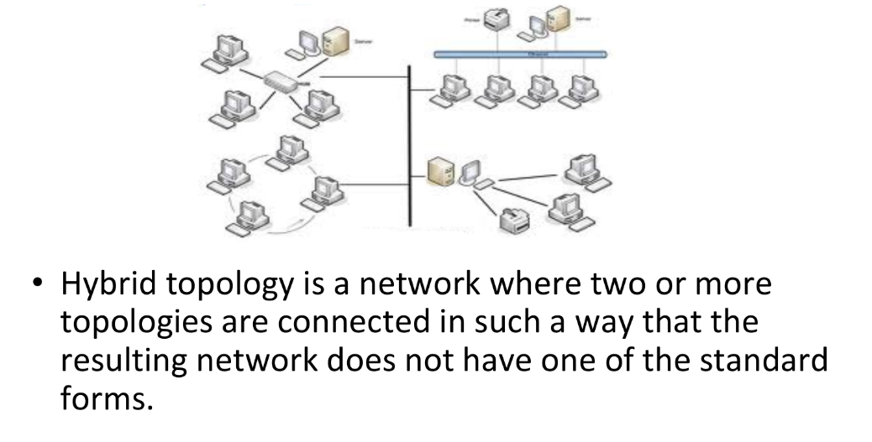

* **Advantages of Hybrid Topology:**

This type of topology combines the benefits of different types of topologies in one topology.

Can be modified as per requirement.

It is extremely flexible.

It is very reliable.

It is easily scalable as Hybrid networks are built in a fashion which enables easy integration of new hardware components.

Error detecting and troubleshooting are easy.

Handles a large volume of traffic.

It is used to create large networks.

The speed of the topology becomes fast when two topologies are put together.

* **Disadvantages of Hybrid Topology :**

It is a type of network expensive.

The design of a hybrid network is very complex.

There is a change in the hardware to connect one topology with another topology.

Usually, hybrid architectures are larger in scale so they require a lot of cables in the installation process.

Hubs which are used to connect two distinct networks are very costly. And hubs are different from usual hubs as they need to be intelligent enough to work with different architectures. Installation is a difficult process. (Anon., 2022)

## Communication and bandwidth requirements

* **Communication**

Communication is the act of giving, receiving, and sharing information -- in other words, talking or writing, and listening or reading. Good communicators listen carefully, speak or write clearly, and respect different opinions.

* **Bandwidth**

Network bandwidth is a measurement indicating the maximum capacity of a wired or wireless communications link to transmit data over a network connection in a given amount of time. Typically, bandwidth is represented in the number of bits, kilobits, megabits or gigabits that can be transmitted in 1 second. Synonymous with capacity, bandwidth describes data transfer rate. Bandwidth is not a measure of network speed -- a common misconception. (Froehlich, 2022)

## Define what network communication

A communication network is a pattern or form that is implemented in the organization to communicate information effectively. The communication network is the established system where the message may flow in one or too many directions in the organization based on requirements.

(Anon., 2022)

## Explain the rules in the network and why these rules are needed

* **Rules**

Establishing the rules:

An identified sender and receiver

Agreed upon method of communicating (face-to-face, telephone, letter,

photograph)

Common language and grammar

Speed and timing of delivery

Confirmation or acknowledgment requirements

* **Message Formatting and Encapsulation:**

Identifier of the recipient’s location

Identifier of the sender’s location

Salutation or greeting

Recipient identifier

The message content

Source identifier

End of message indicator

* **Message Size:**

An overview of the segmenting process:

The size restrictions of frames require the source host to break a long message into individual pieces (or segments) that meet both the minimum and maximum size requirements.

Each segment is encapsulated in a separate frame with the address information, and is sent over the network.

At the receiving host, the messages are de-encapsulated and put back together to be processed and interpreted.

* **Message Timing:**

Access Method

Flow Control

Response Timeout

* **Why it is Needed:**

Rules are an important component of data quality. When used in conjunction, network rules and attribute rule help maintain data integrity.

Network rules dictate which network features can connect or associate in the utility network. These rules are imposed at the class level for specific asset groups and asset types. Features and objects can connect and associate as long as feature restriction are respected and network rules exist to allow such relationships.

## Why bandwidth requiredment is needed

Bandwidth is necessary to ensure your devices and internet connectivity meet your needs. As new gadgets and technology come with increasing performance demands for asset-heavy content, overall network demands follow, spurring many people to get new Broadband equipment. With network demands rising by 50% yearly, bandwidth requirements also increase. (Anon., 2022)

# Discuss the operating principles of networking devices and server types

## How dose router work

Think of a router as an air traffic controller and data packets as aircraft headed to different airports (or networks). Just as each plane has a unique destination and follows a unique route, each packet needs to be guided to its destination as efficiently as possible. In the same way that an air traffic controller ensures that planes reach their destinations without getting lost or suffering a major disruption along the way, a router helps direct data packets to their destination IP address.

In order to direct packets effectively, a router uses an internal routing table — a list of paths to various network destinations. The router reads a packet's header to determine where it is going, then consults the routing table to figure out the most efficient path to that destination. It then forwards the packet to the next network in the path. (Anon., 2022)



## How does switch work

Once a device is connected to a switch, the switch identifies its media access control (MAC) address, a code that’s baked into the device’s network-interface card (NIC). The NIC attaches to the Ethernet cable that attaches to the switch.

The switch uses the MAC address to identify which attached device is sending outgoing packets, and where to deliver incoming packets.

The MAC address identifies the physical device and doesn’t change, as opposed to the network layer (Layer 3) IP address, which can be assigned dynamically to a device and change over time.

When one device sends a data packet to another device, the packet enters the switch and the switch reads the header to determine what to do with it. The switch matches the destination address or addresses and sends the packet out through the appropriate ports that lead to the destination devices.

To reduce the chance for collisions between network traffic going to and from a switch and a connected device at the same time, most switches offer full-duplex functionality in which packets coming from and going to a device have access to the full bandwidth of the switch connection. (Picture two people talking on smartphones as opposed to a walkie-talkie).

While it’s true that switches operate at Layer 2, they can also operate at Layer 3, which is necessary for them to support virtual LANs (VLAN), which are logical network segments that can span subnets. In order for traffic to get from one subnet to another it must pass between switches, and this is facilitated by routing capabilities built into the switches.

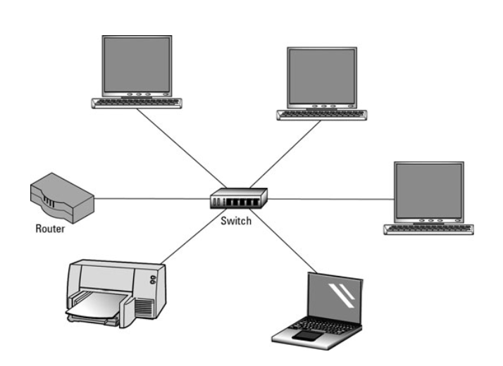

## Some common network device:

1. Firewall

A firewall is a [network security](https://www.forcepoint.com/cyber-edu/network-security) device that monitors incoming and outgoing network traffic and permits or blocks data [packets](https://www.forcepoint.com/cyber-edu/packet-loss) based on a set of security rules. Its purpose is to establish a barrier between your internal network and incoming traffic from external sources (such as the internet) in order to block malicious traffic like viruses and hackers. (Anon., 2022)

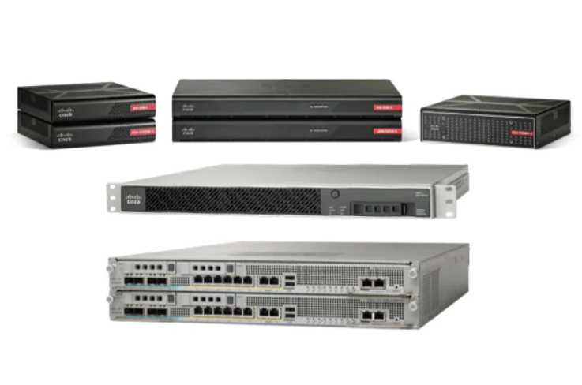

1. Switch

A network switch connects devices within a network (often a local area network, or LAN*) and forwards data packets to and from those devices. Unlike a router, a switch only sends data to the single device it is intended for (which may be another switch, a router, or a user's computer), not to networks of multiple devices. (Anon., 2022)

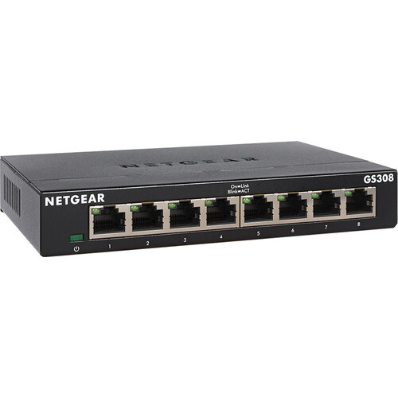

1. Access point

An Access Point is a type of device that enables wireless stations to connect to a wired local area network (LAN). An access point (AP), therefore, provides wireless stations with access to resources on a network. (Anon., 2022)



1. Router

A router is a device that connects two or more packet-switched networks or subnetworks. It serves two primary functions: managing traffic between these networks by forwarding data packets to their intended IP addresses, and allowing multiple devices to use the same Internet connection. (Anon., 2022)

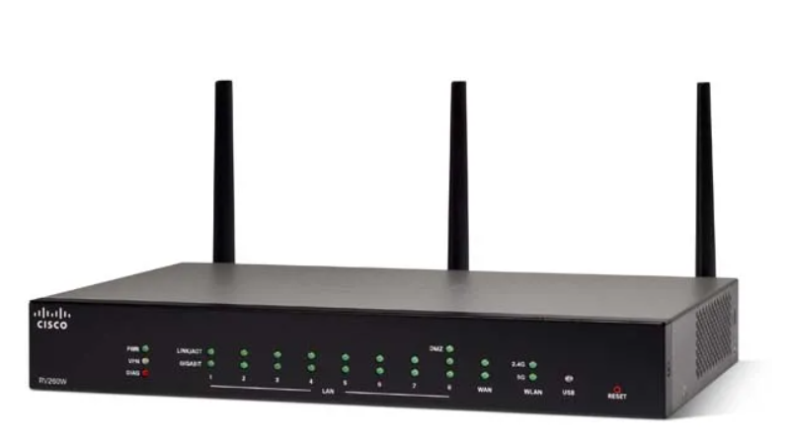

1. Hub

A network hub is a node that broadcasts data to every computer or Ethernet-based device connected to it. A hub is less sophisticated than a switch, the latter of which can isolate data transmissions to specific devices.

Network hubs are best suited for small, simple local area network (LAN) environments. Hubs cannot provide routing capabilities or other advanced network services. Because they operate by forwarding packets across all ports indiscriminately, network hubs are sometimes referred to as "dumb switches." (Scarpati, 2022)

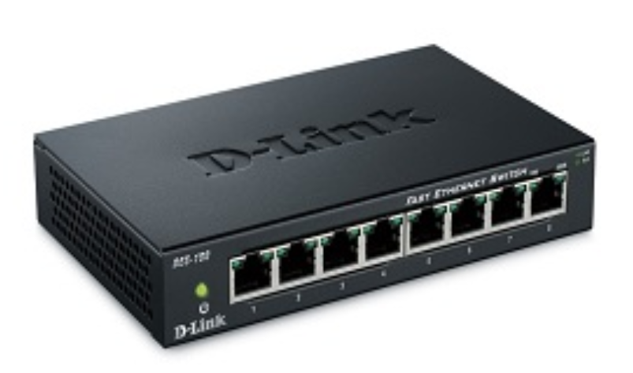

## some common types of servers

1. DHCP sever

A DHCP Server is a network server that automatically provides and assigns IP addresses, default gateways and other network parameters to client devices. It relies on the standard protocol known as Dynamic Host Configuration Protocol or DHCP to respond to broadcast queries by clients. (Anon., 2022)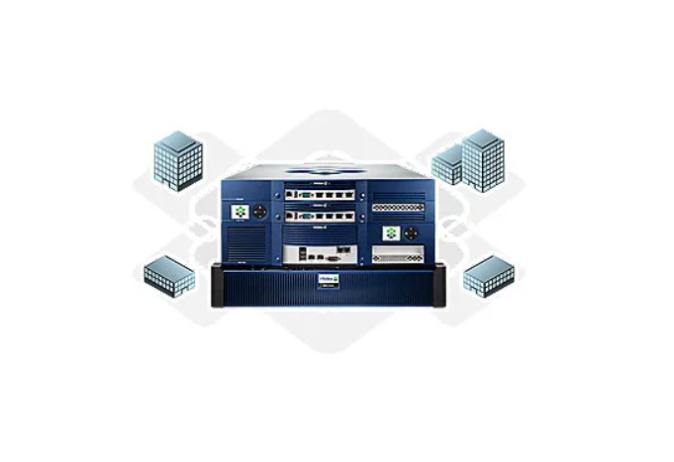

1. DNS sever

The Domain Name System (DNS) Server is a server that is specifically used for matching website hostnames (like example.com)to their corresponding Internet Protocol or IP addresses. The DNS server contains a database of public IP addresses and their corresponding domain names. Every device connected to the internet has a unique IP address that helps to identify it, according to the IPv4 or IPV6 protocols. The same goes for web servers that host websites. For example, the IP address of one CDNetworks server located in Mountain View, California is 157.185.170.144.

DNS servers help us avoid memorization of such long numbers in IP addresses (and even more complex alphanumeric ones in the IPV6 system) as they automatically translate the website names we enter into the browser address bar into these numbers so that the servers can load the right web pages.

(Anon., 2021)

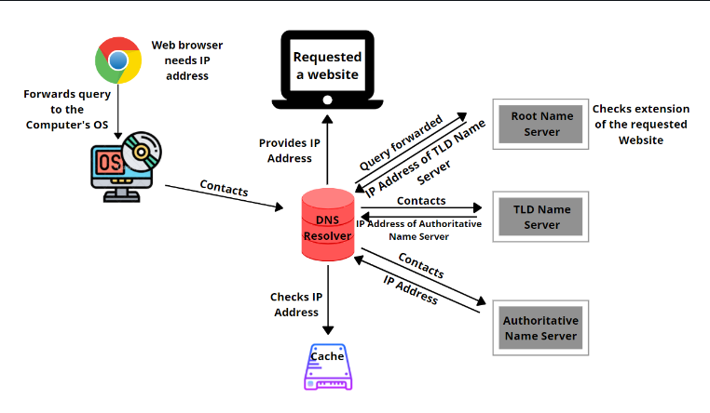

1. Web sever

A web server is a computer that runs websites. It's a computer program that distributes web pages as they are requisitioned. The basic objective of the web server is to store, process and deliver web pages to the users. This intercommunication is done using Hypertext Transfer Protocol (HTTP). These web pages are mostly static content that includes HTML documents, images, style sheets, test etc. Apart from HTTP, a web server also supports SMTP (Simple Mail transfer Protocol) and FTP (File Transfer Protocol) protocol for emailing and for file transfer and storage. (Anon., 2022)

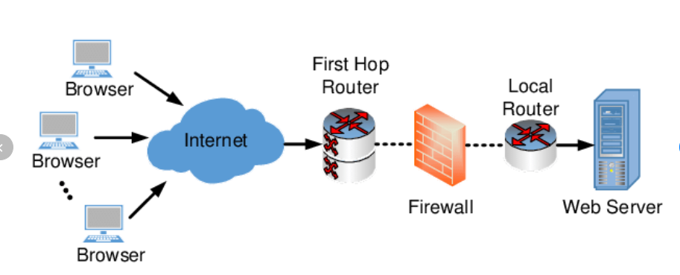

# Discuss the inter-dependence of workstation hardware with relevant networking software

## Interdependence

Interdependence is a connection between subjects where one subject’s needs can be fulfilled by the other subject’s resources and these transfer of resources works both ways. That means both subjects need each other to fulfill their needs. These kinds of relationships can be found almost everywhere since, as humans, we need other people’s help to survive and strive. In the business field, organizations depend on each other in many different levels.

Depending on the nature of the relationship, the degree of interdependence can be so high that the disappearance of one party might cause the other party to disappear too. Interdependence can be found in client-supplier relationships when it comes to raw materials. The supplier needs the client to pay for his goods but the client also needs the supplier in order to produce its own goods.

On the other hand, there’s also interdependence between business and financial companies. The latter needs to loan money to be financially profitable and the former needs to borrow money to leverage itself in order to grow.

**Example:**

A business called City Wheels Co. is a bike rental venture that serves the city of Los Angeles. The company leases bikes to individuals for given periods of time and they have locations all around the city to pick-up and deliver the bikes. From the perspective of interdependence we can identify at least two essential interdependent relationships between the business and other parties.

First of all, City Wheels and its clients are interdependent since these individuals need the bikes for transportation and the company also depends on them to earn the revenues they need to remain operational. And second of all, there’s also interdependence with bike mechanics and bike suppliers, since in both cases these suppliers depend on the company to keep their business running and City Wheels depends on them to keep its business well equipped to serve its clients. (Anon., 2022)

## Network hardware

Network hardware is a set of physical or network devices that are essential for interaction and communication between hardware units operational on a computer network. These are dedicated hardware components that connect to each other and enable a network to function effectively and efficiently. (Kanade, 2022)

## Network software

Networking software is a foundational element for any network. It helps administrators deploy, manage, and monitor a network. Traditional networks are made up of specialized hardware, such as routers and switches, that bundle the networking software into the solution. Software-defined networking (SDN) separates that software from the hardware, making it easier to innovate and adapt the network to quickly meet changing network demands. The separation of functions from hardware, such as firewalls or load balancing, is called network functions virtualization (NFV). (Studios, 2016)

## The relationship between hardware and network software

* Hardware and software are mutually dependent on each other. Both of them must work together to make a computer produce a useful output.
* Software cannot be utilized without supporting hardware
* Hardware without a set of programs to operate upon cannot be utilized and is useless.
* To get a particular job done on the computer, relevant software should be loaded into the hardware.
* Hardware is a one-time expense.
* Software development is very expensive and is a continuing expense.
* Different software applications can be loaded on a hardware to run different jobs.
* A software acts as an interface between the user and the hardware.
* If the hardware is the 'heart' of a computer system, then the software is its 'soul'. Both are complementary to each other. (Anon., 2022)

# References

Abdullah, S., 2022. *TechWalla.* [Online]   
Available at: https://www.techwalla.com/articles/purpose-of-the-ip-protocol  
[Accessed 6 8 2022].

Anon., 2012. *Techopedia.* [Online]   
Available at: https://www.techopedia.com/definition/25890/logical-topology#:~:text=A%20logical%20topology%20is%20a,be%20dynamically%20maintained%20and%20reconfigured.  
[Accessed 6 8 2022].

Anon., 2017. *Techopedia.* [Online]   
Available at: https://www.techopedia.com/definition/4794/physical-topology  
[Accessed 6 8 2022].

Anon., 2020. *Geeksforgeeks.* [Online]   
Available at: https://www.geeksforgeeks.org/difference-between-physical-and-logical-topology/  
[Accessed 6 8 2022].

Anon., 2021. *cdnetworks.* [Online]   
Available at: https://www.cdnetworks.com/web-performance-blog/what-is-a-dns-server/  
[Accessed 9 8 2022].

Anon., 2022. *cloudflare.* [Online]   
Available at: https://www.cloudflare.com/learning/dns/what-is-dns/  
[Accessed 6 8 2022].

Anon., 2022. *cloudflare.* [Online]   
Available at: https://www.cloudflare.com/learning/network-layer/what-is-a-router/#:~:text=A%20router%20is%20a%20device,use%20the%20same%20Internet%20connection.  
[Accessed 9 8 2022].

Anon., 2022. *cloudflare.* [Online]   
Available at: https://www.cloudflare.com/learning/network-layer/what-is-a-network-switch/  
[Accessed 9 8 2022].

Anon., 2022. *cloudflare.* [Online]   
Available at: https://www.cloudflare.com/learning/network-layer/what-is-a-router/  
[Accessed 9 8 2022].

Anon., 2022. *Cloudflare.* [Online]   
Available at: https://www.cloudflare.com/learning/ddos/glossary/hypertext-transfer-protocol-http/  
[Accessed 6 8 2022].

Anon., 2022. *CompTIA.* [Online]   
Available at: https://www.comptia.org/content/guides/what-is-a-network-protocol  
[Accessed 5 8 2022].

Anon., 2022. *economictimes.indiatimes.* [Online]   
Available at: https://economictimes.indiatimes.com/definition/web-server  
[Accessed 9 8 2022].

Anon., 2022. *enetworksupply.* [Online]   
Available at: https://www.enetworksupply.com/what-is-bandwidth-and-why-do-we-need-it/  
[Accessed 9 8 2022].

Anon., 2022. *forcepoint.* [Online]   
Available at: https://www.forcepoint.com/cyber-edu/firewall  
[Accessed 9 8 2022].

Anon., 2022. *geeksforgeeks.* [Online]   
Available at: https://www.geeksforgeeks.org/advantages-and-disadvantages-of-tree-topology/  
[Accessed 9 8 2022].

Anon., 2022. *geeksforgeeks.* [Online]   
Available at: https://www.geeksforgeeks.org/advantages-and-disadvantages-of-hybrid-topology/  
[Accessed 9 8 2022].

Anon., 2022. *Heavy.AI.* [Online]   
Available at: https://www.heavy.ai/technical-glossary/network-topology  
[Accessed 6 8 2022].

Anon., 2022. *infoblox.* [Online]   
Available at: https://www.infoblox.com/glossary/dhcp-server/#:~:text=A%20DHCP%20Server%20is%20a,to%20broadcast%20queries%20by%20clients.  
[Accessed 9 8 2022].

Anon., 2022. *myaccountingcourse.* [Online]   
Available at: https://www.myaccountingcourse.com/accounting-dictionary/interdependence  
[Accessed 9 8 2022].

Anon., 2022. *networkencyclopedia.* [Online]   
Available at: https://networkencyclopedia.com/access-point/  
[Accessed 9 8 2022].

Anon., 2022. *tutorialspoint.* [Online]   
Available at: https://www.tutorialspoint.com/computer_fundamentals/computer_hardware.htm#:~:text=Hardware%20and%20software%20are%20mutually,be%20utilized%20and%20is%20useless.  
[Accessed 9 8 2022].

Anon., 2022. *tyonote.* [Online]   
Available at: https://tyonote.com/communication_network/  
[Accessed 9 8 2022].

aplustopper.com, n.d. [Online]   
Available at: https://www.aplustopper.com/bus-topology-advantages-and-disadvantages/#:~:text=%20Advantages%20and%20Disadvantages%20of%20Bus%20Topology%20,It%20is%20a%20simple%20network%20for...%20More%20

computerhope, 2018. *computerhope.* [Online]   
Available at: https://www.computerhope.com/jargon/s/startopo.htm  
[Accessed 9 8 2022].

computerhope, 2018. *computerhope.* [Online]   
Available at: https://www.computerhope.com/jargon/r/ringtopo.htm  
[Accessed 9 8 2022].

Froehlich, A., 2022. *techtarget.* [Online]   
Available at: https://www.techtarget.com/searchnetworking/definition/bandwidth  
[Accessed 9 8 2022].

Hope, C., 2018. *ComputerHope.* [Online]   
Available at: https://www.computerhope.com/jargon/m/mesh.htm#:~:text=A%20mesh%20topology%20is%20a,commonly%20used%20for%20wireless%20networks.  
[Accessed 9 8 2022].

Kanade, V., 2022. *spiceworks.* [Online]   
Available at: https://www.spiceworks.com/tech/networking/articles/what-is-network-hardware/  
[Accessed 9 8 2022].

Scarpati, J., 2022. *techtarget.* [Online]   
Available at: https://www.techtarget.com/searchnetworking/definition/hub  
[Accessed 9 8 2022].

Studios, S., 2016. *sdxcentral.* [Online]   
Available at: https://www.sdxcentral.com/networking/sdn/definitions/networking-software/  
[Accessed 9 8 2022].