**ASSIGNMENT 1 FRONT SHEET**

|  |  |  |  |
| --- | --- | --- | --- |
| **Qualification** | **BTEC Level 5 HND Diploma in Computing** | | |
| **Unit number and title** | Unit 16: Cloud computing | | |
| **Submission date** | 27/5/2023 | **Date Received 1st submission** |  |
| **Re-submission Date** |  | **Date Received 2nd submission** |  |
| **Student Name** | TRAN MINH HIEU | **Student ID** | GCC200070 |
| **Class** | GCC1001 | **Assessor name** | LE HUYNH QUOC BAO |
| **Student declaration**  I certify that the assignment submission is entirely my own work and I fully understand the consequences of plagiarism. I understand that making a false declaration is a form of malpractice. | | | |
|  |  | **Student’s signature** |  |

**Grading grid**

|  |  |  |  |  |  |  |
| --- | --- | --- | --- | --- | --- | --- |
| P1 | P2 | P3 | P4 | M1 | M2 | D1 |
|  |  |  |  |  |  |  |

|  |  |  |
| --- | --- | --- |
| **❒ Summative Feedback: ❒ Resubmission Feedback:** | | |
| **Grade:** | **Assessor Signature:** | **Date:** |
| **Internal Verifier’s Comments:** | | |
| **Signature & Date:** | | |

|  |
| --- |
| **Submission Format:** |
| *Format:* The submission is in the form of 1 document  You must use font *Calibri size 12, set number of the pages and use multiple line spacing at 1.3. Margins must be: left: 1.25 cm; right: 1 cm; top: 1 cm and bottom: 1 cm.* The reference follows Harvard referencing system.  *Submission* Students are compulsory to submit the assignment in due date and in a way requested by the Tutors. The form of submission will be a soft copy posted on <http://cms.greenwich.edu.vn/>  *Note:* The Assignment *must* be your own work, and not copied by or from another student or from  books etc. If you use ideas, quotes or data (such as diagrams) from books, journals or other sources, you must reference your sources, using the Harvard style. Make sure that you know how to reference properly, and that understand the guidelines on plagiarism. *If you do not, you definitely get failed* |
| **Unit Learning Outcomes:** |
| **LO1** Demonstrate an understanding of the fundamentals of Cloud Computing and its architectures.  **LO2** Evaluate the deployment models, service models and technological drivers of Cloud Computing and validate their use. |
| **Assignment Brief and Guidance:** |
| Scenario  ATN is a Vietnamese company which is selling toys to teenagers in many provinces all over Vietnam. The company has the revenue over 700.000 dollars/year. Currently each shop has its own database to store transactions for that shop only. Each shop has to send the sale data to the board director monthly and the board director needs lots of time to summarize the data collected from all the shops. Besides, the board can’t see the stock information update in real time.  The table of contents in your technical report should be as follows:   1. As a developer, explain to the board director the fundamentals of cloud computing and how it is popular nowadays(about 2500 words) 2. Proposed solution (higher level solution description – around 700 words) and explain the appropriateness of the solution for the scenario (about 400 words with images and diagrams)which might include:    1. Architectural design (architectural diagram and description).    2. Detailed design:       1. Deployment model (discussion on why that model was chosen).       2. Service model (discussion on why that model was chosen).       3. Programming language/ webserver/database server chosen. 3. Summary.   General guidelines:   * Instead of providing definitions but also provide with examples. * Provide more own arguments instead of definitions * Making use of academic references instead of web tutorials * For a cloud architecture look at the bottom of this document |

|  |  |  |
| --- | --- | --- |
| **Learning Outcomes and Assessment Criteria** | | |
| **Pass** | **Merit** | **Distinction** |
| **LO1** Demonstrate an understanding of the fundamentals of Cloud Computing and its architectures | | **LO1 & 2**  **D1** Justify the tools chosen to realise a Cloud Computing solution. |
| **P1** Analyse the evolution and fundamental concepts of Cloud Computing.  **P2** Design an appropriate architectural Cloud Computing framework for a given scenario. | **M1** Discuss why an organisation should migrate to a Cloud Computing solution. |
| **LO2** Evaluate the deployment models, service models and technological drivers of Cloud Computing and validate their use | |
| **P3** Define an appropriate deployment model for a given scenario.  **P4** Compare the service models for choosing an adequate model for a given scenario. | **M2** Demonstrate these deployment models with real world examples. |

Table of Contents

[**Chapter 1: Analyse the evolution and fundamental concepts of Cloud Computing 7**](#_Toc135981360)

[**I. Evolution of Cloud Computing 7**](#_Toc135981361)

[**II. Fundamental concepts of cloud computing 9**](#_Toc135981362)

[**1. Definition of Cloud Computing 9**](#_Toc135981363)

[**2. Client-server model 10**](#_Toc135981364)

[**a. Definition. 10**](#_Toc135981365)

[**b. How the Client-Server Model works 11**](#_Toc135981366)

[**c. How the browser interacts with the servers 11**](#_Toc135981367)

[**d. Example of Client – Server model. 12**](#_Toc135981368)

[**3. Peer-To-Peer (P2P) model 12**](#_Toc135981369)

[**a. Definition. 12**](#_Toc135981370)

[**b. Types of Peer-to-Peer Networks 14**](#_Toc135981371)

[**c. How the P2P model works 16**](#_Toc135981372)

[**d. P2P network architecture 17**](#_Toc135981373)

[**e. Example of P2P model. 17**](#_Toc135981374)

[**4. High Performance Computing (HPC). 18**](#_Toc135981375)

[**a. Definition. 18**](#_Toc135981376)

[**b. How HPC works 18**](#_Toc135981377)

[**c. Parallel Computer Architecture - Models 19**](#_Toc135981378)

[**d. Distributed Architecture 21**](#_Toc135981379)

[**e. Cluster Computing 22**](#_Toc135981380)

[**5. Deployment models 23**](#_Toc135981381)

[**a. Definition 23**](#_Toc135981382)

[**b. Types of Cloud Computing Deployment Models 23**](#_Toc135981383)

[**c. Public Cloud 23**](#_Toc135981384)

[**d. Private Cloud 24**](#_Toc135981385)

[**e. Hybrid Cloud 25**](#_Toc135981386)

[**f. Community Cloud 26**](#_Toc135981387)

[**6. Service Model 27**](#_Toc135981388)

[**a. Software as a Service 27**](#_Toc135981389)

[**b. Platform as a Service 28**](#_Toc135981390)

[**c. Infrastructure as a Service 29**](#_Toc135981391)

[**7. Five characteristic of cloud 30**](#_Toc135981392)

[**a. On-Demand Self-Service 30**](#_Toc135981393)

[**b. Broad Network Access 30**](#_Toc135981394)

[**c. Resource Pooling 30**](#_Toc135981395)

[**d. Rapid Elasticity 31**](#_Toc135981396)

[**e. Measured Service 31**](#_Toc135981397)

[**8. Virtualization and multicore 31**](#_Toc135981398)

[**a. Virtualization 31**](#_Toc135981399)

[**b. Multicore 38**](#_Toc135981400)

[**III. Cloud security 44**](#_Toc135981401)

[**IV. Cloud use cases 44**](#_Toc135981402)

[**V. Characteristics and advantages of cloud computing 45**](#_Toc135981403)

[**VI. Cloud computing examples and use cases 49**](#_Toc135981404)

[**Chapter 2: Design an appropriate architectural Cloud Computing framework for a given scenario 50**](#_Toc135981405)

[**I. Cloud Computing Architecture 50**](#_Toc135981406)

[**1. Frontend: 51**](#_Toc135981407)

[**2. Backend: 52**](#_Toc135981408)

[**3. Layers of Cloud Architecture 53**](#_Toc135981409)

[**II. Architecture design for ATN organization. 56**](#_Toc135981410)

[**Chapter 3: Define an appropriate deployment model for a given scenario 56**](#_Toc135981411)

[**Chapter 4: Compare the service models for choosing an adequate model for a given scenario 57**](#_Toc135981412)

[**References 60**](#_Toc135981413)

# **Chapter 1: Analyse the evolution and fundamental concepts of Cloud Computing**

## **Evolution of Cloud Computing**

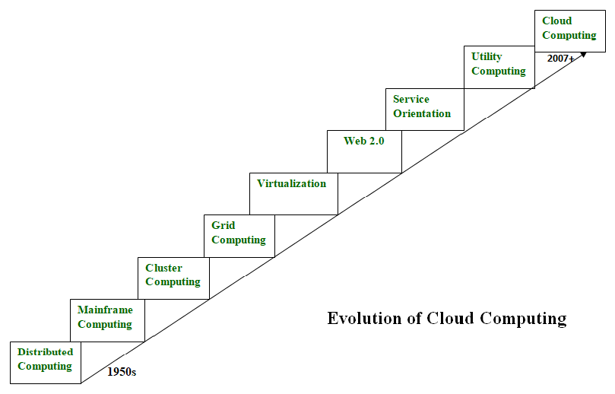Cloud computing is all about renting computing services. This idea first came in the 1950s. In making cloud computing what it is today, five technologies played a vital role. These are distributed systems and its peripherals, virtualization, web 2.0, service orientation, and utility computing. (anukruti16, 2023)

* **Distributed Systems:**

It is a composition of multiple independent systems but all of them are depicted as a single entity to the users. The purpose of distributed systems is to share resources and also use them effectively and efficiently. Distributed systems possess characteristics such as scalability, concurrency, continuous availability, heterogeneity, and independence in failures. But the main problem with this system was that all the systems were required to be present at the same geographical location. Thus to solve this problem, distributed computing led to three more types of computing and they were-Mainframe computing, cluster computing, and grid computing.

* **Mainframe computing:**

Mainframes which first came into existence in 1951 are highly powerful and reliable computing machines. These are responsible for handling large data such as massive input-output operations. Even today these are used for bulk processing tasks such as online transactions etc. These systems have almost no downtime with high fault tolerance. After distributed computing, these increased the processing capabilities of the system. But these were very expensive. To reduce this cost, cluster computing came as an alternative to mainframe technology.

* **Cluster computing:**

In 1980s, cluster computing came as an alternative to mainframe computing. Each machine in the cluster was connected to each other by a network with high bandwidth. These were way cheaper than those mainframe systems. These were equally capable of high computations. Also, new nodes could easily be added to the cluster if it was required. Thus, the problem of the cost was solved to some extent but the problem related to geographical restrictions still pertained. To solve this, the concept of grid computing was introduced.

* **Grid computing:**

In 1990s, the concept of grid computing was introduced. It means that different systems were placed at entirely different geographical locations and these all were connected via the internet. These systems belonged to different organizations and thus the grid consisted of heterogeneous nodes. Although it solved some problems but new problems emerged as the distance between the nodes increased. The main problem which was encountered was the low availability of high bandwidth connectivity and with it other network associated issues. Thus. cloud computing is often referred to as “Successor of grid computing”.

* **Virtualization:**

It was introduced nearly 40 years back. It refers to the process of creating a virtual layer over the hardware which allows the user to run multiple instances simultaneously on the hardware. It is a key technology used in cloud computing. It is the base on which major cloud computing services such as Amazon EC2, VMware vCloud, etc work on. Hardware virtualization is still one of the most common types of virtualization.

* **Web 2.0:**

It is the interface through which the cloud computing services interact with the clients. It is because of Web 2.0 that we have interactive and dynamic web pages. It also increases flexibility among web pages. Popular examples of web 2.0 include Google Maps, Facebook, Twitter, etc. Needless to say, social media is possible because of this technology only. It gained major popularity in 2004.

* **Service orientation:**

It acts as a reference model for cloud computing. It supports low-cost, flexible, and evolvable applications. Two important concepts were introduced in this computing model. These were Quality of Service (QoS) which also includes the SLA (Service Level Agreement) and Software as a Service (SaaS).

* **Utility computing:**

It is a computing model that defines service provisioning techniques for services such as compute services along with other major services such as storage, infrastructure, etc which are provisioned on a pay-per-use basis.

## **Fundamental concepts of cloud computing**

## **Definition of Cloud Computing**

Cloud computing is a general term for anything that involves delivering hosted services over the internet. These services are divided into three main categories or types of cloud computing: infrastructure as a service ([IaaS](https://www.techtarget.com/searchcloudcomputing/definition/Infrastructure-as-a-Service-IaaS)), platform as a service ([PaaS](https://www.techtarget.com/searchcloudcomputing/definition/Platform-as-a-Service-PaaS)) and software as a service ([SaaS](https://www.techtarget.com/searchcloudcomputing/definition/Software-as-a-Service)). (Chai, 2022)

[A cloud can be private or public](https://www.techtarget.com/searchcloudcomputing/feature/Public-cloud-vs-private-cloud-Key-benefits-and-differences). A public cloud sells services to anyone on the internet. A private cloud is a proprietary network or a data center that supplies hosted services to a limited number of people, with certain access and permissions settings. Private or public, the goal of cloud computing is to provide easy, scalable access to computing resources and IT services.

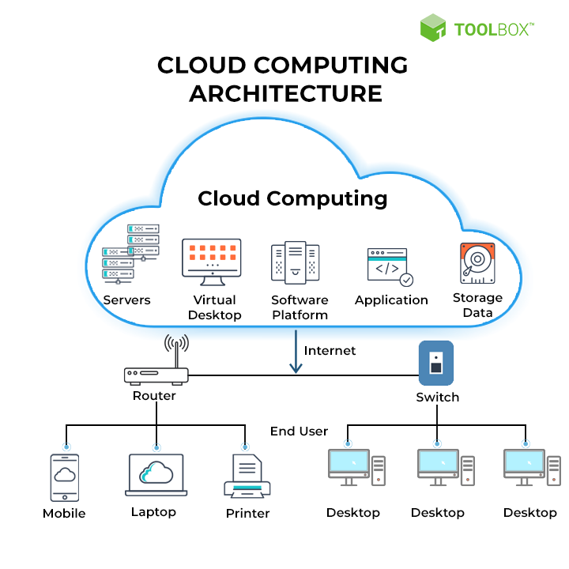Cloud infrastructure involves the hardware and software components required for proper implementation of a cloud computing model. Cloud computing can also be thought of as [utility computing](https://www.techtarget.com/searchdatacenter/definition/utility-computing) or [on-demand computing](https://www.techtarget.com/searchitoperations/definition/on-demand-computing).

## **Client-server model**

### **Definition.**

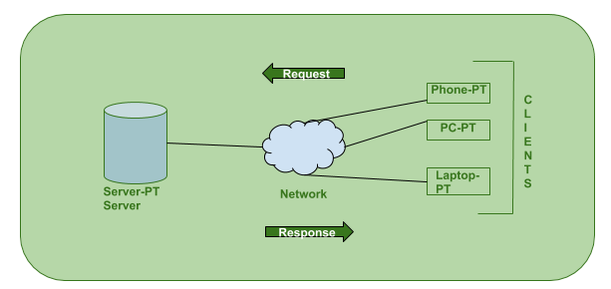The Client-server model is a distributed application structure that partitions task or workload between the providers of a resource or service, called servers, and service requesters called clients. In the client-server architecture, when the client computer sends a request for data to the server through the internet, the server accepts the requested process and deliver the data packets requested back to the client. Clients do not share any of their resources. Examples of Client-Server Model are Email, World Wide Web, etc. (syedmodassirali, 2022)

### **How the Client-Server Model works**

**Client:** When we talk the word Client, it mean to talk of a person or an organization using a particular service. Similarly in the digital world a Client is a computer (Host) i.e. capable of receiving information or using a particular service from the service providers (Servers).

**Servers:** Similarly, when we talk the word Servers, It mean a person or medium that serves something. Similarly in this digital world a Server is a remote computer which provides information (data) or access to particular services. (syedmodassirali, 2022)

### **How the browser interacts with the servers**

There are few steps to follow to interacts with the servers a client.

* User enters the URL(Uniform Resource Locator) of the website or file. The Browser then requests the DNS(DOMAIN NAME SYSTEM) Server.
* DNS Server lookup for the address of the WEB Server.
* DNS Server responds with the IP address of the WEB Server.
* Browser sends over an HTTP/HTTPS request to WEB Server’s IP (provided by DNS server).
* Server sends over the necessary files of the website.
* 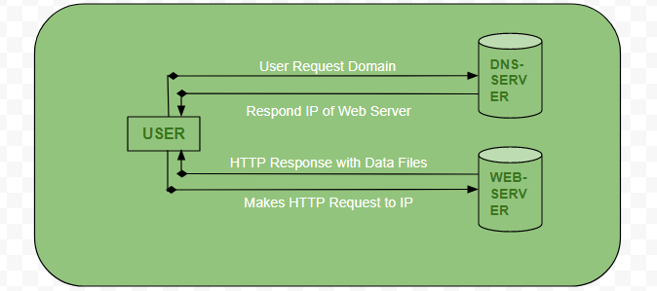Browser then renders the files and the website is displayed. This rendering is done with the help of DOM (Document Object Model) interpreter, CSS interpreter and JS Engine collectively known as the JIT or (Just in Time) Compilers.
* **Advantages of Client-Server model:**
* Centralized system with all data in a single place.
* Cost efficient requires less maintenance cost and Data recovery is possible.
* The capacity of the Client and Servers can be changed separately.
* **Disadvantages of Client-Server model:**
* Clients are prone to viruses, Trojans and worms if present in the Server or uploaded into the Server.
* Server are prone to Denial of Service (DOS) attacks.
* Data packets may be spoofed or modified during transmission.
* Phishing or capturing login credentials or other useful information of the user are common and MITM(Man in the Middle) attacks are common.

### **Example of Client – Server model.**

There’re different examples of the client-server model in daily life. Given are a few client-server examples.

* **Mail Servers:** Email servers can be used for sending & receiving emails. Different software allows email handling.
* **File Servers:** They are the centralized location for the files. For example, cloud services for Microsoft Office and Google docs will be accessed from your devices, and files that you save from the computer will be accessed from your phone. In this way, file stores will be centralized and accessed by multiple clients.
* **Web Servers:** These servers will host different websites and these are high-performance computers where websites get hosted. The client is using, and the web server is a server system, which hosts these websites. The user or client requests resources or server’s site data through high-speed internet. (Sutarwala, 2023)

## **Peer-To-Peer (P2P) model**

### **Definition.**

Peer-to-peer (P2P) is a decentralized communications model in which each party has the same capabilities and either party can initiate a communication session.

Unlike the [client-server model](https://www.techtarget.com/searchnetworking/definition/client-server), in which the client makes a service request and the server fulfills the request, the P2P network model enables each [node](https://www.techtarget.com/searchnetworking/definition/node) to function as both a client and server.

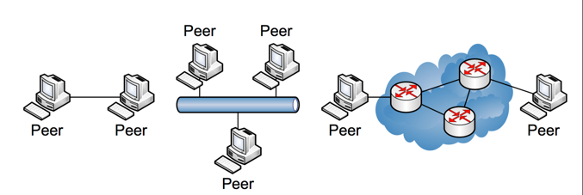P2P systems can provide anonymized routing of network traffic, massive parallel computing environments, distributed storage and other functions. Most P2P programs focus on media sharing, so P2P mostly associates with software piracy and [copyright](https://www.techtarget.com/searchsecurity/definition/copyright) violation. (Rosencrance, 2022)

P2P applications typically enable users to control many parameters of operation. Some of those parameters are the following:

* How many member connections to seek or allow at one time;
* Which systems to connect or avoid;
* Which services to offer; and
* How many system resources to devote to the network.

Some P2P applications simply connect to some subset of active nodes in the network with little user control.

Use cases for the P2P networking topologies have existed since the days of [Advanced Research Projects Agency Network](https://www.techtarget.com/searchnetworking/definition/ARPANET), but the advantages of the P2P communications model didn't become obvious to the general public until the late 1990s when music-sharing P2P applications, like Napster, appeared. Napster and its successors, such as Gnutella and BitTorrent, cut into music and movie industry profits and changed how people thought about acquiring and consuming media.

System administrators tend to discourage the use of P2P applications for a few reasons. For one, P2P applications can tie up [bandwidth](https://www.techtarget.com/searchnetworking/definition/bandwidth). P2P applications can also bypass [firewalls](https://www.techtarget.com/searchsecurity/definition/firewall) and distribute [malware](https://www.techtarget.com/searchsecurity/definition/malware), which can possibly expose an administrator's organization legally. Network administrators often set up networks to prevent PCs from engaging in P2P side talk.

### **Types of Peer-to-Peer Networks**

* **Unstructured Networks:**

These are the **simplest type of P2P network**. The **nodes (PCs) are connected on a random basis**. They are simple to build – making them suitable for most situations.

The nature of the unstructured network makes it straightforward for localized optimizations, but the shared resources can be difficult to find.

Files might be stored with more than one peer; and when a search request goes into the network, **the most popular files are easy to find**.

However, a rarer file – one that is not shared on many nodes – can be lost in the ‘flood’ of requests, making it much harder to find that content.

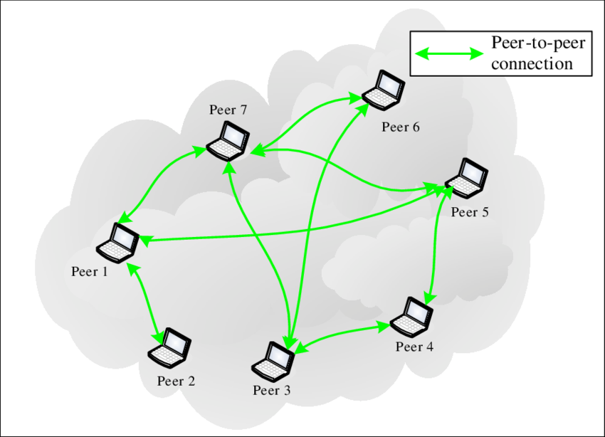Unstructured networks tend to **use more CPU and memory**, but they are **less affected by the number of peers joining or leaving the network (churn rate)**. (Dale, 2021)

* **Structured Networks:**

Unlike the unstructured network, the **structured P2P network is organized into an arrangement based on a distributed hash table** (DHT).

DHT is an advanced form of lookup or search system that allows nodes to access data, such as files, through the use of a key instead of having to make a copy of the data on every node. These keys are formed through hashing – whereby data of varying sizes are assigned generated values of the same size (for example, a mix of 10 digits and letters).

This contrasts with unstructured P2P networks, where whole files may be stored on more than one node.

DHT assigns ownership of a particular file to a specific peer using a variant of hashing called 'consistent hashing'. When a new peer joins a P2P network, normal hashing requires that all keys be regenerated. Consistent hashing is less power-intensive as only some keys need regenerating.

Overall, it is **easier, and less power- and memory-intensive, to search a structured network for content** than an unstructured one.

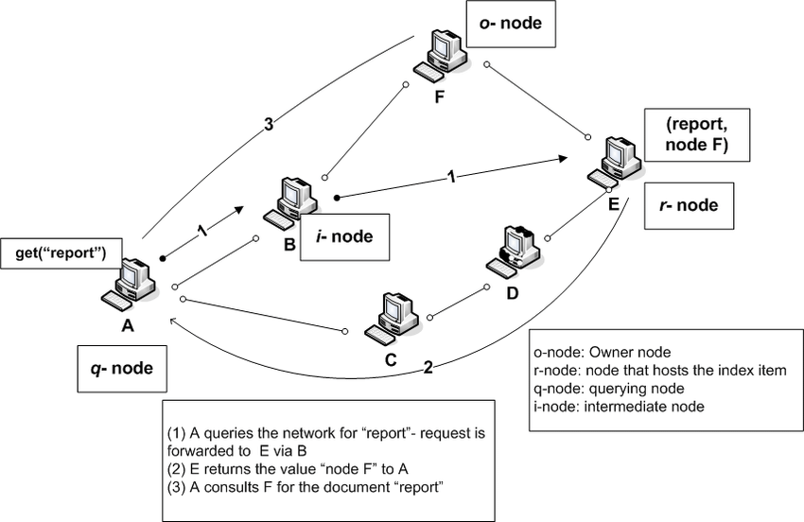However, this type of network is **more problematic with high churn rates** – the routing of requests and information depends on each peer knowing what is available to download and other criteria of the neighbouring node, which must be 'relearned' when peers leave or join the network as the neighbours change.

* **Hybrid Structure:**

This is a structure that looks more like a traditional client/server network.

**A centralized peer is in control**, performing server-like activities with optimum knowledge of the location of files and what resources can be shared.

This is a more complicated network and can prove **more intensive to set up**.

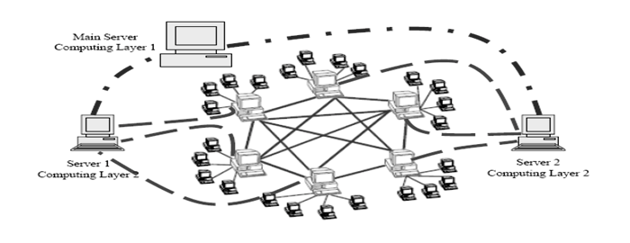While it **makes many routing requests faster**, it puts more pressure on the centralized peer, requiring it to potentially have more power and use more CPU than other nodes. It is a move that is much closer to having a dedicated server and an administrator.

### **How the P2P model works**

When a user downloads a file, the process is typically as follows: The user opens a web browser, visits the appropriate website and downloads the file. In this case, the website acts as a server, and the user's computer acts as a client that receives the data. This process is like a one-way street where the downloaded file transfers from point A, the website, to point B, the user's computer. (Rosencrance, 2022)

If the user downloads the same file through a P2P network, however, the process occurs differently. The user has to install P2P software on their computer, which creates a virtual network of P2P application users. When the user downloads a file, the file downloads in [bits](https://www.techtarget.com/whatis/definition/bit-binary-digit) that come from various computers in the network that already have the file.

Simultaneously, data also travels from the user's computer to other computers in the network that ask for it. This situation is similar to a two-way street -- the file is like numerous small bits of data that come to the user's computer but also leave when requested. In fact, the file transfer load distributes between the peer computers.

### **P2P network architecture**

In a P2P network architecture, each computer has the same responsibilities and capabilities. Since there is no server, the computers connect with each other in a workgroup to share files, printers and internet access. This architecture is practical for workgroups of 12 or fewer computers. (Rosencrance, 2022)

P2P architectures are common in small home networks or office environments where each PC acts as an independent workstation; each computer stores data on its own hard drive but has the ability to share data with other PCs on the network.

* **Advantages of P2P networks**
* P2P networks operate without an expensive server.
* Each user manages their own computer, eliminating the need for a network manager.
* P2P network configuration occurs via wizards in software.
* P2P networks can be set up in homes and small businesses.
* P2P networks typically have less network traffic than a client-server network.
* **Disadvantages of P2P networks**
* Users can't centrally back up files and folders.
* Each computer can access other computers, which slows performance.
* Files aren't centrally organized into a specific shared area, but rather stored on individual computers.
* Each user must ensure viruses aren't introduced into the network.
* There is limited security.

### **Example of P2P model.**

* **Napster**

This music-sharing network was designed in 1999 as a depository for users to be able to upload and download music.

As a P2P sharing network, the idea was that peers connected through the internet and could find and download any song they wanted, from several other users.

Peers could also upload songs to Napster themselves, then share their files with others.

However, Napster (and LimeWire, a similar site that was popular around the same time but is now discontinued) soon came under fire as the songs placed in the depository for download infringed on the copyright of the record labels and musicians. (Dale, 2021)

## **High Performance Computing (HPC).**

### **Definition.**

High-performance computing (HPC) is the practice of using [parallel data processing](https://www.techtarget.com/searchdatacenter/definition/parallel-processing) to improve computing performance and perform complex calculations. HPC achieves these goals by aggregating computing power, so even advanced applications can run efficiently, reliably and quickly as per user needs and expectations. It thus delivers much higher power and better performance than traditional computers, [workstations](https://www.techtarget.com/searchmobilecomputing/definition/workstation) and servers. (Awati, 2021)

### **How HPC works**

Most HPC systems have three main components or resources:

* Compute
* Network
* Storage

In an HPC architecture, multiple servers -- generally hundreds or thousands -- form a network or [cluster](https://www.techtarget.com/whatis/definition/cluster). Each server is a [node](https://www.techtarget.com/searchnetworking/definition/node); and in each cluster, the nodes work in parallel to boost processing speeds and ensure HPC. Clusters are often created and removed automatically in the cloud to save time and reduce costs.

Several software programs and [algorithms](https://www.techtarget.com/whatis/definition/algorithm) run simultaneously on the cluster to support multiple HPC applications. Further, the cluster is networked to the storage components to capture and store the output of these programs. (Awati, 2021)

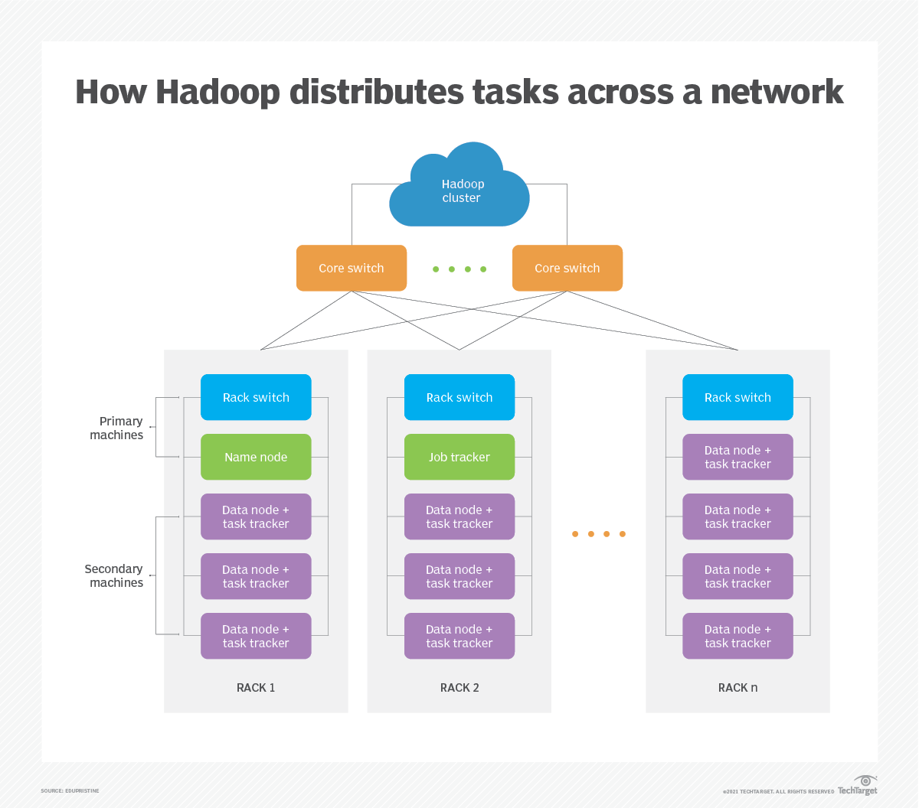

### **Parallel Computer Architecture - Models**

Parallel processing has been developed as an effective technology in modern computers to meet the demand for higher performance, lower cost and accurate results in real-life applications. Concurrent events are common in today’s computers due to the practice of multiprogramming, multiprocessing, or multicomputing. (tutorialspoint, 2023)

Modern computers have powerful and extensive software packages. To analyze the development of the performance of computers, first we have to understand the basic development of hardware and software.

* **Computer Development Milestones −** There is two major stages of development of computer - mechanical or electromechanical parts. Modern computers evolved after the introduction of electronic components. High mobility electrons in electronic computers replaced the operational parts in mechanical computers. For information transmission, electric signal which travels almost at the speed of a light replaced mechanical gears or levers.
* 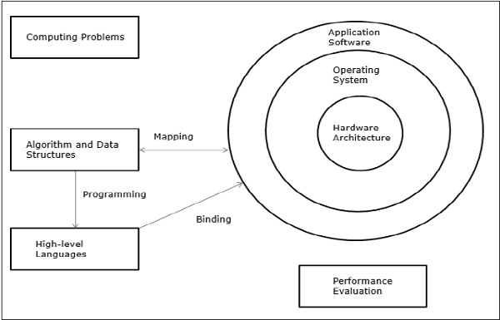**Elements of Modern computers** − A modern computer system consists of computer hardware, instruction sets, application programs, system software and user interface.

The computing problems are categorized as numerical computing, logical reasoning, and transaction processing. Some complex problems may need the combination of all the three processing modes.

* **Evolution of Computer Architecture** − In last four decades, computer architecture has gone through revolutionary changes. We started with Von Neumann architecture and now we have multicomputers and multiprocessors.
* **Performance of a computer system** − Performance of a computer system depends both on machine capability and program behavior. Machine capability can be improved with better hardware technology, advanced architectural features and efficient resource management. Program behavior is unpredictable as it is dependent on application and run-time conditions

### **Distributed Architecture**

In distributed architecture, components are presented on different platforms and several components can cooperate with one another over a communication network in order to achieve a specific objective or goal. (tutorialspoint, 2023)

* In this architecture, information processing is not confined to a single machine rather it is distributed over several independent computers.
* A distributed system can be demonstrated by the client-server architecture which forms the base for multi-tier architectures; alternatives are the broker architecture such as CORBA, and the Service-Oriented Architecture (SOA).
* There are several technology frameworks to support distributed architectures, including .NET, J2EE, CORBA, .NET Web services, AXIS Java Web services, and Globus Grid services.
* Middleware is an infrastructure that appropriately supports the development and execution of distributed applications. It provides a buffer between the applications and the network.
* It sits in the middle of system and manages or supports the different components of a distributed system. Examples are transaction processing monitors, data convertors and communication controllers etc.

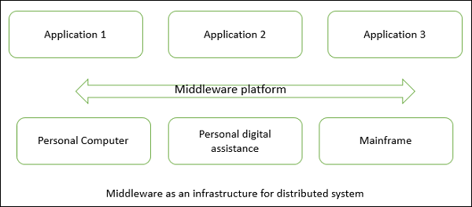Middleware as an infrastructure for distributed system

The basis of a distributed architecture is its transparency, reliability, and availability.

### **Cluster Computing**

Cluster computing refers that many of the computers connected on a network and they perform like a single entity. Each computer that is connected to the network is called a node. Cluster computing offers solutions to solve complicated problems by providing faster computational speed, and enhanced data integrity. The connected computers execute operations all together thus creating the impression like a single system (virtual machine). This process is termed as transparency of the system. Based on the principle of distributed systems, this networking technology performs its operations. And here, LAN is the connection unit. This process is defined as the transparency of the system. Cluster computing goes with the features of:

* All the connected computers are the same kind of machines
* They are tightly connected through dedicated network connections
* All the computers share a common home directory.

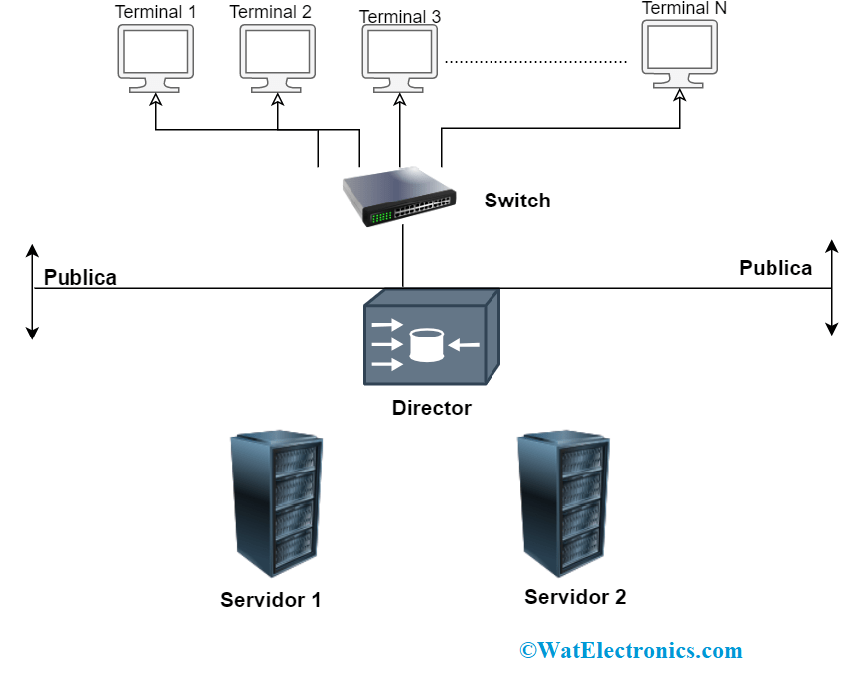Clusters’ hardware configuration differs based on the selected networking technologies. Cluster is categorized as Open and Close clusters wherein Open Clusters all the nodes need IP’s and those are accessed only through the internet or web. This type of clustering causes enhanced security concerns. And in Closed Clustering, the nodes are concealed behind the gateway node and they offer increased protection. (tutorialspoint, 2023)

## **Deployment models**

### **Definition**

Cloud Deployment Model functions as a virtual computing environment with a deployment architecture that varies depending on the amount of data you want to store and who has access to the infrastructure. (sameekshakhandelwal1712, 2023)

### **Types of Cloud Computing Deployment Models**

The cloud deployment model identifies the specific type of cloud environment based on ownership, scale, and access, as well as the cloud’s nature and purpose. The location of the servers you’re utilizing and who controls them are defined by a cloud deployment model. It specifies how your cloud infrastructure will look, what you can change, and whether you will be given services or will have to create everything yourself. Relationships between the infrastructure and your users are also defined by cloud deployment types. [Different types of cloud](https://www.geeksforgeeks.org/types-of-cloud/) computing deployment models are described below. (sameekshakhandelwal1712, 2023)

### **Public Cloud**

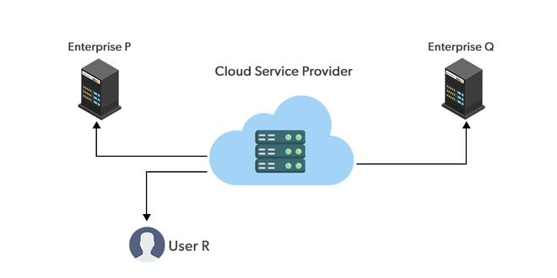The public cloud makes it possible for anybody to access systems and services. The public cloud may be less secure as it is open to everyone. The public cloud is one in which cloud infrastructure services are provided over the internet to the general people or major industry groups. The infrastructure in this cloud model is owned by the entity that delivers the cloud services, not by the consumer. It is a type of cloud hosting that allows customers and users to easily access systems and services. This form of cloud computing is an excellent example of cloud hosting, in which service providers supply services to a variety of customers. In this arrangement, storage backup and retrieval services are given for free, as a subscription, or on a per-user basis. For example, Google App Engine etc. (sameekshakhandelwal1712, 2023)

* **Advantages of the Public Cloud Model**
* **Minimal Investment:**Because it is a pay-per-use service, there is no substantial upfront fee, making it excellent for enterprises that require immediate access to resources.
* **No setup cost:** The entire infrastructure is fully subsidized by the cloud service providers, thus there is no need to set up any hardware.
* **Infrastructure Management is not required:**Using the public cloud does not necessitate infrastructure management.
* **No maintenance:**The maintenance work is done by the service provider (not users).
* **Dynamic Scalability:** To fulfill your company’s needs, on-demand resources are accessible.
* **Disadvantages of the Public Cloud Model**
* **Less secure:**Public cloud is less secure as resources are public so there is no guarantee of high-level security.
* **Low customization:**It is accessed by many public so it can’t be customized according to personal requirements.

### **Private Cloud**

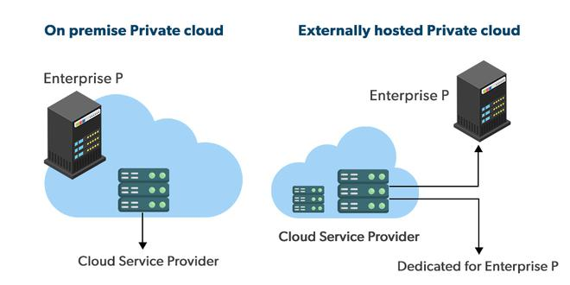The private cloud deployment model is the exact opposite of the public cloud deployment model. It’s a one-on-one environment for a single user (customer). There is no need to share your hardware with anyone else. The distinction between [private and public clouds](https://www.geeksforgeeks.org/difference-between-public-cloud-and-private-cloud/) is in how you handle all of the hardware. It is also called the “internal cloud” & it refers to the ability to access systems and services within a given border or organization. The cloud platform is implemented in a cloud-based secure environment that is protected by powerful firewalls and under the supervision of an organization’s IT department. The private cloud gives greater flexibility of control over cloud resources.

* **Advantages of the Private Cloud Model**
* **Better Control:**You are the sole owner of the property. You gain complete command over service integration, IT operations, policies, and user behavior.
* **Data Security and Privacy:** It’s suitable for storing corporate information to which only authorized staff have access. By segmenting resources within the same infrastructure, improved access and security can be achieved.
* **Supports Legacy Systems:** This approach is designed to work with legacy systems that are unable to access the public cloud.
* **Customization:**Unlike a public cloud deployment, a private cloud allows a company to tailor its solution to meet its specific needs.
* **Disadvantages of the Private Cloud Model**
* **Less scalable:**Private clouds are scaled within a certain range as there is less number of clients. (sameekshakhandelwal1712, 2023)
* **Costly:** Private clouds are more costly as they provide personalized facilities.

### **Hybrid Cloud**

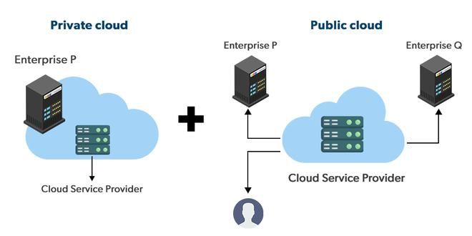By bridging the public and private worlds with a layer of proprietary software, hybrid cloud computing gives the best of both worlds. With a hybrid solution, you may host the app in a safe environment while taking advantage of the public cloud’s cost savings. Organizations can move data and applications between different clouds using a combination of two or more cloud deployment methods, depending on their needs.

* **Advantages of the Hybrid Cloud Model**
* **Flexibility and control:**Businesses with more flexibility can design personalized solutions that meet their particular needs. (sameekshakhandelwal1712, 2023)
* **Cost:** Because public clouds provide scalability, you’ll only be responsible for paying for the extra capacity if you require it.
* **Security:**Because data is properly separated, the chances of data theft by attackers are considerably reduced.
* **Disadvantages of the Hybrid Cloud Model**
* **Difficult to manage:**Hybrid clouds are difficult to manage as it is a combination of both public and private cloud. So, it is complex.
* **Slow data transmission:**Data transmission in the hybrid cloud takes place through the public cloud so latency occurs.

### **Community Cloud**

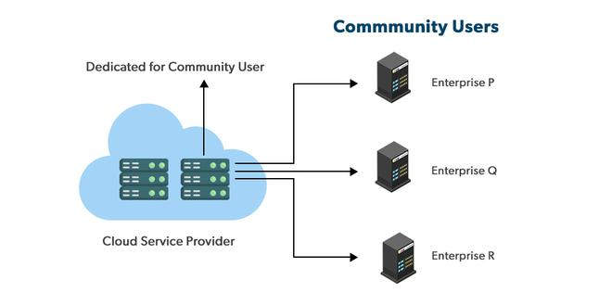It allows systems and services to be accessible by a group of organizations. It is a distributed system that is created by integrating the services of different clouds to address the specific needs of a community, industry, or business. The infrastructure of the community could be shared between the organization which has shared concerns or tasks. It is generally managed by a third party or by the combination of one or more organizations in the community. (sameekshakhandelwal1712, 2023)

* **Advantages of the Community Cloud Model**
* **Cost Effective:**It is cost-effectivebecause the cloud is shared by multiple organizations or communities.
* **Security:** Community cloud provides better security.
* **Shared resources:**It allows you to share resources, infrastructure, etc. with multiple organizations.
* **Collaboration and data sharing:**It is suitable for both collaboration and data sharing.
* **Disadvantages of the Community Cloud Model**
* **Limited Scalability:**Community cloud is relatively less scalable as many organizations share the same resources according to their collaborative interests.
* **Rigid in customization:**As the data and resources are shared among different organizations according to their mutual interests if an organization wants some changes according to their needs they cannot do so because it will have an impact on other organizations.

## **Service Model**

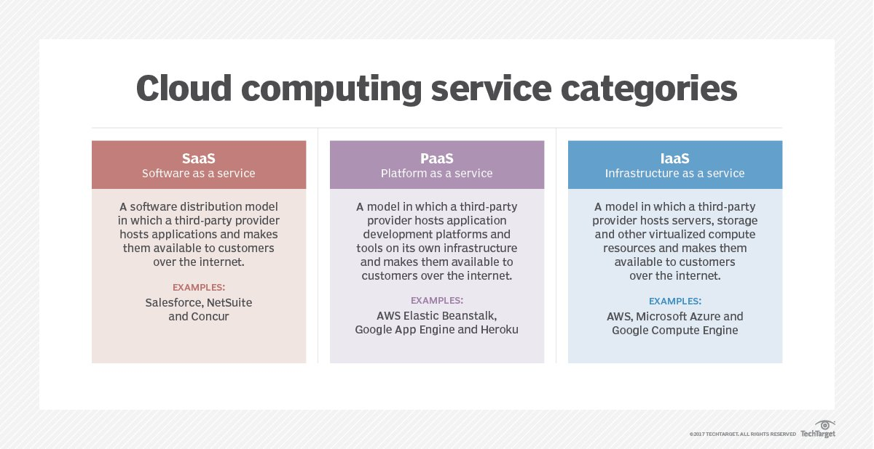There are three major cloud service models: software as a service ([SaaS](https://www.techtarget.com/searchcloudcomputing/definition/Software-as-a-Service)), infrastructure as a service ([IaaS](https://www.techtarget.com/searchcloudcomputing/definition/Infrastructure-as-a-Service-IaaS)) and platform as a service ([PaaS](https://www.techtarget.com/searchcloudcomputing/definition/Platform-as-a-Service-PaaS)). Cloud service pricing models are categorized into pay per use, subscription-based and hybrid, which is a combination of pay-per-use and subscription pricing models. (Rosencrance, 2021)

### **Software as a Service**

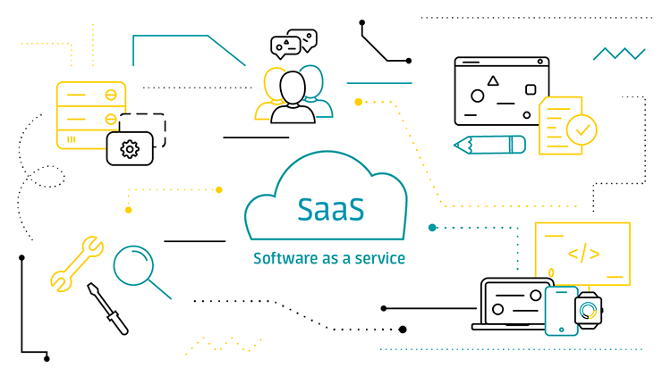[Software as a service vendors](https://www.techtarget.com/searchcloudcomputing/tip/Follow-this-SaaS-vendor-checklist-to-find-the-right-provider) host the applications, making them available to users via the internet. With SaaS, businesses don't have to install or download any software to their existing IT infrastructures. SaaS ensures that users are always running the most up-to-date versions of the software. The SaaS provider handles maintenance and support.

SaaS services include:

* Adobe Creative Cloud
* [Box](https://www.techtarget.com/searchmobilecomputing/definition/Box-Boxnet)
* Salesforce
* Dropbox
* DocuSign
* [Slack](https://www.techtarget.com/searchcontentmanagement/definition/Slack-software)
* [HubSpot](https://www.techtarget.com/whatis/definition/HubSpot)
* Google Workspace
* Oracle Fusion Applications

### **Platform as a Service**

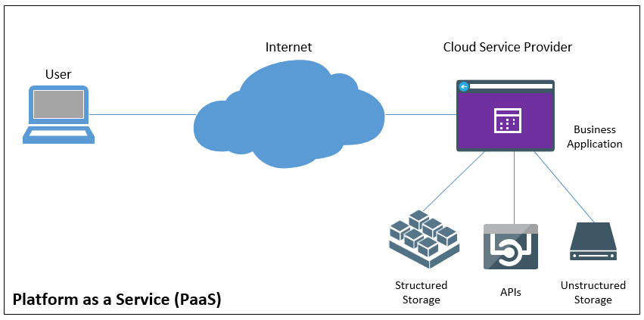Platform as a service offers developers a platform for software development and deployment over the internet, enabling them to access up-to-date tools. PaaS delivers a framework that developers can use to create customized applications. The organization or the PaaS cloud vendor manage the servers, storage and networking, while the developers manage the applications.

PaaS services include:

* [AWS Elastic Beanstalk](https://www.techtarget.com/searchaws/definition/Elastic-Beanstalk)
* Oracle Cloud Platform
* [Google App Engine](https://www.techtarget.com/searchaws/definition/Google-App-Engine)
* [Microsoft Azure](https://www.techtarget.com/searchcloudcomputing/definition/Windows-Azure)
* [Red Hat OpenShift](https://www.techtarget.com/searchcloudcomputing/definition/Red-Hat-OpenShift)

### **Infrastructure as a Service**

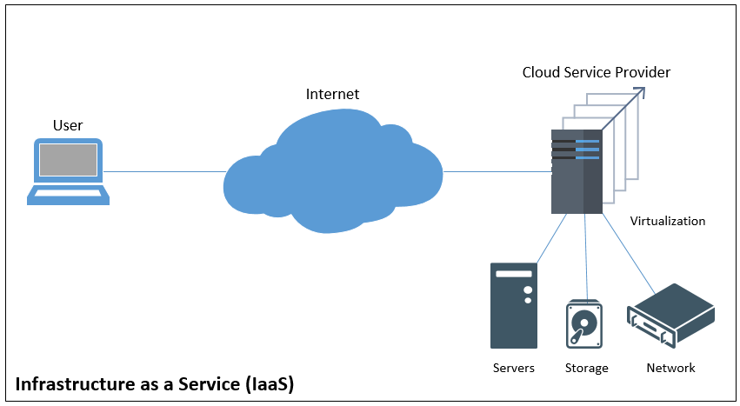Infrastructure as a service is used by companies that don't want to maintain their own on-premises data centers. IaaS provides virtual computing resources over the Internet. The IaaS cloud vendor hosts the infrastructure components that typically exist in an on-premises data center, including servers, storage and networking hardware, as well as the [hypervisor](https://www.techtarget.com/searchitoperations/definition/hypervisor) or virtualization layer.

IaaS services include:

* [Amazon EC2](https://www.techtarget.com/searchaws/definition/Amazon-Elastic-Compute-Cloud-Amazon-EC2)
* [Google Compute Engine](https://www.techtarget.com/searchaws/definition/Google-Compute-Engine)
* Azure Virtual Machines for Linux and Windows
* [Alibaba Elastic Compute Service](https://www.techtarget.com/searchcloudcomputing/feature/An-introduction-to-Alibaba-cloud-offerings)
* [Rackspace Cloud](https://www.techtarget.com/searchstorage/definition/Rackspace-Cloud)

## **Five characteristic of cloud**

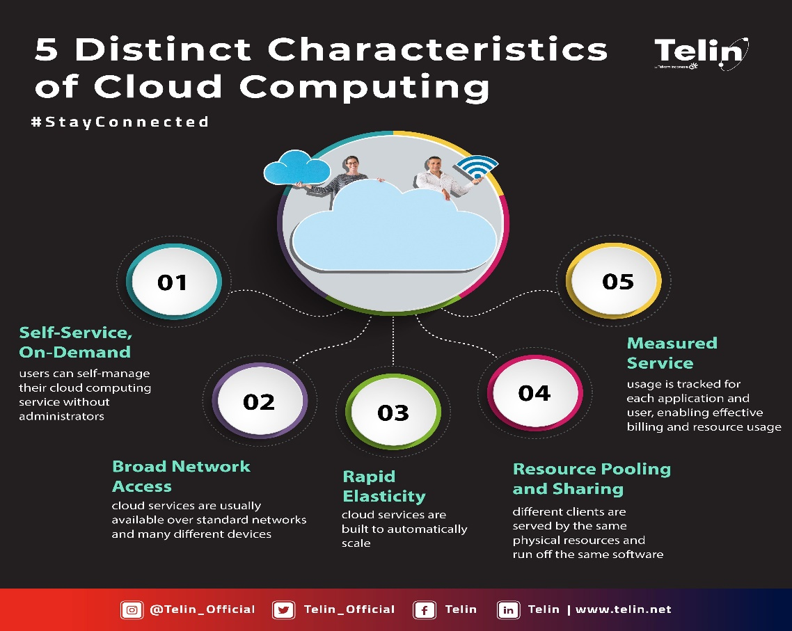The National Institute of Standards Technology (NIST) lists [five essential characteristics of cloud computing](https://www.nist.gov/news-events/news/2011/10/final-version-nist-cloud-computing-definition-published): on-demand self-service, broad network access, resource pooling, rapid elasticity, and measured service. (Bhatia, 2023)

### **On-Demand Self-Service**

With cloud computing, you can provision computing services, like server time and network storage, automatically. You won’t need to interact with the service provider. Cloud customers can access their cloud accounts through a web self-service portal to view their cloud services, monitor their usage, and provision and de-provision services.

### **Broad Network Access**

Another essential cloud computing characteristic is broad network access. You can access cloud services over the network and on portable devices like mobile phones, tablets, laptops, and desktop computers. A public cloud uses the internet; a private cloud uses a local area network. Latency and bandwidth both play a major role in cloud computing and broad network access, as they affect the quality of service.

### **Resource Pooling**

With resource pooling, multiple customers can share physical resources using a multi-tenant model. This model assigns and reassigns physical and virtual resources based on demand. Multi-tenancy allows customers to share the same applications or infrastructure while maintaining privacy and security. Though customers won't know the exact location of their resources, they may be able to specify the location at a higher level of abstraction, such as a country, state, or data center. Memory, processing, and bandwidth are among the resources that customers can pool.

### **Rapid Elasticity**

Cloud services can be elastically provisioned and released, sometimes automatically, so customers can scale quickly based on demand. The capabilities available for provisioning are practically unlimited. Customers can engage with these capabilities at any time in any quantity. Customers can also scale cloud use, capacity, and cost without extra contracts or fees. With rapid elasticity, you won’t need to buy computer hardware. Instead, can use the cloud provider's cloud computing resources.

### **Measured Service**

In cloud systems, a metering capability optimizes resource usage at a level of abstraction appropriate to the type of service. For example, you can use a measured service for storage, processing, bandwidth, and users. Payment is based on actual consumption by the customer via a pay-for-what-you-use model. Monitoring, controlling, and reporting resource use creates a transparent experience for both consumers and providers of the service.

## **Virtualization and multicore**

### **Virtualization**

* **Definition**

Virtualization is the creation of a virtual -- rather than actual -- version of something, such as an operating system (OS), a server, a storage device or network resources.

Virtualization uses software that simulates hardware functionality to create a virtual system. This practice allows IT organizations to operate multiple operating systems, more than one virtual system and various applications on a single server. The benefits of virtualization include greater efficiencies and economies of scale.

OS virtualization is the use of software to allow a piece of hardware to run multiple operating system images at the same time. The technology got its start on mainframes decades ago, allowing administrators to avoid wasting expensive processing power. (Brush, 2021)

* **How virtualization works**

Virtualization describes a technology in which an application, [guest OS](https://searchservervirtualization.techtarget.com/definition/guest-OS) or data storage is abstracted away from the true underlying hardware or software. (Brush, 2021)

A key use of virtualization technology is server virtualization, which uses a software layer -- called a [hypervisor</a -- to emulate the underlying hardware. This often includes the CPU's memory, input/output (I/O) and network traffic.](https://searchservervirtualization.techtarget.com/definition/hypervisor)

Hypervisors take the physical resources and separate them so they can be utilized by the virtual environment. They can sit on top of an OS or they can be directly installed onto the hardware. The latter is how most enterprises virtualize their systems.

The Xen hypervisor is an open source software program that is responsible for managing the low-level interactions that occur between virtual machines ([VMs](https://searchservervirtualization.techtarget.com/definition/virtual-machine)) and the physical hardware. In other words, the Xen hypervisor enables the simultaneous creation, execution and management of various virtual machines in one physical environment.

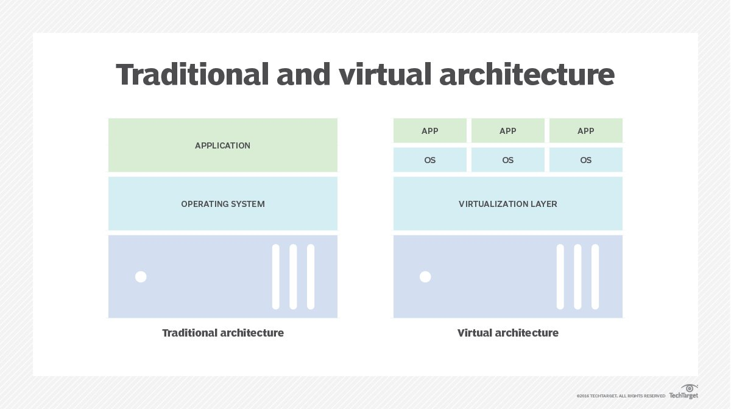With the help of the hypervisor, the guest OS, normally interacting with true hardware, is now doing so with a software emulation of that hardware; often, the guest OS has no idea it's on virtualized hardware.

While the performance of this virtual system is not equal to the performance of the operating system running on true hardware, the concept of virtualization works because most guest operating systems and applications don't need the full use of the underlying hardware.

This allows for greater flexibility, control and isolation by removing the dependency on a given hardware platform. While initially meant for server virtualization, the concept of virtualization has spread to applications, networks, data and desktops.

The virtualization process follows the steps listed below:

* Hypervisors detach the physical resources from their physical environments.
* Resources are taken and divided, as needed, from the physical environment to the various virtual environments.
* System users work with and perform computations within the virtual environment.
* Once the virtual environment is running, a user or program can send an instruction that requires extra resources form the physical environment. In response, the hypervisor relays the message to the physical system and stores the changes. This process will happen at an almost native speed.

The virtual environment is often referred to as a guest machine or virtual machine. The VM acts like a single data file that can be transferred from one computer to another and opened in both; it is expected to perform the same way on every computer.

* **Types of virtualization**

You probably know a little about virtualization if you have ever divided your hard drive into different partitions. A [partition](https://www.techtarget.com/searchstorage/definition/partition) is the logical division of a hard disk drive to create, in effect, two separate hard drives.

There are six areas of IT where virtualization is making headway:

* [**Network virtualization**](https://searchservervirtualization.techtarget.com/definition/network-virtualization) is a method of combining the available resources in a network by splitting up the available bandwidth into channels, each of which is independent from the others and can be assigned -- or reassigned -- to a particular server or device in real time. The idea is that virtualization disguises the true complexity of the network by separating it into manageable parts, much like your partitioned hard drive makes it easier to manage your files.
* [**Storage virtualization**](https://www.techtarget.com/searchstorage/definition/storage-virtualization) is the pooling of physical storage from multiple network storage devices into what appears to be a single storage device that is managed from a central console. Storage virtualization is commonly used in storage area networks.
* [Server virtualization](https://searchservervirtualization.techtarget.com/definition/server-virtualization) is the masking of server resources -- including the number and identity of individual physical servers, processors and operating systems -- from server users. The intention is to spare the user from having to understand and manage complicated details of server resources while increasing resource sharing and utilization and maintaining the capacity to expand later.
* The layer of software that enables this abstraction is often referred to as the hypervisor. The most common hypervisor -- Type 1 -- is designed to sit directly on bare metal and provide the ability to virtualize the hardware platform for use by the virtual machines. [KVM virtualization](https://searchservervirtualization.techtarget.com/tip/Cloud-Linux-vendors-cash-in-on-KVM-based-virtualization) is a Linux kernel-based virtualization hypervisor that provides Type 1 virtualization benefits like other hypervisors. KVM is licensed under open source. A Type 2 hypervisor requires a host operating system and is more often used for testing and labs.
* [**Data virtualization**](https://www.techtarget.com/searchdatamanagement/definition/data-virtualization) is abstracting the traditional technical details of data and data management, such as location, performance or format, in favor of broader access and more resiliency tied to business needs.
* [**Desktop virtualization**](https://www.techtarget.com/searchvirtualdesktop/definition/desktop-virtualization) is virtualizing a workstation load rather than a server. This allows the user to access the desktop remotely, typically using a [thin client](https://www.techtarget.com/searchnetworking/definition/thin-client) at the desk. Since the workstation is essentially running in a data center server, access to it can be both more secure and portable. The operating system license does still need to be accounted for as well as the infrastructure.
* [**Application virtualization**](https://www.techtarget.com/searchvirtualdesktop/definition/app-virtualization) is abstracting the application layer away from the operating system. This way, the application can run in an encapsulated form without being depended upon on by the operating system underneath. This can allow a Windows application to run on Linux and vice versa, in addition to adding a level of isolation. (Brush, 2021)

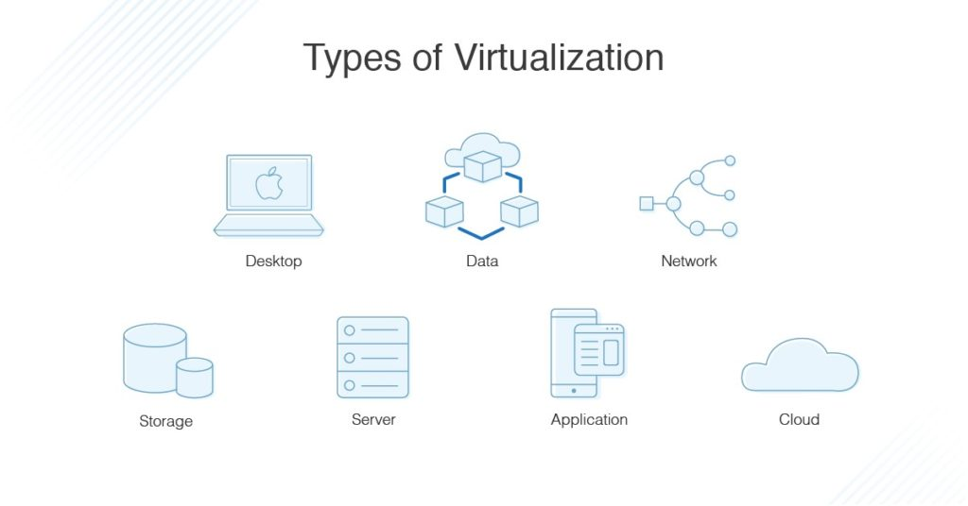

Virtualization can be viewed as part of an overall trend in enterprise IT that includes [autonomic computing](https://www.techtarget.com/whatis/definition/autonomic-computing), a scenario in which the IT environment will be able to manage itself based on perceived activity, and [utility computing](https://www.techtarget.com/searchdatacenter/definition/utility-computing), in which computer processing power is seen as a utility that clients can pay for only as needed. The usual goal of virtualization is to centralize administrative tasks while improving scalability and workloads.

* **Advantages of virtualization**

The advantages of utilizing a virtualized environment include the following:

* **Lower costs.** Virtualization reduces the amount of hardware servers necessary within a company and data center. This lowers the overall cost of buying and maintaining large amounts of hardware.
* **Easier disaster recovery.** Disaster recovery is very simple in a virtualized environment. Regular snapshots provide up-to-date data, allowing virtual machines to be feasibly backed up and recovered. Even in an emergency, a virtual machine can be migrated to a new location within minutes.
* **Easier testing.** Testing is less complicated in a virtual environment. Even if a large mistake is made, the test does not need to stop and go back to the beginning. It can simply return to the previous snapshot and proceed with the test.
* **Quicker backups.** Backups can be taken of both the virtual server and the virtual machine. [Automatic snapshots](https://searchservervirtualization.techtarget.com/tip/Learn-the-differences-between-VM-snapshot-vs-backup) are taken throughout the day to guarantee that all data is up-to-date. Furthermore, the virtual machines can be easily migrated between each other and efficiently redeployed.
* **Improved productivity.** Fewer physical resources result in less time spent managing and maintaining the servers. Tasks that can take days or weeks in a physical environment can be done in minutes. This allows staff members to spend the majority of their time on more productive tasks, such as raising revenue and fostering business initiatives. (Brush, 2021)
* **Benefits of virtualization**

Virtualization provides companies with the benefit of maximizing their output. Additional benefit for both businesses and data centers include the following:

* **Single-minded servers.** Virtualization provides a cost-effective way to separate email, database and web servers, creating a more comprehensive and dependable system.
* **Expedited deployment and redeployment.** When a physical server crashes, the backup server may not always be ready or up to date. There also may not be an image or clone of the server available. If this is the case, then the redeployment process can be time-consuming and tedious. However, if the data center is virtualized, then the process is quick and fairly simple. Virtual backup tools can expedite the process to minutes.
* **Reduced heat and improved energy savings.** Companies that use a lot of hardware servers risk overheating their physical resources. The best way to prevent this from happening is to decrease the number of servers used for [data management](https://www.techtarget.com/searchdatamanagement/definition/data-management), and the best way to do this is through virtualization.
* **Better for the environment.** Companies and data centers that utilize copious amounts of hardware leave a large carbon footprint; they must take responsibility for the pollution they are generating. Virtualization can help reduce these effects by significantly decreasing the necessary amounts of cooling and power, thus helping clean the air and the atmosphere. As a result, companies and data centers that virtualize will improve their reputation while also enhancing the quality of their relationship with customers and the planet.
* **Easier migration to the cloud.** Virtualization brings companies closer to experiencing a completely cloud-based environment. Virtual machines may even be deployed from the data center in order to build a cloud-based infrastructure. The ability to embrace a cloud-based mindset with virtualization makes migrating to the cloud even easier.
* **Lack of vendor dependency.** Virtual machines are [agnostic](https://www.techtarget.com/whatis/definition/agnostic) in hardware configuration. As a result, virtualizing hardware and software means that a company does not need to depend on a vendor for these physical resources.
* **Limitations of virtualization**

Before converting to a virtualized environment, it is important to consider the various upfront costs. The necessary investment in virtualization software, as well as hardware that might be required to make the virtualization possible, can be costly. If the existing infrastructure is more than five years old, an initial renewal budget will have to be considered.

Fortunately, many businesses have the capacity to accommodate virtualization without spending large amounts of cash. Furthermore, the costs can be offset by collaborating with a [managed service provider](https://www.techtarget.com/searchitchannel/definition/managed-service-provider) that provides monthly leasing or purchase options.

There are also software licensing considerations that must be considered when creating a virtualized environment. Companies must ensure that they have a clear understanding of how their vendors view software use within a virtualized environment. This is becoming less of a limitation as more software providers adapt to the increased use of virtualization.

Converting to virtualization takes time and may come with a learning curve. Implementing and controlling a virtualized environment demands each IT staff member to be trained and possess expertise in virtualization. Furthermore, some applications do not adapt well when brought into a virtual environment. The IT staff will need to be prepared to face these challenges and should address them prior to converting.

There are also [security risks involved with virtualization](https://www.techtarget.com/searchitoperations/tip/Follow-this-10-point-virtualization-security-checklist). Data is crucial to the success of a business and, therefore, is a common target for attacks. The chances of experiencing a data breach significantly increase while using virtualization.

Finally, in a virtual environment, users lose control of what they can do because there are several links that must collaborate to perform the same task. If any part is not working, then the entire operation will fail. (Brush, 2021)

### **Multicore**

* **Definition**

A multicore processor is an integrated circuit that has two or more processor cores attached for enhanced performance and reduced power consumption. These processors also enable more efficient simultaneous processing of multiple tasks, such as with [parallel processing](https://www.techtarget.com/searchdatacenter/definition/parallel-processing) and [multithreading](https://www.techtarget.com/whatis/definition/multithreading). A dual core setup is similar to having multiple, separate processors installed on a computer. However, because the two processors are plugged into the same socket, the connection between them is faster.

The use of multicore [processors or microprocessors](https://searchservervirtualization.techtarget.com/tip/CPU-vs-microprocessor-What-are-the-differences) is one approach to boost processor performance without exceeding the practical limitations of semiconductor design and fabrication. Using multicores also ensure safe operation in areas such as heat generation. (Bigelow, 2022)

* **How do multicore processors work**

The heart of every processor is an execution engine, also known as a core. The core is designed to process instructions and data according to the direction of software programs in the computer's memory. Over the years, designers found that every new processor design had limits. Numerous technologies were developed to accelerate performance, including the following ones:

* **Clock speed.** One approach was to make the processor's clock faster. The clock is the "drumbeat" used to synchronize the processing of instructions and data through the processing engine. [Clock speeds](https://www.techtarget.com/whatis/definition/clock-speed) have accelerated from several megahertz to several gigahertz (GHz) today. However, transistors use up power with each clock tick. As a result, clock speeds have nearly reached their limits given current semiconductor fabrication and heat management techniques.
* **Hyper-threading.** Another approach involved the handling of multiple instruction threads. [Intel](https://www.techtarget.com/whatis/definition/Intel) calls this hyper-threading. With hyper-threading, processor cores are designed to handle two separate instruction threads at the same time. When properly enabled and supported by both the computer's firmware and operating system (OS), hyper-threading techniques enable one physical core to function as two logical cores. Still, the processor only possesses a single physical core. The logical abstraction of the physical processor added little real performance to the processor other than to help streamline the behavior of multiple simultaneous applications running on the computer.
* 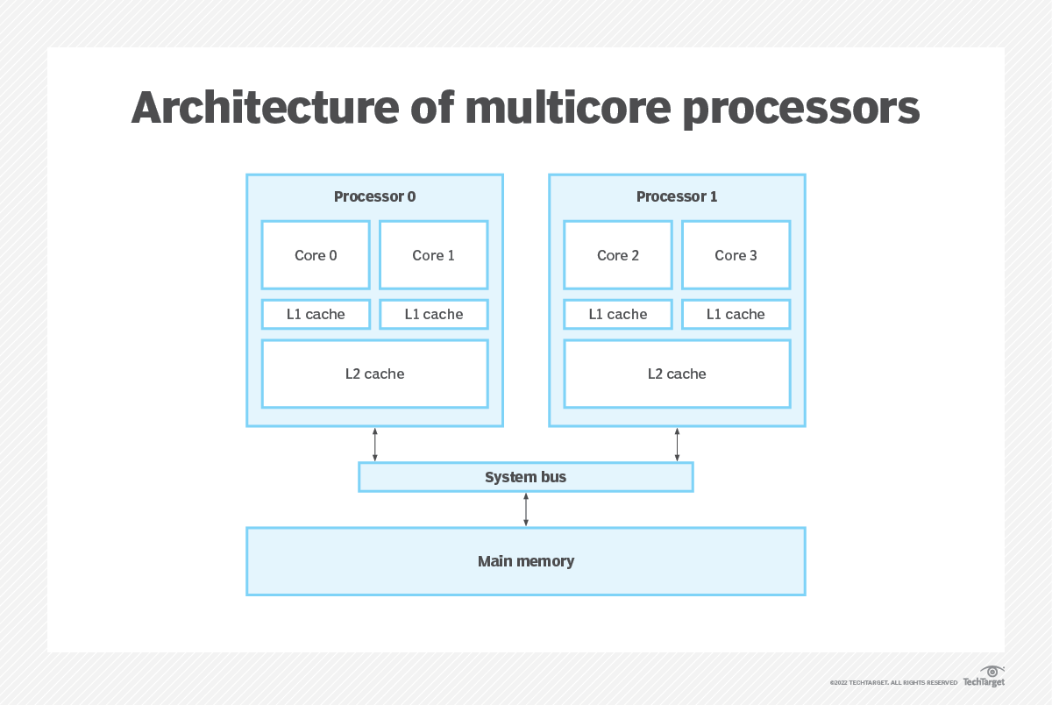**More chips.** The next step was to add processor chips -- or dies -- to the processor package, which is the physical device that plugs into the motherboard. A dual-core processor includes two separate processor cores. A [quad-core processor](https://www.techtarget.com/whatis/definition/quad-core-processor) includes four separate cores. Today's multicore processors can easily include 12, 24 or even more processor cores. The multicore approach is almost identical to the use of multiprocessor motherboards, which have two or four separate processor sockets. The effect is the same. Today's huge processor performance involves the use of processor products that combine fast clock speeds and multiple hyper-threaded cores.

However, multicore chips have several issues to consider. First, the addition of more processor cores doesn't automatically improve computer performance. The OS and applications must direct software program instructions to recognize and use the multiple cores. This must be done in parallel, using various threads to different cores within the processor package. Some software applications may need to be [refactored](https://www.techtarget.com/searchapparchitecture/definition/refactoring) to support and use multicore processor platforms. Otherwise, only the default first processor core is used, and any additional cores are unused or idle. (Bigelow, 2022)

Second, the performance benefit of additional cores is not a direct multiple. That is, adding a second core does not double the processor's performance, or a quad-core processor does not multiply the processor's performance by a factor of four. This happens because of the shared elements of the processor, such as access to internal memory or caches, external [buses](https://www.techtarget.com/searchstorage/definition/bus) and computer system memory.

The benefit of multiple cores can be substantial, but there are practical limits. Still, the acceleration is typically better than a traditional multiprocessor system because the coupling between cores in the same package is tighter and there are shorter distances and fewer components between cores.

Consider the analogy of cars on a road. Each car might be a processor, but each car must share the common roads and traffic limitations. More cars can transport more people and goods in a given time, but more cars also cause congestion and other problems.

* **What are multicore processors used for**

Multicore processors work on any modern computer hardware platform. Virtually all PCs and laptops today build in some multicore processor model. However, the true power and benefit of these processors depend on [software applications designed to emphasize parallelism](https://www.techtarget.com/searchdatamanagement/feature/GPU-databases-bring-greater-parallelism-to-big-data-processing). A parallel approach divides application work into numerous processing threads, and then distributes and manages those threads across two or more processor cores.

There are several major use cases for multicore processors, including the following five:

* **Virtualization.** A virtualization platform, such as VMware, is designed to abstract the software environment from the underlying hardware. Virtualization is capable of abstracting physical processor cores into virtual processors or central processing units ([vCPUs](https://www.techtarget.com/whatis/definition/virtual-CPU-vCPU)) which are then assigned to virtual machines ([VMs](https://searchservervirtualization.techtarget.com/definition/virtual-machine)). Each VM becomes a virtual server capable of running its own OS and application. It is possible to assign more than one vCPU to each VM, allowing each VM and its application to run parallel processing software if desired.
* **Databases.**A database is a complex software platform that frequently needs to run many simultaneous tasks such as queries. As a result, databases are highly dependent on multicore processors to distribute and handle these many task threads. The use of multiple processors in databases is often coupled with extremely high memory capacity that can reach 1 terabyte or more on the physical server.
* **Analytics and HPC.** [Big data analytics](https://www.techtarget.com/searchbusinessanalytics/definition/big-data-analytics), such as machine learning, and high-performance computing ([HPC](https://www.techtarget.com/searchdatacenter/definition/high-performance-computing-HPC)) both require breaking large, complex tasks into smaller and more manageable pieces. Each piece of the computational effort can then be solved by distributing each piece of the problem to a different processor. This approach enables each processor to work in parallel to solve the overarching problem far faster and more efficiently than with a single processor.
* **Cloud.**Organizations building a cloud will almost certainly adopt multicore processors to support all the virtualization needed to accommodate the highly scalable and highly transactional [demands of cloud software platforms](https://www.techtarget.com/searchcloudcomputing/feature/7-key-characteristics-of-cloud-computing) such as OpenStack. A set of servers with multicore processors can allow the cloud to create and scale up more VM instances on demand.
* **Visualization.**Graphics applications, such as games and data-rendering engines, have the same parallelism requirements as other HPC applications. Visual rendering is math- and task-intensive, and visualization applications can make extensive use of multiple processors to distribute the calculations required. Many graphics applications rely on graphics processing units ([GPUs](https://searchvirtualdesktop.techtarget.com/definition/GPU-graphics-processing-unit)) rather than CPUs. GPUs are tailored to optimize graphics-related tasks. GPU packages often contain multiple GPU cores, similar in principle to multicore processors.
* **Pros and cons of multicore processors**

Multicore processor technology is mature and well-defined. However, the technology poses its share of pros and cons, which should be considered when buying and deploying new servers.

* **Multicore advantages**

**Better application performance.** The principle benefit of multicore processors is more potential processing capability. Each processor core is effectively a separate processor that OSes and applications can use. In a virtualized server, each VM can employ one or more virtualized processor cores, enabling many VMs to coexist and operate simultaneously on a physical server. Similarly, an application designed for high levels of parallelism may use any number of cores to provide [high application performance](https://searchservervirtualization.techtarget.com/tip/How-CPU-and-memory-affect-application-performance) that would be impossible with single-chip systems. (Bigelow, 2022)

**Better hardware performance.** By placing two or more processor cores on the same device, it can use shared components -- such as common internal buses and processor caches -- more efficiently. It also benefits from superior performance compared with multiprocessor systems that have separate processor packages on the same motherboard.

* **Multicore disadvantages**

**Software dependent.** The application uses processors -- not the other way around. OSes and applications will always default to use the first processor core, dubbed *core 0*. Any additional cores in the processor package will remain unused or idle until software applications are enabled to use the them. Such applications include database applications and big data processing tools like [Hadoop](https://www.techtarget.com/searchdatamanagement/definition/Hadoop). A business should consider what a server will be used for and the applications it plans to use before making a multicore system investment to ensure that the system delivers its optimum computing potential.

**Performance boosts are limited.** Multiple processors in a processor package must share common system buses and processor caches. The more processor cores share a package, the more sharing must take place across common processor interfaces and resources. This results in diminishing returns to performance as cores are added. For most situations, the performance benefit of having multiple cores far outweighs the performance lost to such sharing, but it's a factor to consider when testing application performance.

**Power, heat and clock restrictions.** A computer may not be able to drive a processor with many cores as hard as a processor with fewer cores or a single-core processor. A modern processor core may contain over 500 million transistors. Each transistor generates heat when it switches, and this heat increases as the clock speed increases. All of that heat generation must be safely dissipated from the core through the processor package. When more cores are running, this heat can multiply and quickly exceed the cooling capability of the processor package. Thus, some multicore processors may actually reduce clock speeds -- for instance, from 3.5 GHz to 3.0 GHz -- to help manage heat. This reduces the performance of all processor cores in the package. High-end [multicore processors require complex cooling systems](https://www.techtarget.com/searchdatacenter/feature/Data-center-liquid-cooling-market-heats-up) and careful deployment and monitoring to ensure long-term system reliability. (Bigelow, 2022)

* **Architecture of multicore processors**

For the purposes of this definition, every multicore processor consists of two or more cores along with a series of caches.

* **Cores** are the central components or multicore processors. Cores contain all of the registers and circuitry -- sometimes hundreds of millions of individual transistors -- needed to perform the closely-synchronized tasks of [ingesting data](https://www.techtarget.com/whatis/definition/data-ingestion) and instruction, processing that content and outputting logical decisions or results.
* **Processor support** circuitry includes an assortment of input/output control and management circuitry, such as clocks, cache consistency, power and thermal control and external bus access.
* **Caches** are relatively small areas of very fast memory. A cache retains often-used instructions or data, making that content readily available to the core without the need to access system memory. A processor checks the cache first. If the required content is present, the core takes that content from the cache, enhancing performance benefits. If the content is absent, the core will access system memory for the required content. A Level 1, or [L1](https://www.techtarget.com/whatis/definition/L1-and-L2), cache is the smallest and fastest cache unique to every core. A Level 2, or L2, cache is a larger storage space shared among the cores. Some multicore processor architectures may dedicate both L1 and L2 caches.
* **Examples of multicore processors**

Most modern processors designed and sold for general-purpose x86 computing include multiple processor cores. Examples of latest [Intel 12th-generation multicore processors](https://www.intel.com/content/www/us/en/products/docs/processors/core/12th-gen-processors.html) include the following:

* Intel Core i9 12900 family provides 8 cores and 24 threads.
* Intel Core i7 12700 family provides 8 cores and 20 threads.
* Top Intel Core i5 12600K processors offer 6 cores and 16 threads.

Examples of latest [AMD Zen multicore processors](https://www.amd.com/en/technologies/zen-core) include:

* AMD Zen 3 family provides 4 to 16 cores.
* AMD Zen 2 family provides up to 64 cores.
* AMD Zen+ family provides 4 to 32 cores.

(Bigelow, 2022)

## **Cloud security**

Traditionally, security concerns have been the primary obstacle for organizations considering cloud services, particularly public cloud services. In response to demand, however, the security offered by cloud service providers is steadily outstripping on-premises security solutions. (IBM, 2023)

Maintaining cloud security demands different procedures and employee skillsets than in legacy IT environments. Some cloud security best practices include the following:

* **Shared responsibility for security:** Generally, the cloud provider is responsible for securing cloud infrastructure and the customer is responsible for protecting its data within the cloud—but it's also important to clearly define data ownership between private and public third parties.
* **Data encryption:** Data should be encrypted while at rest, in transit, and in use. Customers need to maintain full control over security keys and hardware security module.
* **User identity and access management:** Customer and IT teams need full understanding of and visibility into network, device, application, and data access.
* **Collaborative management:** Proper communication and clear, understandable processes between IT, operations, and security teams will ensure seamless cloud integrations that are secure and sustainable.
* **Security and compliance monitoring:** This begins with understanding all regulatory compliance standards applicable to your industry and setting up active monitoring of all connected systems and cloud-based services to maintain visibility of all data exchanges between public, private, and hybrid cloud environments.

## **Cloud use cases**

With 25% of organizations planning to move *all*their applications to cloud within the next year, it would seem that cloud computing use cases are limitless. But even for companies not planning a wholesale shift to the cloud, certain initiatives and cloud computing are a match made in IT heaven. (IBM, 2023)

[Disaster recovery](https://www.ibm.com/topics/disaster-recovery) and business continuity have always been a natural for cloud because cloud provides cost-effective redundancy to protect data against system failures and the physical distance required to recover data and applications in the event of a local outage or disaster. All of the major public cloud providers offer Disaster-Recovery-as-a-Service (DRaaS).

Anything that involves storing and processing huge volumes of data at high speeds—and requires more storage and computing capacity than most organizations can or want to purchase and deploy on-premises—is a target for cloud computing. Examples include:

* Big data analytics
* Internet of Things (IoT)
* [Artificial intelligence](https://www.ibm.com/topics/artificial-intelligence)—particularly [machine learning](https://www.ibm.com/topics/machine-learning) and [deep learning](https://www.ibm.com/topics/deep-learning) applications

For development teams adopting Agile or [DevOps](https://www.ibm.com/topics/devops" \t "_blank) (or [DevSecOps](https://www.ibm.com/topics/devsecops" \t "_blank)) to streamline development, cloud offers the on-demand end-user self-service that keeps operations tasks—such as spinning up development and test servers—from becoming development bottlenecks.

## **Characteristics and advantages of cloud computing**

Cloud computing has been around for several decades now, and today's cloud computing infrastructure demonstrates an array of characteristics that have brought meaningful benefits for businesses of all sizes. Some of the [main characteristics of cloud computing](https://www.techtarget.com/searchcloudcomputing/feature/7-key-characteristics-of-cloud-computing) are the following:

* **Self-service provisioning.**End users can spin up compute resources for almost any type of workload on demand. An end user can provision computing capabilities, such as server time and network storage, eliminating the traditional need for IT administrators to provision and manage compute resources.
* **Elasticity.**Companies can freely scale up as computing needs increase and scale down again as demands decrease. This eliminates the need for massive investments in local infrastructure, which might or might not remain active.
* **Pay per use.**Compute resources are measured at a granular level, enabling users to pay only for the resources and workloads they use.
* **Workload resilience.**CSPs often implement redundant resources to ensure resilient storage and to keep users' important workloads running -- often across multiple global regions. (Chai, 2022)
* **Migration flexibility.**Organizations can [move certain workloads to or from the cloud](https://www.techtarget.com/searchcloudcomputing/tip/Choose-the-right-on-premises-to-cloud-migration-method) -- or to different cloud platforms -- as desired or automatically for better cost savings or to use new services as they emerge.
* **Broad network access.**A user can access cloud data or upload data to the cloud from anywhere with an internet connection using any device.
* 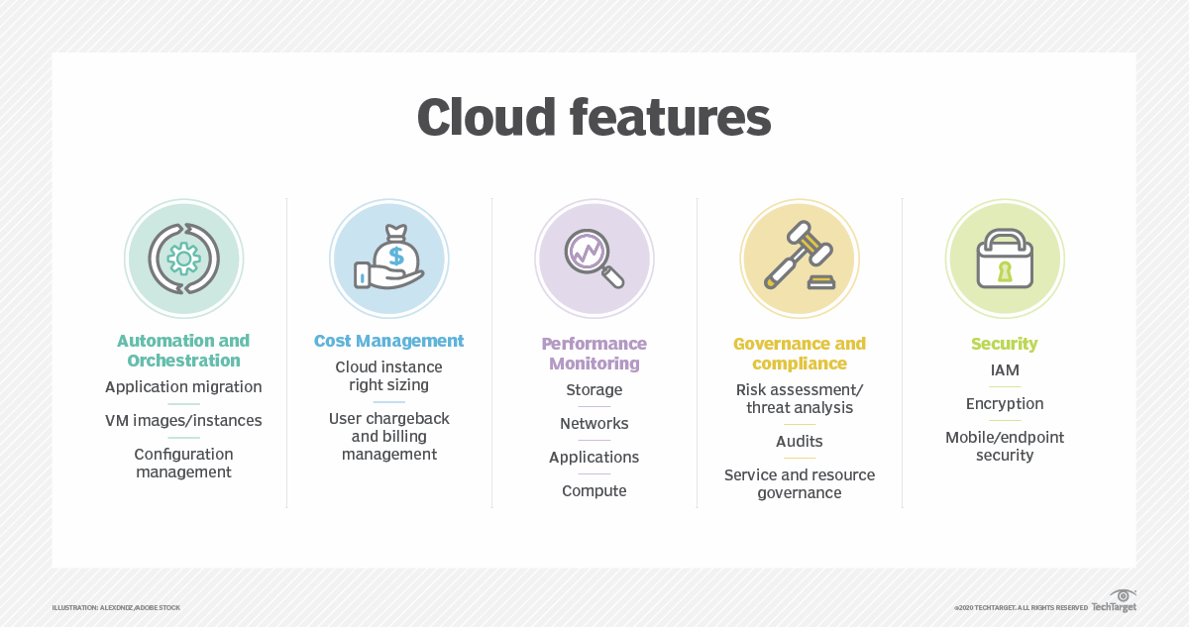**Multi-tenancy and resource pooling.**Multi-tenancy lets numerous customers share the same physical infrastructures or the same applications yet still retain privacy and security over their own data. With resource pooling, cloud providers service numerous customers from the same physical resources. The resource pools of the cloud providers should be large and flexible enough so they can service the requirements of multiple customers.

These characteristics support a variety of [important benefits for modern business](https://www.techtarget.com/searchcloudcomputing/tip/Top-11-benefits-of-cloud-computing), including the following:

* **Cost management.**Using cloud infrastructure can reduce capital costs, as organizations don't have to spend massive amounts of money buying and maintaining equipment. This reduces their capital expenditure costs -- as they don't have to invest in hardware, facilities, utilities or building large data centers to accommodate their growing businesses. Additionally, companies don't need large IT teams to handle cloud data center operations because they can rely on the expertise of their cloud providers' teams. Cloud computing also cuts costs related to downtime. Since downtime rarely happens in cloud computing, companies don't have to spend time and money to fix any issues that might be related to downtime.
* **Data and workload mobility.**Storing information in the cloud means that users can access it from anywhere with any device with just an internet connection. That means users don't have to carry around USB drives, an external hard drive or multiple CDs to access their data. Users can access corporate data via smartphones and other mobile devices, enabling remote employees to stay up to date with co-workers and customers. End users can easily process, store, retrieve and recover resources in the cloud. In addition, cloud vendors provide all the upgrades and updates automatically, saving time and effort.
* **Business continuity and disaster recovery (**[BCDR](https://www.techtarget.com/searchdisasterrecovery/definition/Business-Continuity-and-Disaster-Recovery-BCDR)**).**All organizations worry about data loss. Storing data in the cloud guarantees that users can always access their data even if their devices, e.g., laptops or smartphones, are inoperable. With cloud-based services, organizations can quickly recover their data in the event of emergencies, such as natural disasters or power outages. This benefits BCDR and helps ensure that workloads and data are available even if the business suffers damage or disruption.
* **What are the disadvantages of cloud computing**

Despite the clear upsides to relying on cloud services, [cloud computing carries its own challenges](https://www.techtarget.com/searchcloudcomputing/tip/Explore-the-pros-and-cons-of-cloud-computing) for IT professionals:

* [**Cloud security**](https://searchcompliance.techtarget.com/definition/cloud-computing-security)**.** Security is often considered the greatest challenge facing cloud computing. When relying on the cloud, organizations risk data breaches, hacking of APIs and interfaces, compromised credentials and authentication issues. Furthermore, there is a lack of transparency regarding how and where sensitive information entrusted to the cloud provider is handled. Security demands careful attention to cloud configurations and business policy and practice.
* **Cost unpredictability.** [Pay-as-you-go subscription plans for cloud use](https://www.techtarget.com/searchstorage/definition/pay-as-you-go-cloud-computing-PAYG-cloud-computing), along with scaling resources to accommodate fluctuating workload demands, can make it tough to define and predict final costs. Cloud costs are also frequently interdependent, with one cloud service often utilizing one or more other cloud services -- all of which appear in the recurring monthly bill. This can create additional unplanned cloud costs. (Chai, 2022)
* **Lack of capability and expertise.** With cloud-supporting technologies rapidly advancing, organizations are struggling to keep up with the growing demand for tools and [employees with the proper skill sets](https://www.techtarget.com/whatis/feature/Top-20-cloud-computing-skills-to-boost-your-career) and knowledge needed to architect, deploy, and manage workloads and data in a cloud.
* **IT governance.**The emphasis on do-it-yourself capability in cloud computing can make IT governance difficult, as there is no control over provisioning, deprovisioning and management of infrastructure operations. This can make it challenging to properly manage risks and security, IT compliance and data quality.
* **Compliance with industry laws.**When transferring data from on-premises local storage into cloud storage, it can be difficult to manage compliance with industry regulations through a third party. It's important to know where data and workloads are actually hosted in order to maintain regulatory compliance and proper business governance.
* **Management of multiple clouds.** Every cloud is different, so multi-cloud deployments can disjoint efforts to address more general cloud computing challenges.
* **Cloud performance.** Performance -- such as latency -- is largely beyond the control of the organization contracting cloud services with a provider. Network and provider outages can interfere with productivity and disrupt business processes if organizations are not prepared with contingency plans.
* **Building a private cloud.**Architecting, building and managing private clouds -- whether for its own purpose or for a hybrid cloud goal -- can be a daunting task for IT departments and staff.
* **Cloud migration.**The process of [moving applications and other data to the cloud often causes complications](https://www.techtarget.com/searchcloudcomputing/tip/Prepare-for-these-4-cloud-migration-problems). Migration projects frequently take longer than anticipated and go over budget. The issue of workload and data repatriation -- moving from the cloud back to a local data center -- is often overlooked until unforeseen cost or performance problems arise.
* **Vendor lock-in.**Often, switching between cloud providers can cause significant issues. This includes technical incompatibilities, legal and regulatory limitations and substantial costs incurred from sizable data migrations.

## **Cloud computing examples and use cases**

Cloud computing has evolved and diversified into a wide array of offerings and capabilities designed to suit almost any conceivable business need. Examples of cloud computing capabilities and diversity include the following:

* **Google Docs, Microsoft 365.**Users can access Google Docs and Microsoft 365 through the internet. Users can be more productive because they can access work presentations and spreadsheets stored in the cloud at anytime from anywhere on any device. (Chai, 2022)
* **Email, Calendar, Skype, WhatsApp.**Emails, calendars, Skype and WhatsApp take advantage of the cloud's ability to provide users with access to data remotely so they can access their personal data on any device, whenever and wherever they want.
* **Zoom.** Zoom is a cloud-based software platform for video and audio conferencing that records meetings and saves them to the cloud, enabling users to access them anywhere and at any time. Another common communication and collaboration platform is Microsoft Teams.
* **AWS Lambda.**Lambda enables developers to run code for applications or back-end services without having to provision or manage servers. The pay-as-you-go model constantly scales with an organization to accommodate real-time changes in data usage and data storage. Other major cloud providers also support serverless computing capabilities, such as Google Cloud Functions and Azure Functions.

So, how is the cloud actually used? The myriad services and capabilities found in modern public clouds have been applied across countless use cases, such as the following:

* **Testing and development.** Ready-made, tailored environments can expedite timelines and milestones.
* **Production workload hosting.** Organizations are using the public cloud to host live production workloads. This requires careful design and architecture of cloud resources and services needed to create an adequate operational environment for the workload and its required level of resilience.
* [**Big data analytics**](https://www.techtarget.com/searchbusinessanalytics/definition/big-data-analytics)**.** Remote data centers through cloud storage are flexible and scalable and can provide valuable data-driven insights. Major cloud providers offer services tailored to big data projects, such as Amazon EMR and Google Cloud Dataproc.
* **IaaS.** IaaS enables companies to host IT infrastructures and access compute, storage and network capabilities in a scalable manner. Pay-as-you-go subscription models can help companies save on upfront IT costs.
* **PaaS.** PaaS can help companies develop, run and manage applications in an easier and more flexible way, at a lower cost than maintaining a platform on premises. PaaS services can also increase development speed for applications and enables higher-level programming.
* **Hybrid cloud.** Organizations have the option to use the appropriate cloud -- private or public -- for different workloads and applications to optimize cost and efficiency according to the circumstance.
* **Multi-cloud.** Using multiple different cloud services from separate cloud providers can help subscribers find the best cloud service fit for diverse workloads with specific requirements.
* **Storage.** Large amounts of data can be stored remotely and accessed easily. Clients only have to pay for storage that they actually use.
* **DR.** Cloud offers faster recovery than traditional on-premises DR. Furthermore, it is offered at lower costs.
* **Data backup.** Cloud backup solutions are generally easier to use. Users do not have to worry about availability and capacity, and the cloud provider manages data security.

# **Chapter 2: Design an appropriate architectural Cloud Computing framework for a given scenario**

## **Cloud Computing Architecture**

[Cloud Computing](https://www.geeksforgeeks.org/cloud-computing/) , which is one of the demanding technology of the current time and which is giving a new shape to every organization by providing on demand virtualized services/resources. Starting from small to medium and medium to large, every organization use cloud computing services for storing information and accessing it from anywhere and any time only with the help of internet. In this article, we will know more about the internal architecture of cloud computing. (Satyabrata\_Jena, 2023)

Transparency, scalability, security and intelligent monitoring are some of the most important constraints which every cloud infrastructure should experience. Current research on other important constraints is helping cloud computing system to come up with new features and strategies with a great capability of providing more advanced cloud solutions.

* **Cloud Computing Architecture:**
* Frontend
* Backend

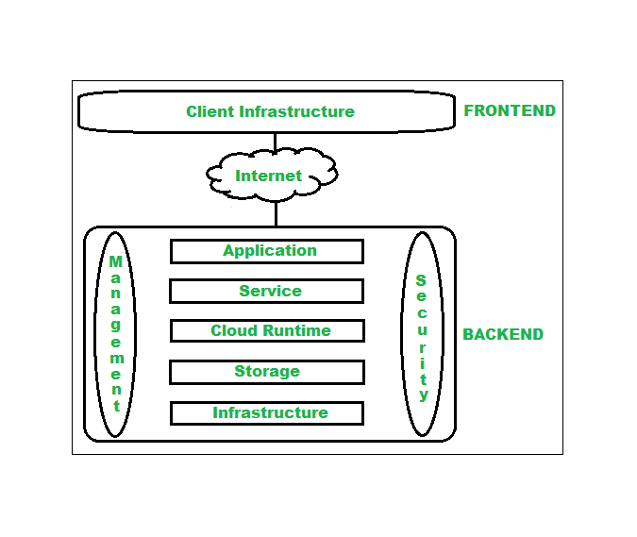The below figure represents an internal architectural view of cloud computing.

Architecture of cloud computing is the combination of both [SOA (Service Oriented Architecture)](https://www.geeksforgeeks.org/service-oriented-architecture/) and EDA (Event Driven Architecture). Client infrastructure, application, service, runtime cloud, storage, infrastructure, management and security all these are the components of cloud computing architecture.

## **Frontend:**

Frontend of the cloud architecture refers to the client side of cloud computing system. Means it contains all the user interfaces and applications which are used by the client to access the cloud computing services/resources. For example, use of a web browser to access the cloud platform.

* Client Infrastructure – Client Infrastructure is a part of the frontend component. It contains the applications and user interfaces which are required to access the cloud platform.
* In other words, it provides a GUI( Graphical User Interface ) to interact with the cloud.

## **Backend:**

Backend refers to the cloud itself which is used by the service provider. It contains the resources as well as manages the resources and provides security mechanisms. Along with this, it includes huge storage, virtual applications, virtual machines, traffic control mechanisms, deployment models, etc. (Satyabrata\_Jena, 2023)

* **Application –** Application in backend refers to a software or platform to which client accesses. Means it provides the service in backend as per the client requirement.
* **Service –** Service in backend refers to the major three types of cloud based services like [SaaS, PaaS and IaaS](https://www.geeksforgeeks.org/cloud-based-services/). Also manages which type of service the user accesses.
* **Runtime Cloud –** Runtime cloud in backend provides the execution and Runtime platform/environment to the Virtual machine.
* **Storage –** Storage in backend provides flexible and scalable storage service and management of stored data.
* **Infrastructure –** Cloud Infrastructure in backend refers to the hardware and software components of cloud like it includes servers, storage, network devices, virtualization software etc.
* **Management –** Management in backend refers to management of backend components like application, service, runtime cloud, storage, infrastructure, and other security mechanisms etc.
* **Security –** Security in backend refers to implementation of different security mechanisms in the backend for secure cloud resources, systems, files, and infrastructure to end-users.
* **Internet –** Internet connection acts as the medium or a bridge between frontend and backend and establishes the interaction and communication between frontend and backend.
* **Database –** Database in backend refers to provide database for storing structured data, such as SQL and NOSQL databases. Example of Databases services include Amazon RDS, Microsoft Azure SQL database and Google CLoud SQL.
* **Networking –** Networking in backend services that provide networking infrastructure for application in the cloud, such as load balancing, DNS and virtual private networks.
* **Analytics –** Analytics in backend service that provides analytics capabillities for data in the cloud, such as warehousing, bussness intellegence and machine learning.
* **Benefits of Cloud Computing Architecture:**
* Makes overall cloud computing system simpler.
* Improves data processing requirements.
* Helps in providing high security.
* Makes it more modularized.
* Results in better disaster recovery.
* Gives good user accessibility.
* Reduces IT operating costs.
* Provides high level reliability.
* Scalability.

## **Layers of Cloud Architecture**

If we consider the users’ access to the cloud then depending on the user’s liberty to access cloud entities, we can classify the cloud architecture into four layers. (T, 2022)

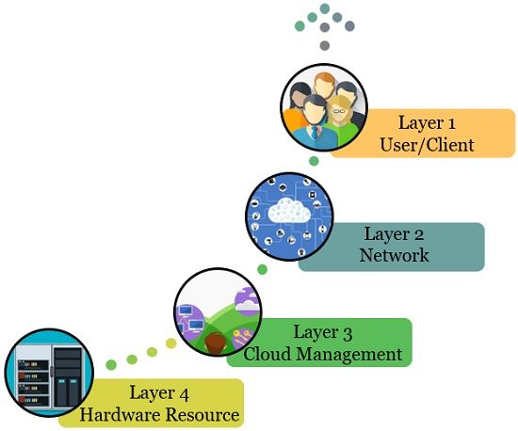

* **Layer 1 (User/ Client Layer)**

It is the topmost layer of cloud architecture. The actors of this layer are the end users and the clients. The clients are the devices that can either be a thick client, a thin client, or a mobile device capable of accessing the web application.

Here a thick client is a computer that is capable of working independently. It is the one with adequate processing capability. Whereas, the thin client is the one with the low processing capability. It depends on another device for complete functionality.

At layer 1, the user and client initiate to connect themselves to the cloud. Accessing cloud applications is similar to accessing web applications.

Access to both types of applications requires the internet or other computer networks. Although the internal properties of the cloud application are different from web applications. Hence, we require layer 1 to set up the connection between the user/client and the cloud.

* **Layer 2 (Network Layer)**

Layer 2 or the network layer is responsible for connecting users to the cloud. The absence of a network layer wouldn’t work for the cloud. Because the entire infrastructure of the cloud depends on the connection where it offers the services to the users.

For accessing the public cloud we make connections using the internet. For accessing the private cloud, the connectivity is established using the local area network, i.e. (LAN). Each kind of connection requires a minimum bandwidth specified by the cloud providers.

However, the network layer is beyond the cloud SLA i.e. service level agreement. SLA promises a minimum level of services to cloud customers. SLA does not consider the connection between the cloud and the user for quality of service (QoS).

* **Layer 3 (Cloud Management Layer)**

The layer is responsible for managing the cloud services. It includes the software that manages the working of the cloud. The software used at this layer can be:

* Cloud OS (Operating System)
* Software is responsible for creating an interface between the cloud and its users.
* Software for managing the resources.

The software at the cloud management layer is responsible for:

* Managing resources (scheduling the cloud services, provisioning resources, etc.)
* Optimization (Server consolidation i.e. reducing the total number of servers of the company by making efficient use of server resources, workload consolidation i.e. integrating multiple computational operations onto fewer platforms, storage consolidation i.e. centralizing the data storage and minimizing the time required to access data)
* Internal cloud governance, the network layer comes under close surveillance of SLA. Thus, the operations that take place at this layer will affect the agreement that SLA decide between the cloud users and the providers.
* So, a delay in connecting to the cloud would also result in a violation of SLA. In such cases, the providers have to pay penalties. The SLA purviews are both public and private and could for any violation.
* **Layer 4 (Hardware Resource Layer)**

It defines the provision of hardware resources. Layer 4 of a public cloud is the huge data centre. Whereas layer 4 of the private cloud is constructed with a huge collection of hardware resources. These resources are interconnected to each other and are present at a specific location or it may be a high configuration system.

The hardware resource layer comes under the purview of service layer agreements (SLAs). We can even say that the layer governs SLAs. As we have discussed previously that the user must be able to access the cloud services as quick as possible. If there occurs any discrepancy in the provisioning of the hardware resources then the provider might have to pay the penalty.

So, the hardware resource layer of any cloud architecture must consist of data centres with high-speed network connections. The data centre must have a highly efficient algorithm that facilitates data transfer from the data centre to the manager.

## **Architecture design for ATN organization.**

The ATN's cloud architecture should be built in a similar way to the framework created. Only the ATN board director has the right to change or export data, while the four scattered ATN shop managers have the capability to submit transaction data. All end users communicate with the database using the website application interface, and the database is managed and maintained through a contract with a single Cloud service provider. This framework will make the company's data exchange procedures quicker, more effective, and easier.

# **Chapter 3: Define an appropriate deployment model for a given scenario**

Similar to how the framework was developed, the cloud architecture of the ATN should be designed. The cloud architecture of the ATN should be designed with only the ATN board director having the authority to alter or export data, while the dispersed ATN shop managers can submit transaction data. The database is administered and maintained by a single Cloud service provider, and all end users interact with it through the website application interface. This framework will simplify, accelerate, and make data interchange processes more efficient.

* **Management:** The service provider will manage open infrastructure management, data protection, and cloud maintenance. Additionally, there are resources available to meet the needs of the business if it decides to build or upgrade its infrastructure.
* **Financial:** Due to the fact that renewal is a public model, a paid service, and there are no time restrictions, it is frequently not unreasonably expensive. Also, there is no upfront cost. We are using the service of the provider, therefore we won't need to bother about hardware.
* **Publicity:** The key difference between this service and other cloud computing services is that it is unrestricted on the public internet, allowing customers to access data from anywhere. This allows the management board to access data from various branches without having to travel to each one in person.

The public cloud is the perfect model for ATN’s organization because cloud computing is a service that joins several servers, so if a problem arises, the publisher's server will quickly take over, allowing operations to be maintained without interruption. This ensures excellent system performance and almost no downtime.

# **Chapter 4: Compare the service models for choosing an adequate model for a given scenario**

|  |  |  |  |
| --- | --- | --- | --- |
| **Basis Of** | **IaaS** | **PaaS** | **SaaS** |
| **Stands for** | Infrastructure as a service. | Platform as a service. | Software as a service. |
| **Uses** | IAAS is used by network architects. | PAAS is used by developers. | SAAS is used by the end user. |
| **Access** | IAAS gives access to the resources like virtual machines and virtual storage. | PAAS gives access to run time environment to deployment and development tools for application. | SAAS gives access to the end user. |
| **Model** | It is a service model that provides virtualized computing resources over the internet. | It is a cloud computing model that delivers tools that are used for the development of applications. | It is a service model in cloud computing that hosts software to make it available to clients. |
| **Technical understanding** | It requires technical knowledge. | Some knowledge is required for the basic setup. | There is no requirement about technicalities company handles everything. |
| **Popularity** | It is popular among developers and researchers. | It is popular among developers who focus on the development of apps and scripts. | It is popular among consumers and companies, such as file sharing, email, and networking. |
| **Percentage rise** | It has around a 12% increment. | It has around 32% increment. | It has about a 27 % rise in the cloud computing model. |
| **Usage** | Used by the skilled developer to develop unique applications. | Used by mid-level developers to build applications. | Used among the users of entertainment. |
| **Cloud services** | Amazon Web Services, sun, vCloud Express. | Facebook, and Google search engine. | MS Office web, Facebook and Google Apps. |
| **Enterprise services** | AWS virtual private cloud. | Microsoft Azure. | IBM cloud analysis. |
| **Outsourced cloud services** | Salesforce. | Force.com, Gigaspaces. | AWS, Terremark. |
| **User Controls** | Operating System, Runtime, Middleware, and Application data. | Data of the application. | Nothing. |
| **Others** | It is highly scalable and flexible. | It is highly scalable to suit the different businesses according to resources. | It is highly scalable to suit the small, mid and enterprise level business. |

(ayushjoshi599, 2023)

The most crucial information in this article is that Platform as a Service (PaaS) is the best solution for ATN since it gives developers a foundation upon which to build and use to produce original apps. PaaS and SaaS vary in that PaaS acts as a development platform for both finished and ongoing cloud applications, whereas SaaS simply hosts finished cloud applications. At every level of software development, from planning to design to application development to deployment and maintenance, ATN gains from the PaaS model. ATN can create and build applications that are incorporated into the PAAS by using special software elements known as middleware, thanks to the PAAS.

* It is possible to develop and deliver agile apps.
* Is able to focus on the most important business resources without worrying about infrastructure costs.
* A PaaS provider's platforms are updated and enhanced versions that enable the development of apps using cutting-edge technologies.
* Minimizes the time needed for development while improving output. The backend activities of the cloud platform environment are not necessary for the developer to understand.

Among the cloud service providers are Google Cloud, Microsoft Azure, Amazon Web Services, and others. Heroku, on the other hand, is a Platform-as-a-Service option for an ATN situation that is user-friendly and presently supports a wide array of programming languages. Operating systems and other internal system configurations don't need to be managed because Heroku executes and maintains applications for you. Additionally, it conceals the whole server's complexity behind a straightforward web interface, making deployments as easy as a single click. Heroku is available to ATN for free, including the service itself as well as a number of add-ons, or they can choose to pay monthly as they go.

# References

anukruti16, 2023. *geeksforgeeks.* [Online]   
Available at: https://www.geeksforgeeks.org/evolution-of-cloud-computing/  
[Accessed 21 5 2023].

Awati, R., 2021. *TechTarget.* [Online]   
Available at: https://www.techtarget.com/searchdatacenter/definition/high-performance-computing-HPC  
[Accessed 22 5 2023].

ayushjoshi599, 2023. *geeksforgeeks.* [Online]   
Available at: https://www.geeksforgeeks.org/difference-between-iaas-paas-and-saas/  
[Accessed 26 5 2023].

Bhatia, V., 2023. *synopsy.* [Online]   
Available at: https://www.synopsys.com/cloud/insights/essential-cloud-computing-characteristics.html#:~:text=The%20National%20Institute%20of%20Standards,rapid%20elasticity%2C%20and%20measured%20service.  
[Accessed 22 5 2023].

Bigelow, S. J., 2022. *TechTarget.* [Online]   
Available at: https://www.techtarget.com/searchdatacenter/definition/multi-core-processor#:~:text=A%20multicore%20processor%20is%20an,with%20parallel%20processing%20and%20multithreading.  
[Accessed 22 5 2023].

Brush, K., 2021. *TechTarget.* [Online]   
Available at: https://www.techtarget.com/searchitoperations/definition/virtualization  
[Accessed 22 5 2023].

Chai, W., 2022. *TechTarget.* [Online]   
Available at: https://www.techtarget.com/searchcloudcomputing/definition/cloud-computing  
[Accessed 21 5 2023].

Dale, N., 2021. *WikiJob.* [Online]   
Available at: https://www.wikijob.co.uk/industry/it-technology/peer-to-peer-network#examples-of-p2p-networks  
[Accessed 21 5 2023].

IBM, 2023. *IBM.* [Online]   
Available at: https://www.ibm.com/topics/cloud-computing  
[Accessed 23 5 2023].

Rosencrance, L., 2021. *TechTarget.* [Online]   
Available at: https://www.techtarget.com/whatis/SaaS-IaaS-PaaS-Comparing-Cloud-Service-Models#:~:text=There%20are%20three%20major%20cloud,use%20and%20subscription%20pricing%20models.  
[Accessed 22 5 2023].

Rosencrance, L., 2022. *TechTarget.* [Online]   
Available at: https://www.techtarget.com/searchnetworking/definition/peer-to-peer  
[Accessed 21 5 2023].

sameekshakhandelwal1712, 2023. *geeksforgeeks.* [Online]   
Available at: https://www.geeksforgeeks.org/cloud-deployment-models/  
[Accessed 22 5 2023].

Satyabrata\_Jena, 2023. *geeksforgeeks.* [Online]   
Available at: https://www.geeksforgeeks.org/architecture-of-cloud-computing/#article-meta-div  
[Accessed 24 5 2023].

Sutarwala, Z., 2023. *The Crazy Programmer.* [Online]   
Available at: https://www.thecrazyprogrammer.com/2021/03/client-server-architecture.html  
[Accessed 21 5 2023].

syedmodassirali, 2022. *geeksforgeeks.* [Online]   
Available at: https://www.geeksforgeeks.org/client-server-model/  
[Accessed 21 5 2023].

T, N., 2022. *Binary Terms.* [Online]   
Available at: https://binaryterms.com/cloud-architecture.html  
[Accessed 24 5 2023].

tutorialspoint, 2023. *tutorialspoint.* [Online]   
Available at: https://www.tutorialspoint.com/software\_architecture\_design/distributed\_architecture.htm  
[Accessed 22 5 2023].

tutorialspoint, 2023. *tutorialspoint.* [Online]   
Available at: https://www.tutorialspoint.com/parallel\_computer\_architecture/parallel\_computer\_architecture\_models.htm  
[Accessed 22 5 2023].

tutorialspoint, 2023. *tutorialspoint.* [Online]   
Available at: https://www.tutorialspoint.com/what-is-cluster-computing  
[Accessed 22 5 2023].