[Function]

* Learn about basic data visualization on Jupyter Notebook.
* Create a basic web app that displays data visualization.

[Materials]

* Resource:
  + Review.csv file -> Data about course.
* Module:
  + Pandas -> read data resource.
  + MathLibPlot -> plot data.
  + Justpy
    - Justpy -> QuaserPage: create web app
    - Justpy -> HighCharts -> create charts

[Result]

* Single line chart

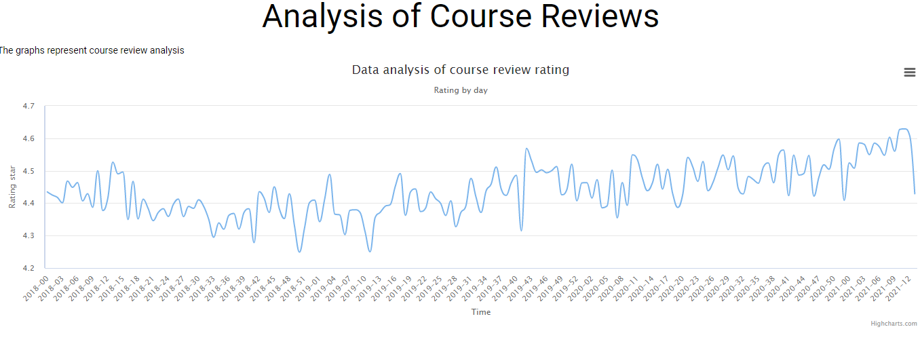

* Multi line chart

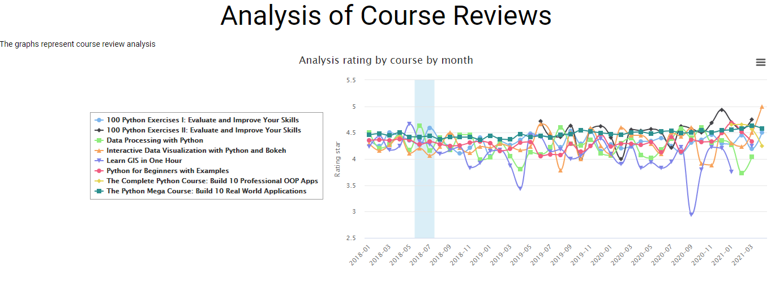

* Pie chart

