[Function]

* Create app using kivy framework and convert to APK file to install on android devices

[Materials]

* Modules:
  + Kivy framework: -> create app to deploy in android
  + Buildozer -> convert to apk file (build in Linux)

[Steps]

1. Create source code (separate UI to .kv file)
2. Convert to APK file (Using Linux - Ubuntu)
   1. Run kivy-buildozer-installer.sh file -> install dependence packages, clone buildozer project, create environment.
   2. Run: buildozer init -> config buildozer.spec file
   3. Run: buildozer android debug/release -> create APK file

[Result]

* Login screen:

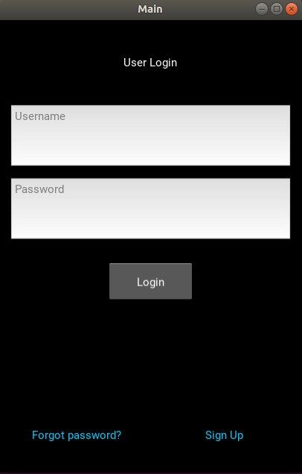

* Sign up screen:

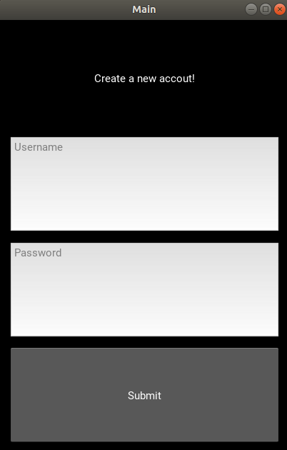

* Main screen:
* 