[Function]

* Create a web map of Volcanoes of North America and Population in the world
* Layer control between Volcanoes and Population

[Materials]

* Resource:
  + Volcanoes.txt file -> list volcanoes info.
  + World.json -> population data
* Module:
  + Pandas -> read csv file
  + Folium -> model to create map
    - FeatureGroup -> group of features
    - Marker -> Volcanoes marker
    - GeoJson -> Population parsing
    - LayerControl -> Control layer Volcanoes and Population

[Result]

* Volcanoes

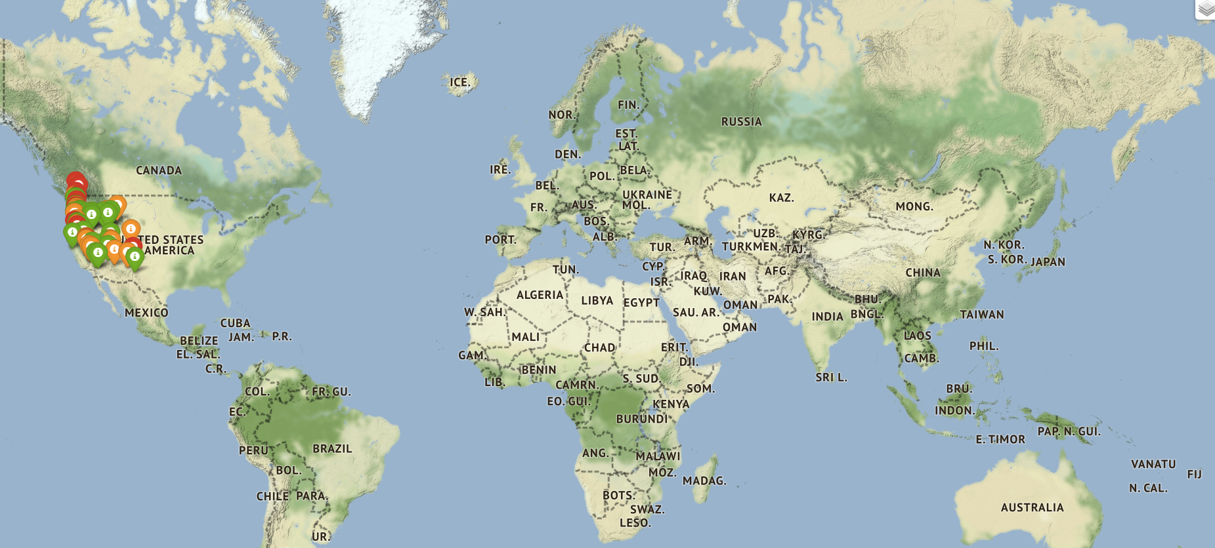

* Population

