## Introduction to Software Engineering

# CMPS 2313

**Home Work #1 NAME: Trinidad Mario Dena**

1. Your first problem is to write a program where you find all the prime numbers in a range of numbers provided by the user (prime numbers between 8 and 20 are 11, 13, 17, 19)
   1. List the possible requirements for the project

* User friendly
* Platform (Web, Desktop, Mobile)
* Timeframe
* Point and click or keyboard based
* Type of user
* Secureness
* Different kinds of input methods
* Different types of data or one type
* Budget
  1. Create a flow chart for the sequence of activities in coding the project

Identify customer requirements -> Analyze requirements -> Analyze possible problems and implementations -> Design structure of the project -> Schedule design and development of parts of the project -> Test the project -> Implement and support the project

* 1. Estimate how much time to complete the project.

1 hour. 30 minutes of thinking. 30 minutes of coding and testing.

* 1. Keep track of your actual time and compare it to your estimate

1:16:59.37

I spent a good deal of time researching the best way to determine if a number is a prime number. Spent about the same amount of time implementing and ensuring proper functionality.

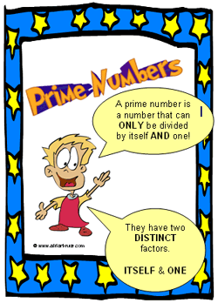

* 1. Write the program (be sure it is user friendly, accurate, and efficient)

<https://github.com/Trinidena/CLASSES/tree/main/CMPS_2313_CLASS_WORK/HW1_Prime_Numbers>

I used SceneBuilder to create the interface the user would interact with. The interface consists of two fields to enter values into, a beginning (from) and an end (to) box. Next to these fields is a button to start the program. The user may also start the program by pressing the enter key. After the user enters two eligible numbers, the program determines the prime numbers in the range. The range is inclusive at the first number and inclusive to the last number entered. I imported the BigInteger class to use the isProbablePrime() method to check all numbers in the range entered by the user. A for loop is used to check each number in the range. If the number is a prime number then it is added to a StringBuilder object. I use this object to display the results to the answer textbox in the lower half of the window. I also added a warning that pops up if the user enters anything but a number into the range.