Predictive Model Development and Validation for Outpatient Appointment No-Shows at University of Port Harcourt Teaching Hospital (UPTH)
Trinitas Chideziri Iwunze
BAN6800 Capstone
Nexford University
Module 4: Predictive Model Development & Validation Pack
Lecturer: Dr Raphael Wanjiku
September 21, 2026.
1. Business Need and Target Definition
Missed outpatient appointments are a common challenge in healthcare because they can lead to wasted appointment slots, disruption of patient flow, and poor use of hospital resources. In my capstone project, I am focusing on this problem in the context of the University of Port Harcourt Teaching Hospital (UPTH). Building on the work I completed in Modules 1–3, this stage of the project focuses on developing and validating a machine learning model that can help identify appointments that are more likely to result in a no-show.
The model is designed as a decision-support tool for hospital staff rather than a replacement for human judgement. Its predictions could help authorized staff identify patients who may need additional reminders or follow-up before their appointments. An important principle throughout my project is that a patient should never have an appointment automatically cancelled or be denied healthcare simply because the model predicts that the patient may not attend.
Predictive Task and Target Variable
For this project, I treated appointment no-show prediction as a binary classification problem. Each scheduled outpatient appointment represents one observation in the dataset. The target variable is NoShow, where 0 means that the patient attended the appointment and 1 means that the patient did not attend.
After completing the data preparation and validation work in Module 3, my final dataset contained 110,521 appointment records. Of these, 88,207 (79.81%) represented attended appointments, while 22,314 (20.19%) were no-shows. This shows that the dataset is imbalanced because there are considerably fewer no-shows than attended appointments.
Because of this imbalance, I did not want to judge the models using accuracy alone. I also evaluated precision, recall, F1-score, and ROC-AUC to obtain a better understanding of how well each model identified patients who actually missed their appointments.
The prediction is intended to be made before the scheduled appointment takes place. This is important because the purpose of the model is to provide information early enough for hospital staff to take supportive action, such as sending an additional reminder.
Success Criteria
For this project, a successful model should not simply achieve high overall accuracy. I gave particular attention to recall for the no-show class because a model that fails to identify most patients who eventually miss their appointments would have limited practical value.
At the same time, I considered precision and F1-score because identifying too many patients incorrectly as likely no-shows could create unnecessary follow-up work for hospital staff. I also used ROC-AUC to assess how well each model could distinguish between attended and missed appointments.
Model performance was only one part of my evaluation. The assignment also requires the model to be explainable and evaluated for fairness, rather than relying only on predictive performance. For this reason, I included explainability and fairness testing as important parts of my success criteria.
Fairness Objectives
I used age and gender as the main protected attributes in my fairness analysis. My aim was to determine whether the model behaved differently across these demographic groups, especially in terms of how frequently patients were predicted as no-shows and how accurately actual no-shows were identified.
I examined demographic parity, disparate impact, true-positive rates, and false-positive rates as part of my fairness assessment (Bird et al., 2020). Where the analysis identified noticeable differences between groups, I investigated them further rather than assuming that every difference automatically represented unfairness. I also tested a mitigation approach by removing Age from the model and comparing the resulting fairness and performance measures.
Throughout the project, I maintained the principle that the model should support human decision-making rather than make healthcare decisions independently. Any prediction of no-show risk should therefore be used for supportive actions, such as reminders and appointment planning, and not for automatically cancelling appointments or restricting access to care.
2. Data Readiness and Feature Set
For this stage of the project, I used the cleaned appointment dataset prepared in Module 3. After the data cleaning and validation process, the final dataset contained 110,521 appointment records. Using the same validated dataset helped me maintain consistency between the data preparation work completed in Module 3 and the predictive modelling carried out in this module. The assignment specifically requires the cleaned Module 3 dataset to be used for modelling.
Feature Preparation
Before training the models, I prepared the variables so that they could be used appropriately by the machine learning algorithms. I used 13 predictors:
- Gender
- Age
- Neighbourhood
- Scholarship
- Hipertension
- Diabetes
- Alcoholism
- Handcap
- SMS_received
- AppointmentLeadTime
- ScheduledDayOfWeek
- AppointmentDayOfWeek
- ScheduledHour
Some additional features were derived from the appointment dates. I converted ScheduledDay and AppointmentDay to datetime format and extracted the scheduled day of the week, appointment day of the week, and scheduled hour. AppointmentLeadTime, which represents the time between scheduling and the actual appointment, was also included because it provides useful information about how long a patient had to wait for an appointment.
Because machine learning models require numerical inputs, I used one-hot encoding for the categorical variables Gender and Neighborhood. Numerical variables were standardized for Logistic Regression using StandardScaler. I placed these preprocessing steps inside a scikit-learn pipeline so that the same transformations were consistently applied during training and testing (Pedregosa et al., 2011).
Leakage Prevention
I paid particular attention to data leakage because information that would only become available after the appointment should not be used to predict whether the patient will attend.
The target variable, NoShow, was therefore kept separate from the predictor variables and was never included as an input feature. I also limited the predictors to information that could reasonably be available before the appointment outcome was known. This was important because including information related to the final outcome could make the model appear more accurate during testing than it would be in actual use.
The dataset was divided into training and testing sets before model evaluation. The test data were kept separate from model training so that I could evaluate performance on appointments that the models had not previously seen.
Class Imbalance and Data Bias
When I examined the target variable, I found that 79.81% of appointments were attended and 20.19% were no-shows. This imbalance was important because a model could achieve relatively high accuracy simply by predicting that most patients would attend.
This became clear when I created a majority-class baseline. The baseline achieved approximately 79.81% accuracy, but its precision, recall, and F1-score for the no-show class were all 0, with a ROC-AUC of 0.50. This confirmed that accuracy alone would give a misleading impression of model performance.
To address the imbalance during model development, I tested class weighting using class_weight="balanced" in Logistic Regression and Random Forest. I also used a stratified train/test split so that the proportion of attended and no-show appointments remained approximately the same in both datasets.
In addition to class imbalance, I considered possible demographic bias. Age and gender were retained for fairness assessment, allowing me to compare prediction rates and model errors across demographic groups later in the analysis. This was important because the assignment requires data bias and leakage risks to be documented before evaluating model fairness.
3. Model Development and Tuning
After preparing the data, I divided the dataset into 80% training data and 20% testing data using a stratified split. This gave me 88,416 training records and 22,105 testing records while maintaining a similar proportion of no-shows in both sets.
I started with a majority-class baseline model. Although it achieved 79.81% accuracy, it failed to identify any actual no-shows, giving a no-show recall and F1-score of zero. This confirmed that accuracy alone was not a suitable measure for this project.
I then developed and compared Logistic Regression, Balanced Logistic Regression, and Random Forest models. The Balanced Logistic Regression improved no-show recall to 0.5857, while the initial Random Forest achieved the highest ROC-AUC of 0.7388 but had a low no-show recall of 0.1620.
To improve the identification of no-shows, I tuned the Random Forest using three-fold cross-validation across six parameter combinations. The tuned model used 150 trees, a maximum depth of 20, and balanced class weights. It achieved a ROC-AUC of 0.7383, no-show recall of 0.6892, precision of 0.3321, and F1-score of 0.4483. I selected this as my main candidate because it identified considerably more actual no-shows while maintaining useful overall discrimination.
I also used MLflow to record the final model parameters and evaluation metrics and registered the model as UPTH_No_Show_Random_Forest Version 1. MLflow provides experiment tracking and model management capabilities that support reproducibility and model lifecycle management (MLflow, 2026a, 2026b). This provided a clear record of the model selected for further explainability and fairness evaluation, as required in the assignment.

Table 1. Model Performance Comparison
Model | Accuracy | Precision | Recall | F1 | ROC-AUC
Baseline | 0.7981 | 0.0000 | 0.0000 | 0.0000 | 0.5000
Logistic Regression | 0.7956 | 0.3632 | 0.0164 | 0.0313 | 0.6632
Balanced Logistic Regression | 0.6547 | 0.3113 | 0.5857 | 0.4065 | 0.6685
Random Forest | 0.7943 | 0.4729 | 0.1620 | 0.2413 | 0.7388
Tuned Random Forest | 0.6575 | 0.3321 | 0.6892 | 0.4483 | 0.7383
Note. Precision, recall, and F1 refer to the no-show class.

4. Model Validation and Performance Interpretation
I evaluated the tuned Random Forest on the 22,105 records in the test set using the confusion matrix, ROC curve, precision, recall, F1-score, and ROC-AUC. This allowed me to look beyond overall accuracy and understand how the model performed specifically when identifying no-shows, as required for model validation.
The confusion matrix showed that the model correctly identified 3,076 actual no-shows, while 1,387 no-shows were incorrectly predicted as attended. It also correctly classified 11,457 attended appointments, while 6,185 attended appointments were incorrectly flagged as possible no-shows. This explains why the model achieved a relatively strong no-show recall of 0.6892 but a lower precision of 0.3321.
For my project, this trade-off is important. The model can identify about 69% of actual no-shows, but it also produces many false-positive predictions. Therefore, I would use the predictions to support low-risk actions such as additional reminders or follow-up rather than automatically cancelling or changing a patient's appointment.
The ROC curve produced an AUC of 0.7383, showing that the model has useful ability to distinguish between attended and missed appointments. However, the results also show that the model is not perfect and should remain a decision-support tool with human oversight.

Figure 1. Confusion Matrix for the Tuned Random Forest Model
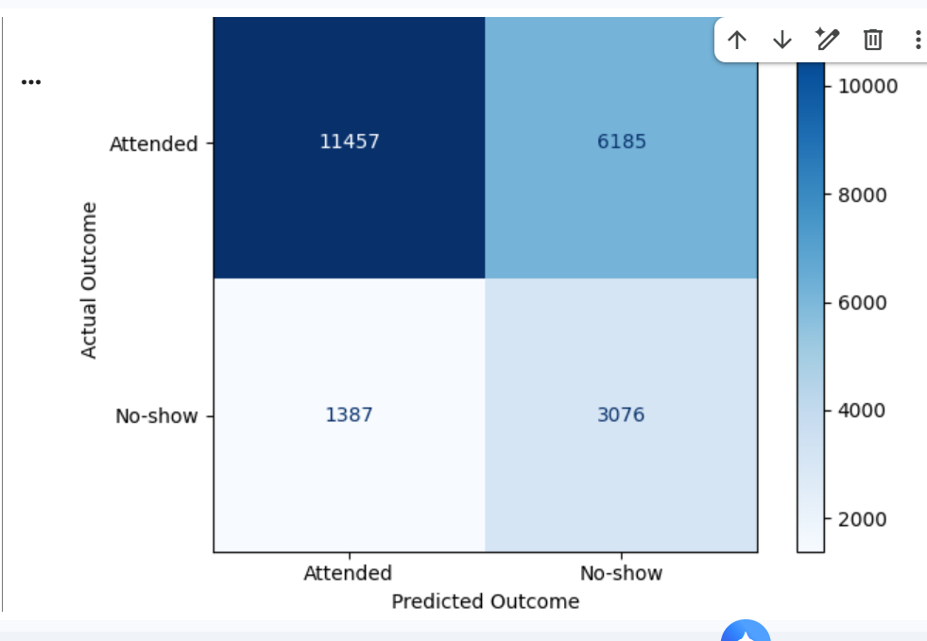

Figure 2. ROC Curve for the Tuned Random Forest Model
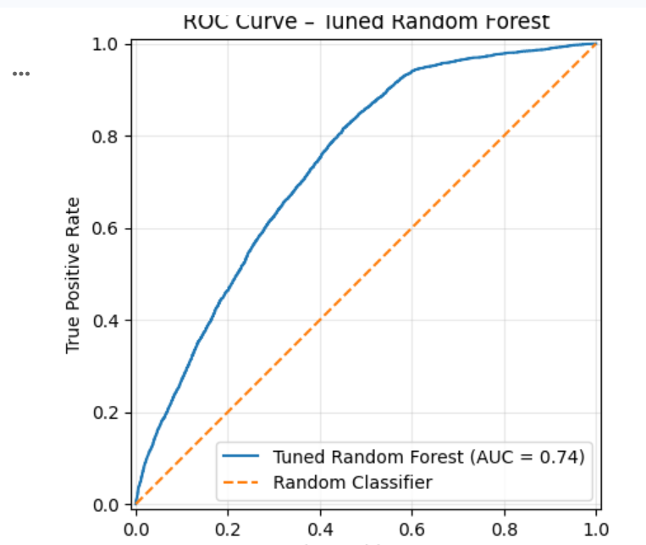

5. Explainability, Fairness, and Bias Mitigation
To understand how the model made its predictions, I used SHAP for both global and individual explanations. SHAP provides a game-theoretic approach for explaining the contribution of features to model predictions (Lundberg & Lee, 2017). The global SHAP analysis showed that AppointmentLeadTime and Age were among the most influential features, followed by factors such as SMS received and ScheduledHour. This helped me understand which variables contributed most to the model's predictions rather than treating the model as a black box. The assignment requires both global and local explainability evidence.
For the local explanation, I examined one individual appointment using a SHAP waterfall plot. The patient was an actual no-show, while the model predicted a no-show probability of 0.4853. I also carried out a counterfactual analysis by changing AppointmentLeadTime while keeping the other characteristics unchanged. The predicted probability changed as lead time changed, showing that this feature influenced the individual prediction. However, I treated this as an explanation of model behavior rather than evidence of a causal relationship.
I also assessed fairness across gender and age groups. For gender, the demographic parity difference was 0.0483, while the disparate impact ratio was 0.8892. Differences were more noticeable across age groups. For example, patients aged 18–34 had a predicted no-show rate of 59.90%, compared with 12.06% for patients aged 65 and above.
To investigate this further, I tested a mitigation approach by removing Age from the model. After mitigation, the ROC-AUC decreased from 0.7383 to 0.7261, while no-show recall increased from 0.6892 to 0.7336. Differences between age groups were reduced in some areas but were not eliminated. This showed me that simply removing a protected attribute does not automatically remove bias because other variables may still contain related information. Therefore, fairness should continue to be monitored before and after any future deployment.
Figure 3. Global SHAP Summary Plot for the Tuned Random Forest
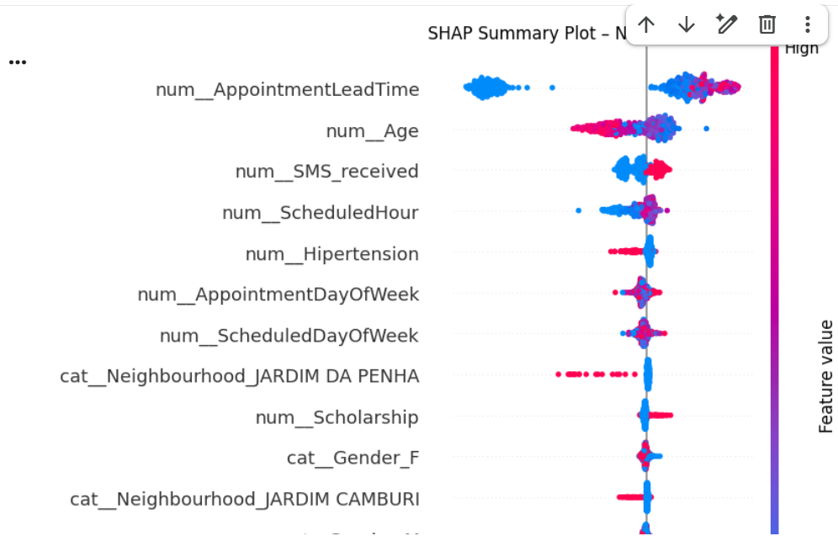.

Figure 4. Local SHAP Explanation for an Individual Appointment
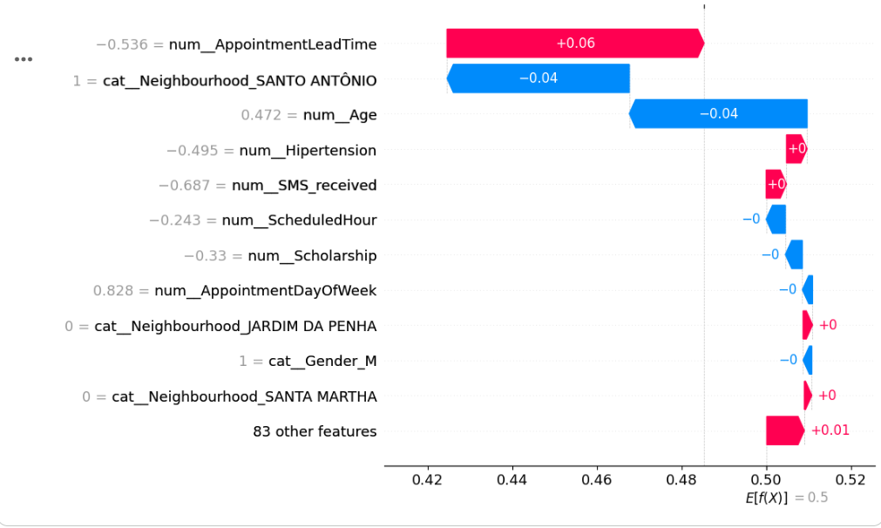
Table 2. Fairness Assessment Before and After Age Mitigation
Age Group | Records | Actual No-show Rate | Before Mitigation |  | After Mitigation
0–17 | 5,520 | 0.2136 |  | 0.5290 |  | 0.4906
18–34 | 4,850 | 0.2365 |  | 0.5990 |  | 0.5348
35–49 | 4,306 | 0.2095 |  | 0.5035 |  | 0.4984
50–64 | 4,511 | 0.1738 |  | 0.2031 |  | 0.4205
65+ | 2,918 | 0.1546 |  | 0.1206 |  | 0.3588

6. Sensitivity Analysis, Risks, Monitoring, and Deployment
To further understand the behavior of the model, I carried out a sensitivity analysis using AppointmentLeadTime because it was one of the most influential features identified by SHAP. For one test appointment, I changed the lead time while keeping the other features unchanged. The predicted no-show probability increased from 0.2662 at zero days to 0.5408 at 30 days and crossed the 0.50 classification threshold between the tested values of 3 and 7 days. This result applies to the selected appointment and should not be interpreted as proof that longer lead times cause patients to miss appointments.
I also considered the risks of using the model in practice. These include false-positive predictions, changes in patient behavior over time, and differences between the dataset used for this prototype and the actual UPTH patient population. For this reason, the model would require local validation before being used in a real hospital environment.
For monitoring, I tested Population Stability Index (PSI) on important features. AppointmentLeadTime, Age, SMS received, ScheduledHour, and AppointmentDayOfWeek all had PSI values below 0.10 when the training and test sets were compared. I would treat PSI below 0.10 as stable, 0.10–0.25 as requiring closer monitoring, and 0.25 or above as requiring investigation. This analysis provides a baseline for future monitoring rather than evidence of real production drift.
Finally, I serialized the tuned model as a joblib file and created a FastAPI /predict endpoint to demonstrate how predictions could be served. Any future deployment should continue to monitor model performance and fairness, and retraining should require validation and approval before a new model replaces the registered version. These steps address the assignment's requirement to connect model results with deployment risks and monitoring hooks.
Figure 5. Sensitivity Analysis of Appointment Lead Time
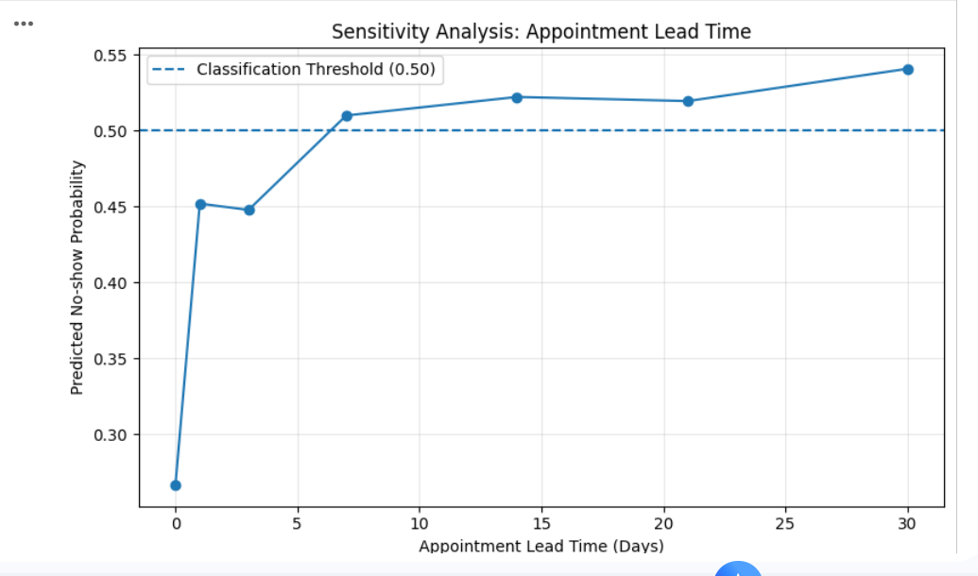
7. Conclusion
In this module, I developed and validated a predictive model for identifying outpatient appointments that may result in no-shows. After comparing several models, I selected the tuned Random Forest as my main candidate because it achieved a ROC-AUC of 0.7383 and identified 68.92% of actual no-shows.
The explainability analysis helped me understand how features such as AppointmentLeadTime and Age influenced predictions, while the fairness assessment showed that model performance and prediction rates varied across demographic groups. My mitigation experiment also showed that removing Age alone did not eliminate these differences.
Overall, the project demonstrates how machine learning could support appointment planning and reminder strategies. However, the model should remain a decision-support tool with human oversight. Before any real-world use at UPTH, it would require local validation, continued fairness assessment, performance monitoring, and appropriate governance.

References
Bird, S., Dudík, M., Edgar, R., Horn, B., Lutz, R., Milan, V., Sameki, M., Wallach, H., & Walker, K. (2020). Fairlearn: A toolkit for assessing and improving fairness in AI. Microsoft Research.
https://www.microsoft.com/en-us/research/publication/fairlearn-a-toolkit-for-assessing-and-improving-fairness-in-ai/
Lundberg, S. M., & Lee, S.-I. (2017). A unified approach to interpreting model predictions. Advances in Neural Information Processing Systems, 30, 4765–4774.
https://proceedings.neurips.cc/paper/2017/hash/8a20a8621978632d76c43dfd28b67767-Abstract.html
MLflow. (2026a). MLflow Model Registry.
https://mlflow.org/docs/latest/ml/model-registry/
MLflow. (2026b). MLflow Tracking.
https://mlflow.org/docs/latest/ml/tracking/
Pedregosa, F., Varoquaux, G., Gramfort, A., Michel, V., Thirion, B., Grisel, O., Blondel, M., Prettenhofer, P., Weiss, R., Dubourg, V., VanderPlas, J., Passos, A., Cournapeau, D., Brucher, M., Perrot, M., & Duchesnay, É. (2011). Scikit-learn: Machine learning in Python. Journal of Machine Learning Research, 12, 2825–2830.
https://www.jmlr.org/papers/v12/pedregosa11a.html

