C256 – Developer Introduction Notes

# Introduction to the C256 System

## Hardware

The C256 system uses a 65C816 micro-processor.

System clock is 14MHz.

Power supply required is +12V 1A with a 2.5mm plug.

Keyboard requires a PS/2 connector.

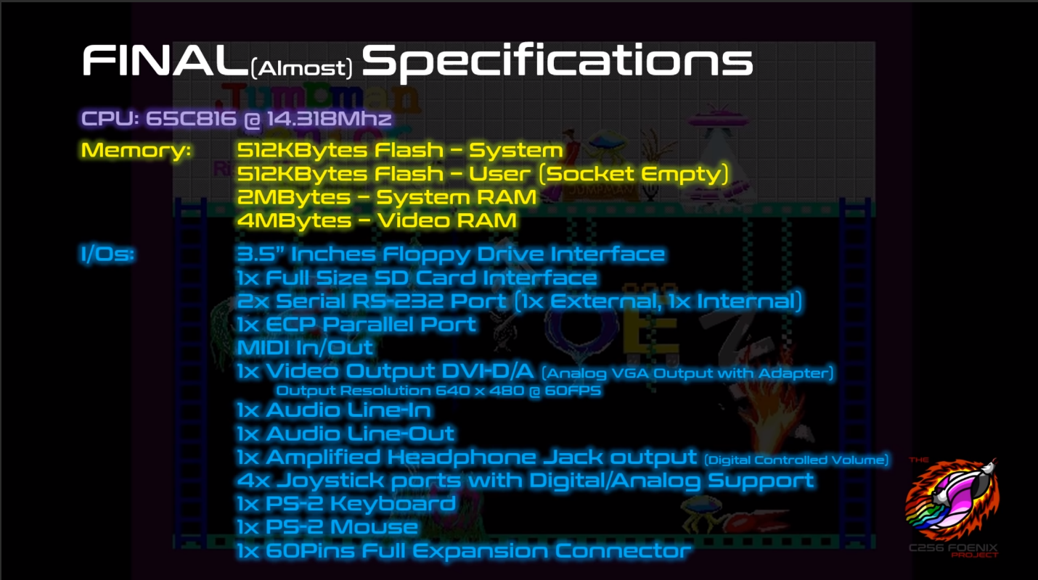

# Git Repositories

Foenix IDE: <https://github.com/Trinity-11/FoenixIDE.git>

C256 Kernel: <https://github.com/Trinity-11/Kernel>

# Tools

To modify the Foenix IDE, you will need Visual Studio 2017 Community edition for C#.

# Memory Map

The CPU can access 24-bit worth of addresses.

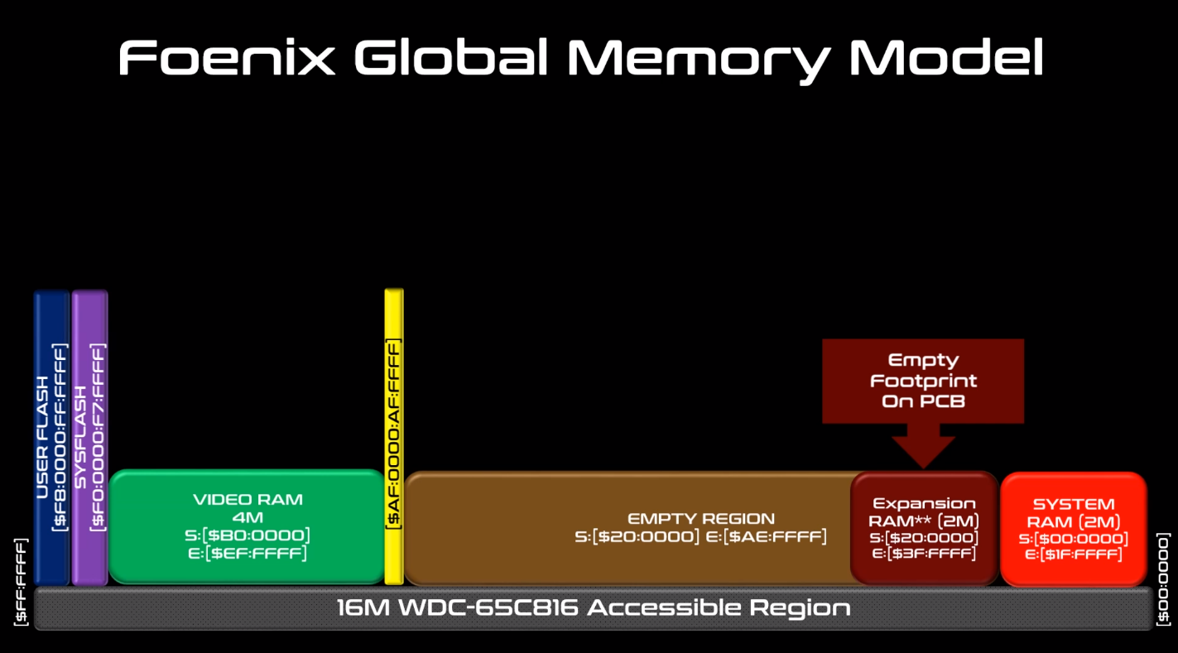

|  |  |  |
| --- | --- | --- |
| $FF:0000 - $FF:FFFF | Bank $FF | **16 MB Address Space** |
| $FE:0000 - $FE:FFFF | Bank $FE |
|  |  |
|  |  |
|  |  |
|  |  |
| $00:0000 - $01:FFFF | Bank $01 |
| $00:0000 - $00:FFFF | Bank $00 |

The address space is mapped as follows:

|  |  |
| --- | --- |
| $F8:0000 - $FF:FFFF | 512 KB User Flash (if populated) |
| $F0:0000 - $F7:FFFF | 512 KB System Flash |
| $B0:0000 - $EF:FFFF | 4 MB Video RAM |
| $AF:0000 - $AF:FFFF | IO Space |
| $40:0000 - $AE:FFFF | <empty> |
| $20:0000 - $3F:FFFF | 2 MB RAM (optional) |
| $00:0000 - $1F:FFFF | 2 MB RAM |

On boot, Gavin copies the first 64KB of the content of System Flash (or User Flash, if present) to Bank $00. The entire 512KB are copied to address range $18:0000 to $1F:FFFF.

IO Space is mapped to Vicky: $AF:0000 to $AF:DFFF and Beatrix: $AF:E000 to $AF:FFFF.

SuperIO address space includes KBD_DATA_BUF = 0xAF_1060 to KBD_STATUS_PORT = 0xAF_1064

## Gavin – Location $00:0000 to $00:FFFF

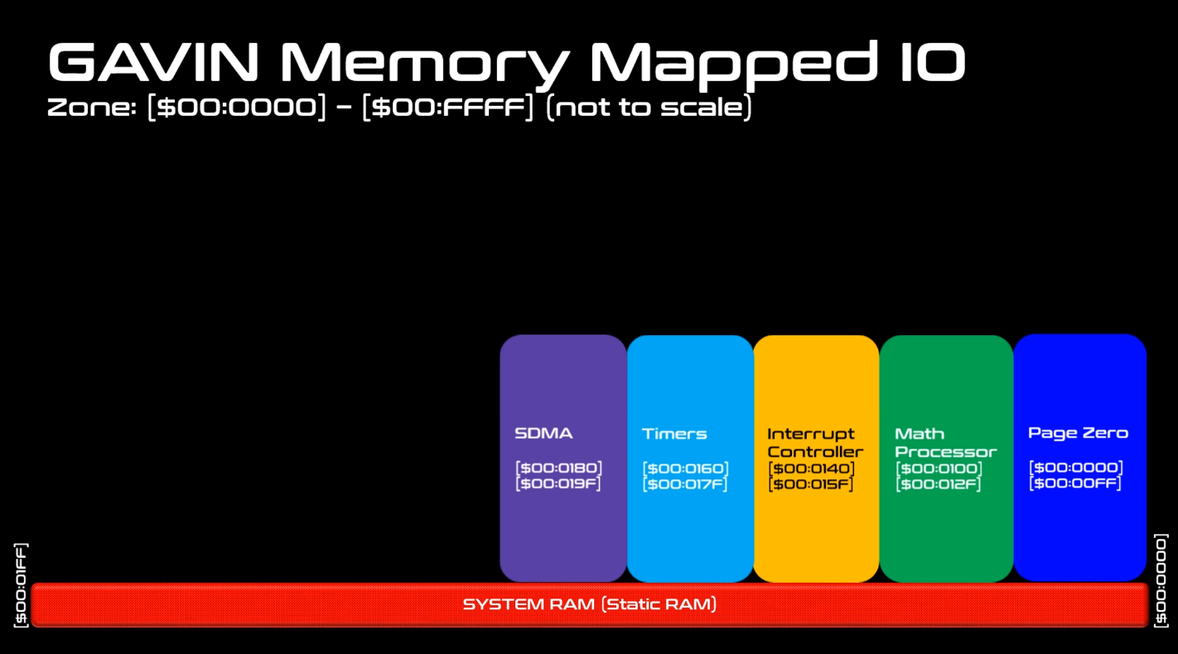

### Math Co-Processor

The C256 provides a math co-processor to perform long addition, multiplications and divisions.

To perform an operation, you write the little-endian values in the appropriate address locations and the results are automatically returned in the result addresses.

#### Multiplications

There are two multiplier locations: $00:0100 and $00:0108. Multiplier 0 is unsigned and Multiplier 1 is signed. Each operand must be 16-bits, and the result is 32-bits.

|  |  |  |
| --- | --- | --- |
| **Address** | **Name** | **Description** |
| $00:0100 | M0_OPERAND_A | 16-bit unsigned value |
| $00:0102 | M0_OPERAND_B | 16-bit unsigned value |
| $00:0104 | M0_RESULT | 32-bit unsigned result of the multiplication of A and B |

|  |  |  |
| --- | --- | --- |
| **Address** | **Name** | **Description** |
| $00:0108 | M1_OPERAND_A | 16-bit signed value |
| $00:010A | M1_OPERAND_B | 16-bit signed value |
| $00:010C | M1_RESULT | 32-bit signed result of the multiplication of A and B |

#### Divisions

There are two divider locations: $00:0110 and $00:0118. Divider 0 is unsigned and Divider 1 is signed. Each operand must be 16-bits. The result and remainder are 16-bits also.

|  |  |  |
| --- | --- | --- |
| **Address** | **Name** | **Description** |
| $00:0110 | D0_OPERAND_A | 16-bit unsigned value for the dividend |
| $00:0112 | D0_OPERAND_B | 16-bit unsigned value for the divisor |
| $00:0114 | D0_RESULT | 16-bit unsigned result for the quotient |
| $00:0116 | D0_REMAINDER | 16-bit unsigned result for the remainder |

|  |  |  |
| --- | --- | --- |
| **Address** | **Name** | **Description** |
| $00:0118 | D1_OPERAND_A | 16-bit signed value for the dividend |
| $00:011A | D1_OPERAND_B | 16-bit signed value for the divisor |
| $00:011C | D1_RESULT | 16-bit signed result for the quotient |
| $00:011E | D1_ REMAINDER | 16-bit signed result for the remainder |

#### Long Signed Additions

There is one long signed adder located at $00:0120. Both operands must be 32-bit signed integers. The result is also 32-bit signed.

|  |  |  |
| --- | --- | --- |
| **Address** | **Name** | **Description** |
| $00:0120 | ADDER32_A | 32-bit signed value |
| $00:0124 | ADDER32_B | 32-bit signed value |
| $00:0128 | ADDER32_R | 32-bit signed result of the addition of A and B |

### Interrupt Controller

INT_PENDING_REG0 = $000140 ;

INT_PENDING_REG1 = $000141 ;

INT_PENDING_REG2 = $000142 ;

; Polarity Set

INT_POL_REG0 = $000144 ;

INT_POL_REG1 = $000145 ;

INT_POL_REG2 = $000146 ;

; Edge Detection Enable

INT_EDGE_REG0 = $000148 ;

INT_EDGE_REG1 = $000149 ;

INT_EDGE_REG2 = $00014A ;

; Mask

INT_MASK_REG0 = $00014C ;

INT_MASK_REG1 = $00014D ;

INT_MASK_REG2 = $00014E ;

------------------------ (edited)

INTERRUPT LIST:

-----------------------------

INT_REG0 - Bit fields:

[0] - Not used Always 1

[1] = VICKY_INT0 - Start of Frame (for now)

[2] = VICKY_INT1 - Line Interrupt (For Split Screen)

[3] = Timer0

[4] = Timer1

[5] = Timer2

[6] = RTC Interrupt (Clock Alarm, etc..., See the chip spec for more detail for the registers: BQ4802

[7] = LPC_INT[6] - Floppy Disk Controller

--------------------------------- (edited)

INT_REG1

[0] = LPC_INT[1] Keyboard Interrupt (8042)

[1] = VICKY_INT2 - Sprite Collision

[2] = VICKY_INT3 - Tile Collision (TBD)

[3] = LPC_INT[3] - COM2 - Serial Port

[4] = LPC_INT[4] - COM1 - Serial Port

[5] = LPC_INT[5] - MPU-401 - Midi

[6] = LPC_INT[7] - LPT1 - Parallel Port

[7] = SDCARD Controller

---------------------------------------------

INT_REG2

[0] = OPL2_Right_Channel

[1] = OPL2_Left_Channel

[2] = Beatrix Interrupt (TBD)

[3] = Gavin DMA Controller

[4] = Always 1

[5] = DAC - Hot-Plug Interrupt

[6] = Expansion Port Connector Interrupt

[7] = Always 1

Interrupt Notes

At this time, the Polarity (INT_POL_REG#) and Edge (INT_EDGE_REG#) are not currently used. An IRQ is generated by setting the corresponding INT_REG# bit unless the corresponding mask bit is set in INT_MASK_REG#.

There are two ways you can use the Interrupts:

1. Either you let the IRQ being triggered by your Device and you process some code in the IRQ Handler
2. Or you can Poll the Interrupt from the Pending Register INT_PENDING_REG0/INT_PENDING_REG1/INT_PENDING_REG2 without triggering an actual interrupt

You would set the masked bit in the corresponding interrupt register to prevent the interrupt controller from generating an IRQ. Then you would poll the Pending Register and act on the fact that an Interrupt has been received. Note that you need to clear the interrupt pending register by writing back to it a bitmask of the bit you want cleared. You can do that at the beginning or at the end of the code you are trying to process.

INT_PENDING_REG# -> bit==1 means interrupt pending for that input  
INT_MASK_REG# -> bit==1 indicates this interrupt is masked, i.e. will not generate an IRQ when pending bit set  
(not used)INT_POL_REG# -> bit==1 indicates active high input  
(not used)INT_EDGE_REG# -> bit==1 indicates input edge triggered on polarity set by INT_POL_REG# (otherwise level triggered)

65C816 interrupt input pins  
RESET -> a reset signal, level-triggered  
NMI -> a non-maskable interrupt, edge-triggered  
IRQ -> a maskable interrupt, level-triggered  
ABORT -> a special-purpose, non-maskable interrupt level-triggered

## Vicky – Location $AF:0000 to $AF:DFFF

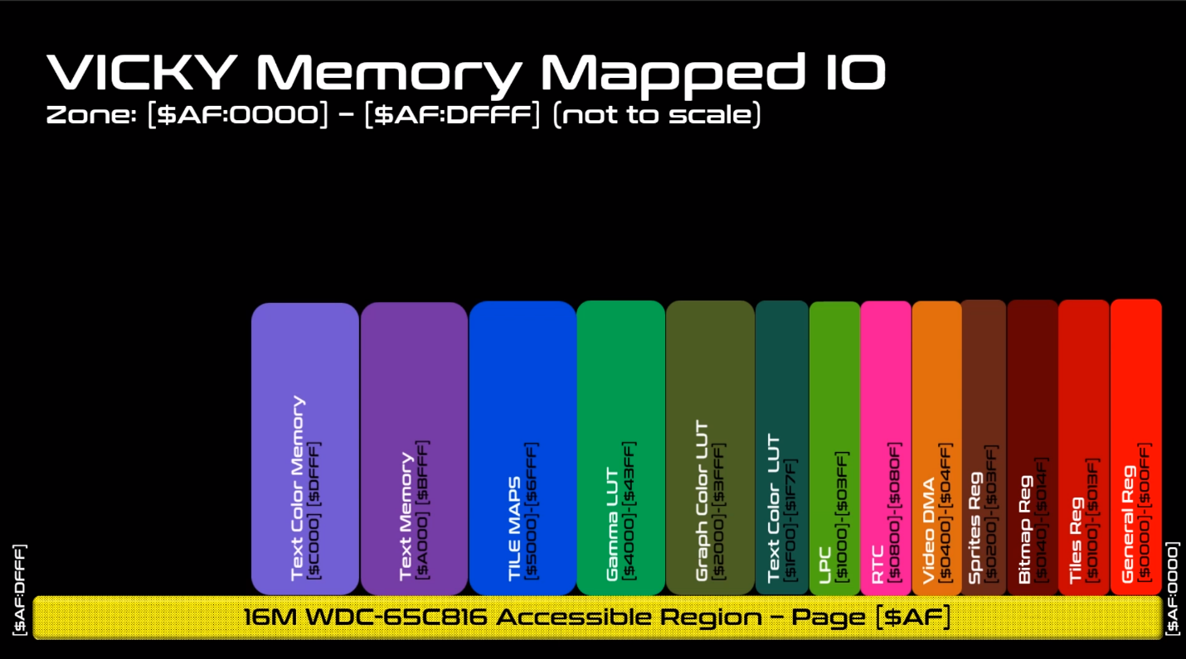

### Vicky Memory

|  |
| --- |
| $AF:0000 - $AF:00FF (Internal Memory) Vicky General Registers |
| BORDER_COLOR_B = $AF:0005 - when in text mode, this is the border color shown.  BORDER_COLOR_G = $AF:0006  BORDER_COLOR_R = $AF:0007 |
| BACKGROUND_COLOR_B = $AF:000D - When in Graphic Mode, if a pixel is "0" then the Background pixel is chosen  BACKGROUND_COLOR_G = $AF:000E  BACKGROUND_COLOR_R = $AF:000F |
| $AF:0100 - $AF:013F (Internal Memory) Vicky Tiles Registers |
| $AF:0140 - $AF:014F (Internal Memory) Vicky Bitmap Registers |
| $AF:0200 - $AF:03FF (Internal Memory) Vicky Sprites |
| $AF:0400 - $AF:04FF (Internal Memory) Vicky VDMA |
| $AF:0800 - $AF:080F Real-time clock (RTC) |

$AF:1F00 - $AF:1F3F (Internal Memory) Vicky Text Mode 16 Color Look-up Table Foreground Color

$AF:1F40 - $AF:1F7F (Internal Memory) Vicky Text Mode 16 Color Look-up Table Background Color

$AF:2000 - $AF:23FF (Internal Memory) Graphic Mode LUT0

$AF:2400 - $AF:27FF (Internal Memory) Graphics Mode LUT1

$AF:2800 - $AF:2BFF (Internal Memory) Graphics Mode LUT2

$AF:2C00 - $AF:2FFF (Internal Memory) Graphics Mode LUT3

$AF:4000 - $AF:40FF (External Memory) 256 Bytes GAMMA LUT - RED

$AF:4100 - $AF:41FF (External Memory) 256 Bytes GAMMA LUT - GREEN

$AF:4200 - $AF:42FF (External Memory) 256 Bytes GAMMA LUT – BLUE

FONT_MEMORY_BANK0 = $AF:8000 - $AF:8FFF

FONT_MEMORY_BANK1 = $AF:9000 - $AF:9FFF

### Screen Page 0 – Location $AF:A000

Screen Page 0 memory is used to store text characters for display.

One page of text is 128 columns by 64 rows. This adds up to 8 KB of memory of text. C256 does not display the entire buffer on the screen. Typically, we render 72 characters per row, with 56 rows.

This uses 576 x 448 of the available 640 x 480 resolution. The border size can be modified or turned off completely.

The display process reads Screen Page 0 and for each character, displays it’s character set bitmap.

### Screen Page 1 – Location $AF:C000

An additional page of 128 x 64 is used to store the colors. Each byte is split into foreground (4bits) and background (4 bits). The high nibble (bits 7..4) are the foreground and the low nibble (bits 3..0) are the background.

The colors used (the 4 bits) are used to lookup RBG values in two lookup tables (LUT).

The foreground (FG) LUT is located at $AF:1F40 for 64 bytes – only 16 x 3 = 48 bytes are used. The extra byte may be used for alpha (transparency) later on.

The background (BG) LUT is located at $AF:1F80 for 64 bytes – only 16 x 3 = 48 bytes are used. The extra byte may be used for alpha (transparency) later on.

The colors are assigned 8-bit blue, 8-bit green, 8-bit red, 8-bit alpha (not used) for each of those colors in Text Mode.

#### Example – Color Lookup

Consider the following Foreground and Background Lookup Tables

|  |  |
| --- | --- |
| Foreground Color Lookup Table, starting at address $AF:1F40 | Background Color Lookup Table, starting at address $AF:1F80 |
| |  |  |  |  |  |  | | --- | --- | --- | --- | --- | --- | | Index | Blue | Green | Red | Alpha | Color | | 0 | $00 | $00 | $00 | $FF | Black | | 1 | $00 | $00 | $80 | $FF | Maroon | | 2 | $00 | $80 | $00 | $FF | Green | | 3 | $80 | $00 | $00 | $FF | Navy | | 4 | $00 | $80 | $80 | $FF | Olive | | 5 | $80 | $80 | $00 | $FF | Teal | | 6 | $80 | $00 | $80 | $FF | Purple | | 7 | $80 | $80 | $80 | $FF | Gray | | 8 | $00 | $45 | $FF | $FF | Orange | | 9 | $13 | $45 | $8B | $FF | Brown | | A | $00 | $00 | $20 | $FF | Dark Red | | B | $00 | $20 | $00 | $FF | Dark Green | | C | $20 | $00 | $00 | $FF | Indigo | | D | $20 | $20 | $20 | $FF | Dark Gray | | E | $40 | $40 | $40 | $FF | Slate Gray | | F | $FF | $FF | $FF | $FF | White | | |  |  |  |  |  |  | | --- | --- | --- | --- | --- | --- | | Index | Blue | Green | Red | Alpha | Color | | 0 | $00 | $00 | $00 | $FF | Black | | 1 | $00 | $00 | $80 | $FF | Maroon | | 2 | $00 | $80 | $00 | $FF | Green | | 3 | $80 | $00 | $00 | $FF | Navy | | 4 | $00 | $20 | $20 | $FF | ?? | | 5 | $20 | $20 | $00 | $FF | ?? | | 6 | $20 | $00 | $20 | $FF | ?? | | 7 | $20 | $20 | $20 | $FF | ?? | | 8 | $1E | $69 | $D2 | $FF |  | | 9 | $13 | $45 | $8B | $FF | Brown | | A | $00 | $00 | $20 | $FF | Dark Red | | B | $00 | $20 | $00 | $FF | Dark Green | | C | $40 | $00 | $00 | $FF | Blue | | D | $10 | $10 | $10 | $FF | Midnight Gray | | E | $40 | $40 | $40 | $FF | Slate Gray | | F | $FF | $FF | $FF | $FF | White | |

If a character in Screen Page 1 is $ED (the default text color combination), then the foreground color index is E and the background color index is D. Looking up the index for E will make the foreground “Slate Gray” and the background “Midnight Gray”. The image below shows this color combination in text.

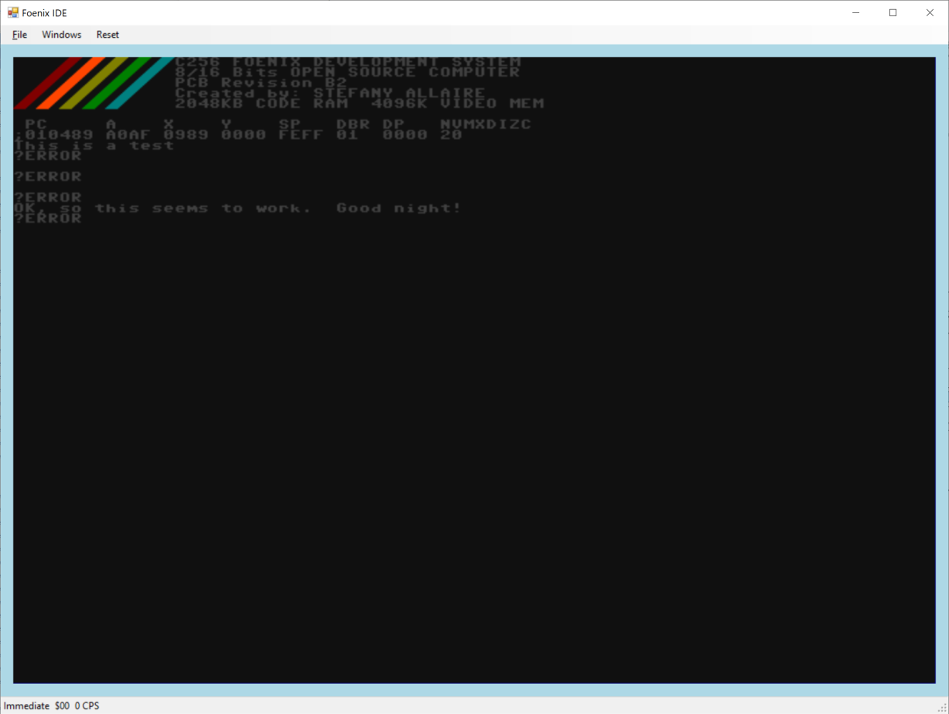

### Text Gamma Lookup Table

The Gamma lookup table is used to adjust the color between different display devices (such as DVI versus VGA). Each of the red, green and blue can be corrected. Each table consists of 256 values.

GAMMA_B_LUT_PTR = $AF:4000

GAMMA_G_LUT_PTR = $AF:4100

GAMMA_R_LUT_PTR = $AF:4200

Gamma can be enabled or disabled.

### Master Control Register

The Master Control Register (MCR) is used to enable/disable various video mode. The MCR is located at address $AF:0000.

|  |  |  |  |  |  |  |  |
| --- | --- | --- | --- | --- | --- | --- | --- |
| **Master Control Register ($AF:0000)** | | | | | | | |
| 7 | 6 | 5 | 4 | 3 | 2 | 1 | 0 |
| Disable Vid | Gamma | Sprite | Tilemap | Bitmap | Graph Mode | Text Overlay | Text Mode |

|  |  |  |
| --- | --- | --- |
| **MCR Bit** | **MCR Name** | **Description** |
| 0 | Mstr_Ctrl_Text_Mode_En | Enable the Text Mode |
| 1 | Mstr_Ctrl_Text_Overlay | Enable the Overlay of the text mode on top of Graphic Mode (the Background Color is ignored) |
| 2 | Mstr_Ctrl_Graph_Mode_En | Enable the Graphic Mode |
| 3 | Mstr_Ctrl_Bitmap_En | Enable the Bitmap Module in Vicky |
| 4 | Mstr_Ctrl_TileMap_En | Enable the Tile Module in Vicky |
| 5 | Mstr_Ctrl_Sprite_En | Enable the Sprite Module in Vicky |
| 6 | Mstr_Ctrl_GAMMA_En | Enable the GAMMA correction - The Analog and DVI have different color value, the GAMMA is great to correct the difference.  NOTE: This could also be used for fade-in and out. |
| 7 | Mstr_Ctrl_Disable_Vid | This bit disables the Scanning of the Video Memory, hence giving 100% bandwidth to the CPU to access graphic data.  NOTE: In this case the Border color or the background is displayed on the screen (I can't remember) to be advised |

### Displaying Graphics

C256 has 4 MB of Video RAM available, starting at $B0:0000 and ending at $EF:FFFF.

The order in which images are drawn are:

* L0 - Sprites (Closest to the Viewer)
* L1 - Tile Layer 0
* L2 - Sprite Layers
* L3 - Tile Layer 1
* L4 - Sprite Layers
* L5 - Tile Layer 2
* L6 - Sprite Layers
* L7 - Tile Layer 3
* L8 - Sprite Layers
* L9 - Background (bitmap)

#### Bitmaps

Once the Bitmap bit is set in the MCR, Vicky will retrieve the Bitmap Control Register at address $AF:0140.

The Bitmap Control Register is shown below.

|  |  |  |
| --- | --- | --- |
| **Bitmap Control Register ($AF:0140)** | | |
| 7 .. 4 | 3 .. 1 | 0 |
| Reserved | LUT | Enable |

|  |  |  |
| --- | --- | --- |
| **BCR Bit** | **BCR Name** | **Description** |
| 0 | Enabled | Enable the bitmap |
| 1 .. 3 | LUT | Lookup Table Index 0 to 7 |
| 4 .. 7 | Reserved | Reserved |

The address pointer of the bitmap in the Video RAM is located at addresses $AF:0141 to $AF:0143. The address stored must be offset by $B0:0000. As an example, if the bitmap data is stored in at address $B1:4000 in memory, the address pointer must be $01:4000.

The bitmap width is saved in the word $AF:0144 to $AF:0145.

The bitmap height is saved in the word $AF:0146 to $AF:0147.

#### Tiles

Once the Tile bit is set in the MCR, Vicky will retrieve the Tile Control Register at addresses $AF:0100, $AF:0108, $AF:0110 and $AF:0118 to determine if a tileset should be displayed. There can be four tilesets at any given time in the display.

The Tile Control Registers are shown below.

|  |  |  |  |
| --- | --- | --- | --- |
| **Tile Control Register ($AF:0100, $AF:0108, $AF:0110, $AF:0118)** | | | |
| 7 | 6 .. 4 | 3 .. 1 | 0 |
| Tile Striding | Reserved | LUT | Enable |

|  |  |  |
| --- | --- | --- |
| **TCR Bit** | **TCR Name** | **Description** |
| 0 | Enabled | Enable the bitmap |
| 1 .. 3 | LUT | Lookup Table Index 0 to 7 |
| 4 .. 6 | Reserved | Reserved |
| 7 | Tile Striding | 0: sequential, 1: 256 x 256 Tile sheet striding |

Each tile has its own control register, video address pointer, X and Y stride.

|  |  |  |  |  |
| --- | --- | --- | --- | --- |
|  | Tile 0 | Tile 1 | Tile 2 | Tile 3 |
| Tile Control Register | $AF:0100 | $AF:0108 | $AF:0110 | $AF:0118 |
| Tile Start Address | $AF:0101 .. $AF:0103 | $AF:0109 .. $AF:010B | $AF:0111 .. $AF:0113 | $AF:0119 .. $AF:011B |
| Tile Map X Stride | $AF:0104 .. $AF:0105 | $AF:010C .. $AF:010E | $AF:0114 .. $AF:0115 | $AF:011C .. $AF:011E |
| Tile Map Y Stride | $AF:0106 .. $AF:0107 | $AF:010E .. $AF:010F | $AF:0116 .. $AF:0117 | $AF:011E .. $AF:011F |

Tile maps are stored at addresses $AF:5000, $AF:5800, $AF:6000 and $AF:6800.

#### Sprites

Once the Sprite bit is set in the MCR, Vicky will display sprites in the appropriate layer. There can be 32 sprites displayed for each screen refresh.

The Sprite Control Registers are shown below.

|  |  |  |  |
| --- | --- | --- | --- |
| **Sprite Control Register ($AF:0200 to $AF:02F8, offset by 8 bytes)** | | | |
| 7 | 6 .. 4 | 3 .. 1 | 0 |
| Tile Striding | Layer | LUT | Enable |

Each sprite has a Control Register, a video memory address, and X and Y locations.

## SuperIO Location $AF:1060 to $AF:13FF

|  |
| --- |
| $AF:1000 - $AF:13FF - SUPER IO Devices --- (TOTAL USAGE) --- |
| // Super IO Details: |
| // $AF:1060 - $AF:1064 - LOGIC DEVICE 7 - KEYBOARD |
| // $AF:1100 - $AF:117F - LOGIC DEVICE A - PME (Runtime Registers) |
| // $AF:1200 - $AF:1200 - LOGIC DEVICE 9 - GAME PORT |
| // $AF:12F8 - $AF:12FF - LOGIC DEVICE 5 - SERIAL 2 |
| // $AF:1330 - $AF:1331 - LOGIC DEVICE B - MPU-401 |
| // $AF:1378 - $AF:137F - LOGIC DEVICE 3 - PARALLEL PORT |
| // $AF:13F0 - $AF:13F7 - LOGIC DEVICE 0 - FLOPPY CONTROLLER |
| // $AF:13F8 - $AF:13FF - LOGIC DEVICE 4 - SERIAL 1 |

## Beatrix

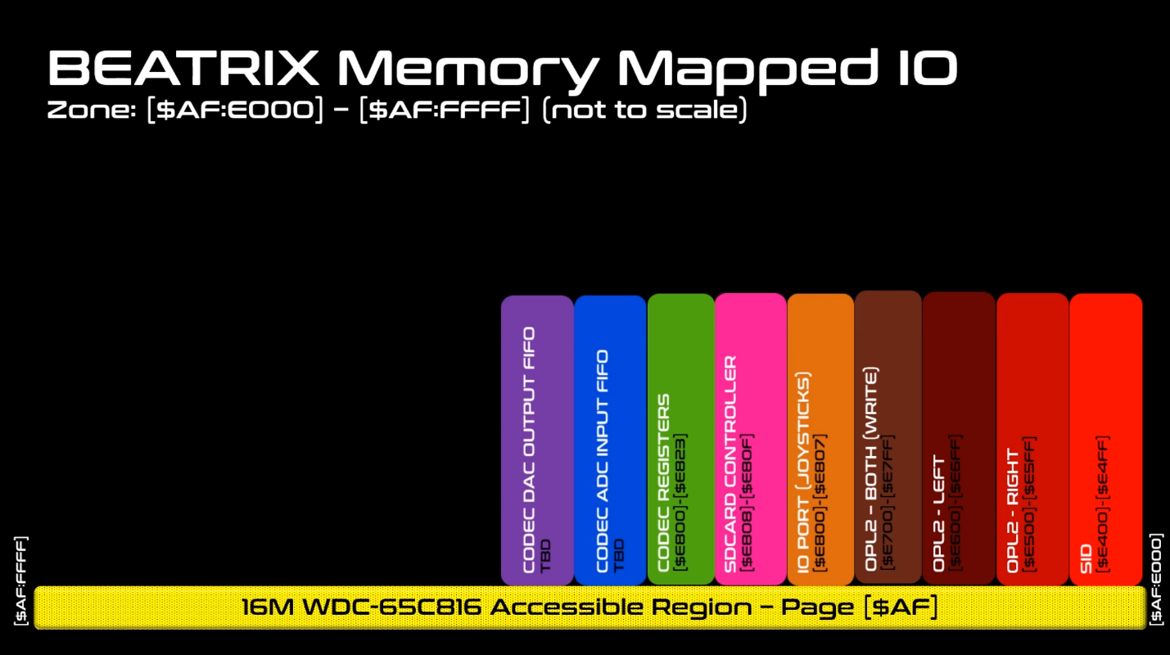

// $AF:E400..$AF:E4FF // SID (Still to be defined) Not Implemented yet

// $AF:E500..$AF:E5FF // OPL2 - Left Side

// $AF:E600..$AF:E6FF // OPL2 - Right Side

// $AF:E700..$AF:E7FF // OPL2 - Both Side (Write Sequence Only)

// $AF:E800..$AF:E807 // Joystick + AD Channel + SD Controller

// $AF:E820..$AF:E823 // CODEC Register

// $AF:E810..$AF:E81F //SD Card Stat

; Joystick Ports

JOYSTICK0 = $AF:E800 ;(R) Joystick 0 - J7 (Next to Buzzer)

JOYSTICK1 = $AF:E801 ;(R) Joystick 1 - J8

JOYSTICK2 = $AF:E802 ;(R) Joystick 2 - J9

JOYSTICK3 = $AF:E803 ;(R) Joystick 3 - J10 (next to SD Card)

; Dip switch Ports

DIPSWITCH = $AF:E804 ;(R) $AFE804...$AFE807

; SD Card CH376S Port

SDCARD_DATA = $AF:E808 ;(R/W) SDCARD (CH376S) Data PORT_A (A0 = 0)

SDCARD_CMD = $AF:E809 ;(R/W) SDCARD (CH376S) CMD/STATUS Port (A0 = 1)

; SD Card Card Presence / Write Protect Status Reg

SDCARD_STAT = $AF:E810 ;(R) SDCARD (Bit[0] = CD, Bit[1] = WP)

; Audio WM8776 CODEC Control Interface (Write Only)

CODEC_DATA_LO = $AF:E820 ;(W) LSB of Add/Data Reg to Control CODEC See WM8776 Spec

CODEC_DATA_HI = $AF:E821 ;(W) MSB od Add/Data Reg to Control CODEC See WM8776 Spec

CODEC_WR_CTRL = $AF:E822 ;(W) Bit[0] = 1 -> Start Writing the CODEC Control Register